**How to reduce, reuse and recycle your unwanted clothing**

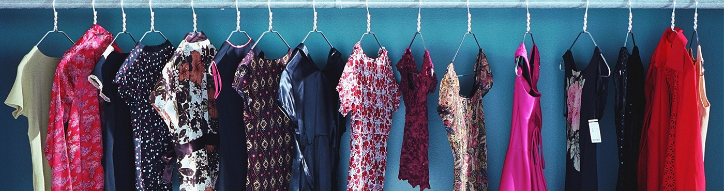

If you are overhauling your wardrobe or making space for new items, make sure you dispose of your unwanted clothing correctly. Clothing can be recycled and reused in many ways, but not through regular kerbside recycling collection.

According to the Council of Textile and Fashion Industries of Australia, Australians send around $500 million worth of fashion clothing to the tip each year, yet over 95% of it can be recycled and reused.

Recycling your clothing will:

* conserve raw materials and save water and energy
* reduce greenhouse gas emissions
* reduce landfill
* provide affordable clothing to needy families and individuals.

Reduce

* Reduce your need to recycle clothing by buying for the long term
* Buy better quality clothing that will last longer
* Buy sustainably wherever you can to avoid supporting unsustainable supply chains
* Freshen your look with accessories
* Swap or borrow from friends and family members for special occasions, rather than regularly buying new clothing that is only worn a handful of times
* Plan your clothes shopping like you would grocery shopping and avoid wasteful impulse buys
* Buy clothes that can be layered so that you can wear them in multiple seasons
* Look after your clothes by following care instructions
* Investing in small repairs can be a cost-effective way to make your clothing last longer
* Shopping your wardrobe is a fashion movement which encourages consumers to take a fresh look at clothes already in their wardrobe, in hopes that they will rediscover garments that may not have been worn in a while
* Keep your wardrobe tidy your wardrobe so that you can see everything that is available to be worn.

Reuse

* Look for ways that your clothes can be reused. Hand-me-downs, charity shops, community and online marketplaces, garage sales and swap meets are all ways to resell or reuse your unwanted clothing
* Recycle clothing in good condition by donating to your local charity store or second-hand clothing shops
* Check with your charity shop to confirm which items are accepted, and whenever possible, take your clothes in during opening hours and hand them to someone working there
* Remember that leaving items outside a closed store or next to a collection bin is [illegal dumping](https://www.sustainability.vic.gov.au/en/You-and-your-home/Waste-and-recycling/Litter-and-illegal-dumping)
* You can sell clothes through online marketplaces, community markets and garage sales or give them to family and friends
* The National Association of Charitable Recycling Organisations (NACRO) ensures its members use all collected goods and proceeds exclusively for their welfare programs
* A range of other clothing donation programs offer their proceeds to various good causes such as disadvantaged people looking for employment, and local and international communities in need of clothing and footwear

Recycle and repurpose

* Some retailers now run recycling programs and accept used clothing in store which are resold or processed for rags or other textile by products
* Search a comprehensive list of drop-off locations for unwanted clothing on Planet Ark's [Recycling Near You](https://recyclingnearyou.com.au/charities/) website

What happens to recycled clothing?

Good quality clothes are resold by charities in their retail outlets for fundraising purposes, or they may be given to disadvantaged people.

Some charities will recycle clothes which are in poor condition into industrial rags, sound-absorption materials, insulation or stuffing. Ask the charity what their acceptance criteria is, because the charity will be liable for any costs associated with sending inappropriate clothing to landfill.

Some clothing (preferably natural fibres) can be used for weed matting. A community garden or landcare / bushcare group may accept donations.

How to dispose of clothing right, through kerbside waste and hard rubbish collections

As a last resort, clothing that can't be reused or recycled can be discarded in your kerbside waste bin or through your local hard rubbish collection.

Clothing and textiles are not recycled through the kerbside recycling bin.

Depending on the facilities at the recycling plant which processes your kerbside collections, clothing and textiles that are in recycling can get caught in the sorting machines and contribute to machinery wear and tear or slow down the sorting process.