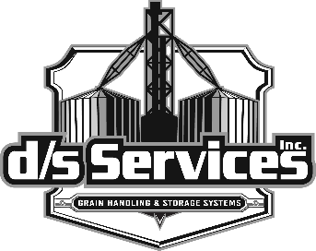

At Will: Policy Statement

Your employment with d/s Services, Inc. is at will. This means your employment is for an indefinite period of time and it is subject to termination by you or d/s Services, with or without cause, with or without notice, and at any time. Nothing in this policy or any other policy of d/s Services, Inc. shall be interpreted to be in conflict with or to eliminate or modify in any way, the at will employment status of d/s Services, Inc. employees.
The at will employment status of an employee of d/s Services, Inc. may be modified only in a written employment agreement with that employee and by the President, or the Chairman of the Board of Directors, of d/s Services, Inc.
By your signature below, you acknowledge your understanding that your employment with d/s Services, Inc, is at will, and that nothing in this handbook is intended to constitute a contract of employment, express or implied.

_____________________________________
Employee Signature

_____________________________________
Employee Printed Name

_____________________________________
Date

