**THE ACCEPTABILITY AND UTILIZATION OF RECYCLED AND RENOVATED GARMENTS BY HOME ECONOMICS STUDENTS IN UNIVERSITY OF ILORIN**

**BY**

**ADEYEMO, Fatimoh Iretioluwa**

**Matric No: 16/10AR004**

**A PROJECT REPORT SUBMITTED TO THE DEPARTMENT OF HOME ECONOMICS AND FOOD SCIENCE, FACULTY OF AGRICULTURE, UNIVERSITY OF ILORIN, ILORIN, NIGERIA IN PARTIAL FULFILMENT FOR THE REQUIREMENT OF THE AWARD OF BACHELOR OF SCIENCE/DEGREE (B.Sc.) IN HOME ECONOMICS**

**JUNE, 2021**

**DEDICATION**

This project is dedicated to Almighty Allah the most Beneficent and the most Merciful who has given me the ability and strength to begin and complete this work with his immeasurable bounties and to my adorable son Adedayo Abdullah Ademide, Thank you for coming at the right time and my lovely husband who stood by me, supported me in everything by sparing his time. I really appreciate you both.

**ACKNOWLEDGEMENTS**

All praises and adorations are due to Almighty Allah the most Beneficent and the most Merciful and his Messenger who with his immeasurable grace sustain me throughout this study. My profound appreciation goes to my supervisor Dr. (Mrs.) Adebisi T.T for her unrelenting motherly effort, supervision, and guidance towards the success of this study, my love for you is immeasurable, thank you so much ma. I also appreciate and commend the efforts of the Head of Department Dr. (Mrs.) F.L. Kolawole, and the lecturers: Dr. (Mrs.) C.T. Gbadebo, Dr. (Mrs.) A.A. Babayeju, Dr. Mrs. D.O Opaleke, Mrs. W.O. Johnson, Mrs. S.O. Abdulkadir and all lecturers in the Department of Home Economics and Food Science Also, I acknowledge Mr. M.B. Kareem, Mrs. G.O. Adeyanju.

My sincere gratitude also goes to my mother, Mrs. khadijat Adeyemo. For her love, immeasurable financial support, encouragement, advice and prayers and I pray that Almighty Allah continue to bless and guide you in this life and the hereafter In shaa Allah, Ameen. I also acknowledge my husband Mr. Qasim Adedayo (QA) for his love, immeasurable financial support, word of encouragement, advice and prayers and I pray that Almighty Allah continue to bless and guide you in this life and the hereafter In shaa Allah, Ameen. Also, I acknowledge my siblings my one and only big sister, Mariam Adeyemo, and brother, Yusuf Adeyemo. I also acknowledge my son Abdullah Adedayo who in no way inconvenient me. I also acknowledge my wonderful roommate Ayomide Olaleye thank you so much for your help and support.

Finally, I appreciate my friends and classmates; Halimat Musa, Mistura Atunshe, Kamilat Kamaldeen, Taofeekat Adekeye, Wakeelat Bello, Ganiyat Aderibigbe, Asiyat Abdulkareem, Bolu Ogundele, Damilola Sulaimon, Fatimah Adulwahab, Yetunde Babatunde, Mariam Kareem, Balqis Babatunde and so many others. I wish everyone success in all their endeavor.

**TABLE OF CONTENTS**

TITLE PAGE i

CERTIFICATION ii

DEDICATION iii

ACKNOWLEDGEMENT iv

TABLE OF CONTENT vi

LIST OF TABLES ix

LIST OF FIGURES x

ABSTRACT xi

**CHAPTER ONE: INTRODUCTION**

1.1 Background to the Study 1

1.2 Statement of Problem 6

1.3 Objectives of the Study 7

1.4 Research Questions 7

1.5 Significance of Study 8

1.6 Scope of Study 9

**CHAPTER TWO: REVIEW OF RELATED LITERATURE**

2.1 Concept of Garments 10

2.2 Concept of Reasons for Garment Disposal 13

2.3 Garments that can be Recycled and Renovated 17

2.4 Benefits of Recycling and Renovation 19

2.5 Methods of Recycling and Renovation 24

2.6 Concept of Colour, Style, Balance, Proportion 40

**CHAPTER THREE: MATERIALS AND METHODS**

3.1 Design of Study 46

3.2 Area of Study 47

3.3 Population of the Study 47

3.4 Sample and Sampling Technique 47

3.5 Instrument for Data Collection 47

3.6 Validity of the Instrument 48

3.7 Reliability of the Instrument 48

3.8 Method of Data Collection 49

3.9 Method of Data Analysis 49

3.10 Materials and Methods 49

**CHAPTER FOUR: PRESENTATION OF FINDINGS AND DISCUSSION OF RESULTS**

4.1 Answers to the Research Questions Raised in the Study 51

4.2 Discussion of Findings 61

**CHAPTER FIVE: SUMMARY, CONCLUSION, AND RECOMMENDATIONS**

5.1 Summary 64

5.2 Conclusion 66

5.3 Recommendations 66

**REFERENCES** 67

**APPENDICES**

Appendix A: Questionnaire 76

Appendix B: Letter of Introduction 80

Appendix C: Reliability Table 81

Appendix D: Raw Score of Field Survey of Data Analysis 82

**LIST OF TABLE**

**Table 1:** Mean and Rank Order of Respondents’ Knowledge on 52

Reasons for garment disposal

**Table 2:** Mean and Rank Order of Respondents’ Responses on 53

Garments that can be recycled and renovated

**Table 3:** Mean and Rank Order of Respondents’ Responses 54

On benefits of recycling and renovation

**Table 4:** Mean and Rank Order of Respondents’ knowledge on 55

Methods of recycling and renovation

**Table 5.1:** Frequency and Percentage analysis of BDFG 56

**Table 5.2:** Frequency and Percentage analysis of ACSS 57

**Table 5.3:** Frequency and Percentage analysis of TSTJ 58

**Table 5.4:** Frequency and Percentage analysis of TDTS 59

**Table 5.5:** Frequency and Percentage analysis of CSUA 59

**Table 5.6:** Frequency and Percentage analysis of BDFD 60

**LIST OF FIGURE**

**Figure 1**: Flow chart of applique production 50

**Figure 2**: Flow chart of production tie dye 50

**Figure 3a**: Father’s shirt89

**Figure 3b**: Baby’s dress 89

**Figure 4a**: Stained shirt 89

**Figure 4b**:Apron and Chef Cap 89

**Figure 5a**: T- shirt 89

**Figure 5b**: Jacket 89

**Figure 6a**: Faded T- shirt 90

**Figure 6b**: Tie dye T- Shirt 90

**Figure 7a**: Simple gown 90

**Figure 7b**: Applique gown 90

**Figure 8a**: Big dress 90

**Figure 8b**: Fitted dress 90

**ABSTRACT**

*The study assessed the acceptability and utilization of recycled and renovated garments among Home Economics students, University of Ilorin. Five research questions were raised. Research and Development (R and D) research design was adopted. Questionnaires were distributed at random to students of Home Economics, University of Ilorin. Twenty respondents were used for pilot study and was found reliable at 0.871. Seventy respondents were used for the main study. Frequency, mean, standard deviation and percentages were used to analyze the* *data. The findings reveal that all the statements on reasons for garments disposal among home economics students in university of Ilorin have mean scores that are above the average (benchmark) mean value of 3.00 for determining the main influential reasons. However, items 9 (x̅ = 4.24 & σ = 0.984), 7 (x̅ = 4.19 & σ = 0.873), 10 (x̅ = 4.18 & σ = 1.133) and 6 (x̅ = 4.01 & σ = 1.148) took precedence over others and were ranked between 1st and 4th respectively however, the major reasons for garments disposal among home economics students, university of Ilorin are change the appearance of the garment, to renew the old garment and look unique, outgrown some of the garments and when the garments are too tight, all the items on benefits for recycling and renovating in the study area except items 11 and 4 have mean scores that are below the average (benchmark) mean value of 3.00 determining the benefits. However, items 1 (x̅ = 4.44 & σ = 0.773), 12 (x̅ = 4.32 & σ = 0.978), 2 (x̅ = 4.27 & σ = 0.850), 9 (x̅ = 4.21 & σ = 0.915) and 7 (x̅ = 4.17 & σ = 1.204) took precedence over others and were ranked between 1st and 5th respectively. Therefore, benefits for recycling and renovation are; it changes the outlook of the garment, it gives the garment a second life, it saves money to purchase another garment, it prevents wastage of garment and it exhibit one’s creativity. Based on the findings, the researcher concluded that recycling and renovation of garments is very essential to help give garment a second life , because garments still have their potential fibres, through recycling and renovation an individual can exhibit his or her creativity.* *Among the recommendations stated are: Home economics students are enjoined to utilize high quality fabrics so that they can derive maximum benefit from the garments and home economics students should learn the skills required to recycle and renovate garments effectively*

**CHAPTER ONE**

**INTRODUCTION**

**1.1 Background of Study**

When garments has been used to meet various psychological, sociological, cultural and physical needs, the garments might get too tight or small in size and may not be fit enough for the consumer (students) again. Sometimes the styles can also be out of fashion. Consumers (students) gets tired of the style, in which they might decide not to use them again. Proper recycling of garments helps to keep them in good condition so that appearance of the wearer is enhanced. (Fisher 2008). The destination for garments that has become disused depends upon the wearer’s personal sentiments, sense of civic or social duty, or feeling of guilt. According to Stall-Meadows and Goudeau, (2012). Consumer (students) are not aware of the value the fibres in each garment hold, nor are they aware that this value extends beyond immediate utilization thereby wasting the potential fibre value of the garments.

Garment is one of the necessities of the family and with the escalating price of everything in the market, one cannot afford to buy clothes as often as before. Therefore, adequate care should be taken of the clothes already available. Many people feel that when a garment has served its original purpose or is out of fashion it is no longer needed. The garment may not be old, torn or faded. Much use can still be made of such garments if one has the knowledge and imagination to plan and organise so that success can be achieved in making something new from old garment. Renovation also provides the opportunity to extend one's ward-robe without having to spend a lot of money. This is important especially now that new clothes are out of the reach of so many people. Because of these factors and more, there is the need to know the techniques of how to use some of the old garments within the family to produce new ones. Articles of clothes that could be used for renovation are:- Those garments that are out of fashion, Those damaged by insects, moths, termites, fire etc., Faded garments, Clothes that have out lived their usefulness but are still strong in texture e.g. wedding gown.

There are many reasons for recycling or renovating a garment, Change of body size may require major adjustments. You may want to add to the family wardrobe without straining the family budget, Often you have a garment you no longer need or want which can be made into something for another member of the family, Sometimes a favourite garment is not quite in fashion but can become so with a few changes. An easy place to begin is making a child's garment from an adult's. A child's skirt and vest could be made from a woman's dress or coat. A pair of slacks could be made from a pair of men's or women's pants. Once a fairly easy project is accomplished and you know how to proceed, you will have the confidence to renovate clothing for adults. (Jane and Gerda, 2012)

Recycling and renovation is designed for minimal use of energy, minimize or eliminate waste material, to use an item more than once, this is a way without reprocessing which help save time, money, energy and resource, changing the outlook of the garment, reduce environmental pollution, to save new materials, It increases the garment in wardrobe, it boost status, exhibit creativity, Recycle is the third component of the waste hierarchy, and is processing used waste materials into new products that need creativity (Leung 2011).

According to Fletcher(2008) recycling is a transition of used things into something more socially acceptable and less energy intensive. Recycling is the construction of an entirely new article or garment from one that is worn out or damaged in a particular area while on the other hand, Renovation is making minor changes in the appearance of garments to renew them. Olugbamigbe (2010) Renovation is the process of enhancing the appearance of old articles, refurnishing old items or recycling out of used materials or items in order to make them useful and also enhance their face values. Many favourite garments could be altered, improved and made fashionable with little initiative. Each worn garment presents its problem, and this calls for one to see to those problems. (Ogunyide,Olusanya, Egbuchulam, Eyisi, Anfani-joe, 2009) asserted that a pleated or gathered skirt may be unpicked, pressed and cut into the latest styles and made up, using sewing process.

Old garment can be renewed and look attractive again, The length of a skirt maybe increased by lengthening, a hole on a fabric can be mended by darning, use of patch work, the hip of a trouser may be expanded by introducing a strapped seam at the side to renovate them, father’s garment can be made into a baby’s dress, an oversized garment can also be made fitted by adding elastic band to it thereby reducing its width, a t-shirt can also be made into a jacket to change the outlook of the garment, an apron and chef cap can also be obtained from a damaged shirt using the sewing process. A long sleeved shirt that is damaged at the cuff can be changed into a short sleeved shirt, Forster, (2014). Garments articles lose their original colour due to constant use and frequent washing, exposure of the materials to direct sunshine, heat and dust also aid colour loss. It is necessary to renovate these fabrics by dyeing so that they can continue to be useful. Faded old garments articles look new by simple tie and dye, batik and screen printing them. A new colour different from the original colour can also be achieved, Anyakoha (2015). what could be made from old garments : Wrapper to Apron, girl 's dress, boy's jumper or shorts, napkins, dusters, pinafore, scarf etc., Mother 's skirt to boy's shorts, girl 's wrapper, scarfs, girl 's dress, girl 's night dress, , Father's trousers to boy's shorts, boy's trousers, Bed sheet to Cot sheet, inner pillow slips, dust sheet, baby's napkins, pillow cases etc., Table linen to table napkins, tray covers, radio/TV cover, etc., Blanket to polishing cloth, pot holder, Ironing board cover, under blanket, duster etc., Big towel to face cloth, wash cloth, bath mat, lavatory towels, toys etc., Curtains to Dust sheets, children's bed cover, pillow cases, smaller curtains for small windows, etc.

A designer may choose to use recycle fabrics and create products in which their fabrics can be recycled at the end of the lifecycle. The recycling of materials saves new materials, but needs energy for the mechanical processing of natural fibres, chemical processing of synthetic fibres and re-spinning them into new yarns. Moreover, fabric blend remain a problem in terms of their recycling. Designing with recycling in mind is a way to avoid problems. Fabric is a great resource and used fabric in garments has so many possibilities for being reused again. By saving old garments and turning them into something else. Make hair bands, bracelets, necklace, belts, hats, scarf and gloves from old fabric (Anon 2010).

Creativity needs to be emphasized in producing new designs or modifying current designs into other designs (innovative).creativity is the ability to make a new solution to a problem, or a new artistic object, creativity is the ability to think, take action, produce something original, innovative and the consumers’ needs to be highly imaginative. The skill exists when and consumers have high degree of innovative, different thinking and willingness to take risk. Achor (2014) defines creativity as the disposition to make and recognize valuable innovations. It manifests itself in the ability of the individual to create his own symbols of experience. A person is said to be creative if he has the ability to combine or rearrange established patterns of knowledge in a unique fashion. Creativity is the fundamental premise and genesis of entrepreneur activity and is not exclusive right possession of a chosen few Creativity in converting table cloths into napkins and dusters, bed sheets into ironing sheets, pillow cases and patching pieces for other items in the home, small pants and shorts could be made from men trousers, slightly torn or worn blankets could be made into babies blankets or cots or ironing board blankets and faded dress can be dyed to make the article look new again.

“Here today, gone tomorrow” is the strategic view of the current fast-fashion retailers to increase the store visitation rate with customers disposing of their garments more frequently, and increasing their revenue (Bhardwaj and Fairhurst, 2010). Many famous fashion retailers produce new garment lines every 2 to 3 weeks with very low prices. This strategy stimulates the consumer’s (students) impulse to purchase (Foroohar and Stabe, 2005). As a result, consumers (students), who wish to keep up with latest fashion trends, will purchase any garment that has been launched. This results in excessive garments consumption, and, hence, the overconsumption rate will lead to the disposal of superfluous garments. Therefore, as the phenomenon of fast fashion is growing rapidly, there is concern regarding the methods used by these young consumers (students) to dispose of their seasoned garments, as the constant change in fashion leads to over garments consumption and the underutilization of some garments, which will only be worn a few times (Birtwistle, 2007). Human not only need to re-use and recycled resources effectively, but also need to improve the world, the place we live in. They also brought forward the comprehension towards the roles of consumers (students) where each one of us needs to protect the planet from the aftermath of irresponsible human behaviour.

**1.2 Statement of Problem**

It has been perceived that when garments has been used to meet various ( physiological, sociological and cultural)needs, some tend to become too tight, smaller in size, outgrown some of the garments, show signs of wear and tear, due to constant use and frequent washing, garments lose its original colour for these reasons and more garments tend to be disposed in which much can still be done to such garments if one has the knowledge and imagination to plan and organise something new from the old garment. Also, students, who wish to keep up with latest fashion trends, will purchase any garment that has been launched. This results in excessive garments consumption, and hence, the overconsumption rate as the constant change in fashion leads to over garments consumption and the underutilization of some garments, which will only be worn a few times leading eventually to garments disposal thereby contributing to environmental pollution. Each worn garment presents its problem, and this calls for one to see to those problems.

**1.3 Objective of Study**

The broad objective of the study is to investigate the acceptability and utilization of recycled and renovated garments by home economics students in university of Ilorin.

The specific objectives are to:

1. Identify reasons for garments disposal among home economics students, university of Ilorin.
2. Investigate garments that can be recycled and renovated among home economics students, university of Ilorin.
3. Examine the benefits for recycling and renovating garments among home economics students, university of Ilorin.
4. Investigate garments recycling and renovation methods adopted by among home economics students, university of Ilorin.
5. Assess the acceptability of garments recycled and renovated among home economics students, university of Ilorin based on colour, style, balance, proportion, and overall acceptability.

**1.4 Research Questions**

These questions are raised as guidelines for the study:

1. What are the reasons for garments disposal among home economics students, university of Ilorin.?
2. What are the various garments that can be recycled and renovated among home economics students, university of Ilorin?
3. What are the benefits for recycling and renovating among home economics students, university of Ilorin?
4. What are the methods of recycling and renovation of garments adopted by home economics students, university of Ilorin?
5. What is the acceptability of garments being recycled and renovated among home economics students, university of Ilorin based on colour, style, balance, proportion and overall acceptability?

**1.5 Significance of Study**

The research study seeks to assess home economics students in university of Ilorin on acceptability and utilization of recycled and renovated garments. The study is significant in a way that it will be beneficial to environmental agencies, households, students and fashion houses by increasing their awareness on methods, benefits and reasons of recycling and renovating old, worn-out, outgrown garments in producing new ones. Styles and designs can be modified using their initiative and creativity rather than disposing it. It is beneficial to environmental agencies in a way that it creates awareness about reduction in air pollution that may affect health of the members of the community. Through proper recycling and renovation of garments, there would be no form of garment disposal because it is through disposal of garment that air pollution arise due to burning of such garments by environmental agencies. It will be beneficial to households, students, and fashion houses by creating awareness through exhibitions. Exhibition is the display of various items or articles produced and they are usually put for sale, awareness can also be made through the use of flowchart to explain the methods, skills and materials required to recycle and renovate old garments to produce new ones.

**1.6 Scope of Study**

The study focused on the acceptability and utilization of recycled and renovated garments among home economics students, University of Ilorin. Old, stained, oversize, faded, simple garments were recycled and renovated involving six pieces of garments in which a father’s garment was recycled into a baby’s dress, a stained shirt was recycled into apron and chef cap, a T- shirt was recycled into jacket, a T- shirt was renovated by the application of tie dye, a simple gown was renovated using applique to form new designs, a big dress was renovated and made more fitted using elastic bands. This study is to promote and encourage proper utilization of recycling and renovation methods.

**CHAPTER TWO**

**REVIEW OF RELATED LITERATURE**

The related literatures were reviewed under the following subheadings:

* 1. Concept of Garment
  2. Concept of Reasons for Garment Disposal
  3. Garments that can be Recycled and Renovated.
  4. Benefits of Recycling and Renovation of Garment.
  5. Methods of Recycling and Renovation of Garment.
  6. Concept of Colour, Style, Balance and Proportion

**2.1 Concept of Garment**

Garment also known as apparel or attire, this can be made from textile, animal skin or other sheet of materials put together. Collins (2012) a garment is any article of clothing or an outer covering or outward appearance. The amount and type of garment worn depend on body type, social and geographical consideration.

A garment is an integral part of our self-image, a means of consciously or unconsciously expressing ourselves and communicating with others (Miller-Spillman and Michelman, 2005). Along with air, water, food and shelter, garment is universally demanded across the globe, with virtually every member of our species requiring garment in some form or another. Most garments are made from 100% cotton. The environmental justice foundation estimates that it takes around 2,720 liters of water to produce one cotton garment; equivalent to what an average person might drink over three years. Social and environmental concerns surround cotton production because of the impact on natural resources such as land and water, use of chemicals.

**Functions of garment**

Garment, which is made from textile, is one of the three basic necessities of man, alongside food and shelter (Adu-Akwaboa, 2010). Although, garment (garmenting) is usually prioritized second to food, Agyemang (2011) posits that one can go unnoticed without food or shelter for a moment, but without garmenting, he or she may be perceived in a civilized world as insane or a mad person. All items used in covering and ornamenting the body which is found in body arts can be termed as fashion.

In countries where it is either very warm or very cold most of the time, the same form of garment is worn year after year. Where the temperature is constantly changing, as in the temperate zone, the style of garment is also subject to frequent change; and these varying modes constitute what is called "fashion." While the primary use of garment is to afford protection from the heat and cold, they should be made and worn with a view to pleasing the eye. Elise, (2008). It is essential, therefore, that they be carefully cut and neatly made, and they should be kept clean and in good order.

Ahia (2001), has stated that beyond the use of garment to protect the bare body, it serves as a means of group identification, gender stereotyping, ritual distinction and status symbolization and these other functions of clothes create serious religious, social and economic pressure which people of the world have to bear. Shailong and Igbo (2009), have opined that besides protection, garment act as means of personal communication by expressing the individual unique personalities for modesty and for attraction, easy identification and for social statues. Garment performs a range of social and cultural functions, such as individual, occupational and sexual differentiation, and social status. In many societies, norms about garment reflect standards of modesty, religion, gender, and social status. Garment may also function as a form of adornment and an expression of personal taste or style. (Marshal, Jackson, Stanley, Kegan, Mary and Touchie, 2010) noted tht when an individual’s clothing and appearance send messages that do not correspond with their personality, cognitive dissonance occurs, or what is called disintegrated personality or problem of mistaken identity. Garment can and has in history been made from a very wide variety of materials. Materials have ranged from leather and furs, to woven materials, to elaborate and exotic natural and synthetic fabrics. Anderson, (2008). Human without garment is considered as lunatic in this current age. Aside protection, garment is used for other purposes in our societies such as body adornment etc. Fundamentally, man without garment is considered to be uncivilized in the society and loss dignity as human. Okorie (2000) regards creativity and knowledge of measurements as imperative characteristics of garment designers. Garment play an important role in existence ranging from protection from adverse weather condition, aesthetic purpose, cultural heritage, identification etc.one of the major function is protection of human body from adverse weather conditions. It also unifies our role (Woodward, 2005) with regard to identity, sexuality, sociality, and hence garment choices externalizes the inner self in social contexts. The functions of garment are also the reasons why people choose and wear garment. They are the motivations for garment.

**2.2 Concept of Reasons for Garment Disposal**

A consumer’s disposition behaviour is explained as the consumer’s behaviour and decision making during his or her unused product disposition stage. Laitala (2014) defined disposal as “the act of getting rid of something, i.e. the end of life stage of the garment with the present owner, regardless of whether the garment is discarded of as waste or delivered to recycling or reuse”. This behaviour involves reusing used garment, recycling it, donating it to charities, giving it away, giving it to a second-hand store, eliminating it completely, and so on (Bianchi and Birtwistle, 2010). There are several ways for consumers to dispose of their garment, they become unfashionable; they no longer fit, they fit but do not look or feel good, Colour fadedness, the styles became unfashionable, getting tired, worn out, stains mar the garment, too tight, wear latest and look unique in the society, be socially involved in the society, change the garment in my wardrobe, outgrown some of my garments; or a change in life style also inspire disposability. These are all common reasons for throwing away garments. Moreover, the destination for garments that has become disused depends upon the wearer’s personal sentiments, sense of civic or social duty, or feeling of guilt, (Fisher 2008). Donation to charity, give away to family or friends, resell it, or discard in rubbish bins. Specifically, donation to charities and give away to family and friends are the most common methods for sustainable garment disposal (Birtwistle and Moore, 2007; Hiller, 2010). These two methods save a lot of cost in the disposal process and benefit the needy. Some disposal methods, such as reuse and redesign, help to prolong the life of the garment. In addition, the donation of used garment to developing countries for charity purposes is a usual option for disposal by developed countries such as the United States, while superior-quality garment are sold to second-hand garment shops (Fletcher, 2013). Garment redesign is also found to be a main disposal method and some recyclers prefer to reuse or redesign their old garment, instead of converting those into rags However, due to the differences across the countries in terms of culture and industrialization, the main influential factors for the garment disposal methods by consumers remain unsolved. Hence, this study aims to shed some insight into the factors that affect the garment disposal behaviour among young consumers.

Garment disposal is, as mentioned above, strongly connected to the rise of fast-fashion in the sense that over consumption of garment lead to their over disposal. Morgan and Birtwistle (2009) argue that the relationship between garment waste and fast-fashion is unmistakable. Fast-fashion retailers are able to offer garment that follow the new trends in very competitive prices and thus achieve large sales volume. Furthermore, they offer garment that are expected to be worn less than ten times and are mainly made of synthetic fibres that constitute, as discussed above, a threat to the environment in the case of disposition into landfills. Due to these facts, consumers tend to purchase garment with higher frequency and as a result they tend to dispose these garment more frequently than before, even if they are still wearable. The disposal of garment that are worn only a few times is characterized as disposable fashion or throwaway fashion. Garment disposal is considered a complex issue of great significance for the modern society. Although disposal in general and specifically disposal of garment and textiles was in the past a neglected subject, it has recently drawn a lot of attention.

Garment disposition is considered primarily as environmental issue directly related to the amount of garment waste that concludes to landfills, and consequently to the effect that arise from their decomposition. Some studies conducted in recent years have especially focused on consumers’ garment disposal behaviours. Birtwistle and Moore (2006), Ha-Brookshire and Hodges (2009), Morgan and Birtwistle (2009), Bianchi and Birtwistle (2010), Bianchi and Birtwistle (2012), Joung and Park‐Poaps (2013), and Borthakur and Govind (2016) have investigated the ways of garment disposal. According to the results, the most common garment disposal behaviours of consumers are donating to charity, giving away to family or friends, and selling through websites such as eBay. The results indicate a significant positive relationship between consumer fashion innovativeness, recycling behaviour, awareness of the environment and sustainable textile disposal behaviour. To understand the consumer textile disposal behaviour it is necessary to understand what consumers do with their purchased garment. In most wardrobes, there will be garment that are actively worn and used, and there will also be inactive, unused garment that are mainly stored. Cluver (2008) categorised consumer’s wardrobe inventories into different levels of inactivity: permanent (garment which will probably never be disposed because of emotional attachment), temporary (garment which will be eventually disposed, but kept in case of future opportunity for use), invisible (garment are somehow forgotten and invisible, not noticed), and transitional (garment are intended for disposal, but consumer requires time and psychological preparation to do so; these garment might be stored separately in the interim) (Cluver, 2008). It is possible that a garment that had been in the inactive stage of a wardrobe can be reactivated, but it can also move into any of the other inactive stages.

However, most inactive garment will be eventually disposed. The impact of inactive garment on textile waste is exacerbated by the high percentage of inactive garment that consumers keep in their closets. Therefore, it is necessary to understand what makes a garment inactive, that is to say, what reasons are responsible for consumers to not wear a garment since the same reasons will eventually lead to a disposition of the garment.

There are many reasons why consumers want to get rid of their garment and remove them from their wardrobes. It describes different factors which influence a consumer’s choice of disposition and grouped them in three categories: “psychological characteristics of the decision maker” such as personality, attitude, or social conscience; “intrinsic factors to the product” such as condition, age, style, or initial cost; and **“**situational factors extrinsic to the product” such as finances, storage space, or fashion change. Different academic researchers have found different factors for textile disposal (Birtwistle and Moore, 2007; Lee, 2013; Smith, 2012) Note also that while all factors individually can lead to disposal, a garment can also have several reasons for disposal (Laitala, 2014).

Managing unwanted textiles is based on individual, product, and situational factors, and will ultimately depend on the consumer. Focusing on the consumer is essential because even if a garment loses its value due to wear and tear. The consumer decides whether the garment can still be worn or if it is ready for disposal. Consumers might decide not to wear garment with signs of wear and tear (Cluver, 2008), or the garment might hold sentimental value for the consumer (Sego, 2010). The main reason for garment disposal noted by Smith was the consumer disliking the garment style, which is a shift usually connected with the consumer’s fashion identity: Reasons include a person’s perceptions of age and body shape.

**2.3 Garments that can be Recycled and Renovated**

Each time garment in the home presents its own problems. (Marshal, Jackson, Stanley, Kegan, Mary and Touchie, 2010) opined that garment recycling and renovation needs a complete recycling and renovation kits like hand needles, sewing machines, threads, scissors ,dyes, ironing boards, machine needles etc. CESAC enlisted some guidelines for recycling and renovation of garments articles. That is before any garment article can be recycled and renovated it has to follow some guidelines which include:

* The garment to be recycled must not be too old
* The garment to be recycled and renovated should be sufficient in producing new ones
* The new garment can be made attractive by using sewing accessories
* The garment should be suitable for which it was intended.

(Koester 2005) agreed that garment recycling and renovation activities are making new things out of old garments, remodelling out of fashion garment into a garment of current fashion or style, and dying of faded garments. The mismanagement, wastage of household garments shows ingenuity on the part of the homemaker. The non-ingenious house maker may discard an old garment or allow a child to wear it as it is which the case is often. But a good home maker will renovate it by making children’s garment. Even a pleated or gathered skirt, can be unpicked, pressed and cut into the latest style and made up. Kattlean, (2015) out of fashion garment be renovated or recycled neatly and well done, the garment can appear almost as good as new. (Ogunyide, Egbechulam, Eyisi, Anfani-joe, Olusanya, 2009) asserted that;

* Table garment may be converted into table napkins and dusters
* Bed sheets could be made into ironing sheets, pillow case, ironing towels, boiling bags, and patching pieces for other items in the home
* Slightly torn or worn blankets could be made into babies blankets, for cots, or ironing board blankets as well as patches for blankets
* Big bath towels can be made into face towels, by cutting out pieces of 20cm square, then loop stitching, or crocheting round the edges with threads. Baby feeders or bibs can also be made and bound with bias binding
* Small pants and shorts could be made from men’s trousers.
* Small dresses could be made from oversize dresses, wrappers and night dresses
* Adult garment into a child’s garment
* For an in experienced dress maker, second hand dresses are very useful in making babies dresses.

Wrapper to Apron, girl 's dress, boy's jumper or shorts, napkins, dusters, pinafore, scarf etc., Mother 's skirt to boy's shorts, girl 's wrapper, scarfs, girl 's dress, girl 's night dress, , Father's trousers to boy's shorts, boy's trousers, Bed sheet to Cot sheet, inner pillow slips, dust sheet, baby's napkins, pillow cases etc., Table linen to table napkins, tray covers, radio/TV cover, etc., Blanket to polishing cloth, pot holder, Ironing board cover, under blanket, duster etc., Big towel to face cloth, wash cloth, bath mat, lavatory towels, toys etc, Curtains to Dust sheets, children's bed cover, pillow cases, smaller curtains for small windows, etc.,

**2.4 Benefits of Recycling and Renovation**

Aggarwal (2010) recycling means taking materials from products that one has finished using and trying to make new products out of them.it involves processing used material into products to prevent waste of potentially useful materials. Gwilt and Rissanen (2011) found few opinions from the designers that defined recycling as when someone can determine the real value of waste material through transformation during designing and manufacturing. Recycling activities are among the activities that contribute towards the sustainability of the environment that is able to reduce destruction of nature and reduce the usage of raw materials to create new things which is efficient because it can be used multiple times before disposal. Meanwhile the word up cycling and the antonym down cycling mean variation of recycling that are normally related to reducing wastage and re-use everything that we dispose. Ngack (2011) also defined recycling as reuse of disposed materials to develop a product that has higher value compared to the original product. Up-cycling is a hybrid process of reuse where the final product often becomes a reengineered version of itself, with a new twist. More specifically, up-cycling is the idea of adding value to something that is considered waste, to again eliminate the idea of waste altogether. An example of this is taking an old pair of blue jeans, cutting and re-sewing them into a skirt. Alterations and repairs like this that gives a garment a new life have been taking place in homes forever as a way to extend the life cycle of garment that people already own.

Renovation is making minor changes in the appearance of garment to renew them. This is done to alter or adjust the fit, to update the article to suit current fashion, Prevent waste and increase wardrobe. Olugbamigbe (2010) Renovation is the process of enhancing the appearance of old articles, remodelling old items or recycling out of used materials or items in order to make them useful and also enhance their face values. Many favourite garments could be altered, improved and made fashionable with little initiative. The length of a skirt maybe increased by lengthening, a hole on a fabric can be mended by darning, use of patch work, the hip of a trouser may be expanded by introducing a strapped seam at the side to renovate them. (Okafor, 2008) Garment articles lose their original colour due to constant use and frequent washing, exposure of the materials to direct sunshine, heat and dust also aid colour loss. It is necessary to renovate these fabrics by dyeing so that they can continue to be useful. Faded old garment articles look new by simple tie and dye, batik and screen printing them. A new colour different from the original colour can also be achieved. A renovated garment utilizes existing materials, adds value back to garment that may otherwise be considered waste and adds longevity to garment by refreshing their styles. Kattlean, (2015) out of fashion garment be renovated or recycled neatly and well done, the garment can appear almost as good as new.

**Simple Renovation of Garment**

Garment articles lose their original colours due to constant use and frequent washing. Exposure of the materials to direct sunshine, heat, and dust also aid colour loss. It is necessary to renovate these materials by dyeing so that they can continue to be useful, faded old garment articles look new by simple tie and dye, batik and screen printing them. A new colour different from the original can also be achieved. (Anyakoha, 2015). Otubelu (2015) observed that the fabric which is mostly used in dyeing is light weight cotton fabric although silk, or any other fabric of light weight quality can be used. Before embarking on actual dyeing or resist operations, the fabric must be treated by washing to remove different fabric and any likely impurity in form of dirt or dust. This will ensure even dyeing. Okafor (2008) noted that fabric dyeing colouration could take any of the following method – tying, spiral, folding and tying, stitching, marbling, batik and printing techniques. Dyes offer us beauty and chance for self-expression (Griffin, 2012).

Recycling existing materials is desirable because it means that fewer new materials need to be produced. This can in turn lead to benefits including decreased factory emissions, reduced Dependency on new natural resources, and a lower dependency on landfills (Liming, 2011).

Although the concept of recycling is a generally accepted as good idea and an excellent alternative to disposing of all wastes into landfills, recycling industries do also have their critics. Critics argue that the time and resources devoted to collecting and engineering recycling processes can never be recovered economically or justified by environmental benefit. Specifically in regards to textile recycling, Norris(2012) argues that industrial textile recycling is a form of unfair down-cycling, where value of the handled materials is constantly falling, still seen as waste and continues to contribute to the social economic inequality that exists in the shadow of capitalism. Contrarily, Baxi (2014) argues that although there is controversy over the global transport of wastes and its handling by many of the world’s poorest and most desperate populations, recycling industries should be viewed as providers of economic and material resources in a world where natural resources are strained and consumption is not slowing. To this point, proponents of recycling industries, including textile recycling, make claims that recycling contributes significant economic and environmental value. By working with businesses and industry, recycling movements cultivate alternatives to landfills disposal, local employment and environmental protection of forests, waterways and ecosystems (MacBride, 2013).

The current trend shows that disposed garments being transformed into different styles are considered recycling. Although few authors call it trend, others consider it as a movement that is permanent here. In the book Sustainable Fashion and Textiles, Fletcher and Grose (2012) defined recycling as adding value through brilliant ideas. Meanwhile, Murray (2002) described recycling as not merely nurturing of resources that enters into the production of certain things, but adding value to its content, by using knowledge in carrying out the re-designing activities. Thus, if an individual able to add value, economy, intellectual, emotion, material of a product through the process of re-use, it can be called as up cycle. In that book also, a common term was mentioned regarding up cycle (McDonough and Braungart, 2013).

The recycling and renovation of garment helps to (Phyllis, 2014, pg.: 453):

1. Exhibit creativity: new and unique designs may be created in existing articles by renovating them. For instance, trimmings such as lace and applique may be attached to existing garment to create new styles.
2. Update wardrobe to suit current fashion: simple changes in the styling such as the reduction of the width of a collar, lengthening and shortening of dresses. Blouses and “kaba” or a major change in the outline of a garment, changes the style to suit current fashion. Updating your wardrobe is one way to stay current with garment styles without buying or sewing new garment with every fashion change.
3. Save money: keeping abreast with the trends of fashion can be very costly or expensive. Fashion changes very often and one way of keeping abreast with fashion without wasting much money is to renovate or recycle what one already has.
4. Increase wardrobe: garment that is out of fashion and size may simply be discarded, but if updated, they increase the items in a wardrobe and make it possible for us to get the right garment for different functions.
5. Build our self-confidence: having the rights garment and articles for different functions makes us confident and improve our self-esteem.
6. Saves new material: renovation of garment helps to waste materials, that is, instead of disposing garment. It can be recycled to produce a new garment which is more beautiful than the previous one. For instance, a faded jean can be re dyed to make it look more new instead of disposing the garment thereby wasting the potential value of fibre in such garment.
7. Conserve energy: when garment’ are not disposed because of it colour fadedness or because a consumer wants to suit current fashion, but are renovated into something more beautiful than the previous one , it saves the time of going to the market to get another one , sew it , during this process, energy is being conserved.
8. Preserve resources: Consumers are not aware of the value the fibres in each garment hold, nor are they aware that this value extends beyond whether the garment can be reused or not (Stall-Meadows and Goudeau, 2012). As a result, consumers often feel they should throw their used garment into the waste bin because of stains, damage, or signs of wear and tear (Laitala, 2014), thereby wasting the potential fibre value of the garment. Fabric is a great resource and used fabric in garment has so many possibilities for being reused again. By saving old garment and turning them into something else, resources are being preserved.

**2.5 Methods of Recycling and Renovation**

Renovation is making minor changes in the appearance of garment to renew them. This is done to alter or adjust the fit, to update the article to suit current fashion, Prevent waste and increase wardrobe (Phyllis, 2014). The length of a skirt maybe increased by lengthening, a hole on a fabric can be mended by darning, use of patch work, the hip of a trouser may be expanded by introducing a strapped seam at the side to renovate them (Awosika, 2003). Garment articles lose their original colour due to constant use and frequent washing, exposure of the materials to direct sunshine, heat and dust also aid colour loss. It is necessary to renovate these fabrics by dyeing so that they can continue to be useful. A new colour different from the original colour can also be achieved. Kattlean, (2015) out of fashion garment be renovated or recycled neatly and well done, the garment can appear almost as good as new. A renovated garment utilizes existing materials, adds value back to garment that may otherwise be considered waste and adds longevity to garment by refreshing their styles. (Marshal et al, 2010) opined that garment recycling and renovation needs a complete recycling and renovation kits like hand needles, sewing machines, threads, scissors, dyes, ironing boards, machine needles etc.

**Home dyeing**: Home dyeing is an important way of renovating garment and house hold linen. To carry out home dyeing, one need to understand the different types of dyes available and the procedures for home dyeing.

**Dyes:** In the word of Ezeoguine, (2018) a dye can be considered as a substance which can be fixed to a material by the selective absorption of certain wave length which will produce a sensation of colour. According to him, dyeing is craft practiced in many countries all over the world. Otubelu (2015) observed that the fabric which is mostly used in dyeing is light weight cotton fabric although silk, or any other fabric of light weight quality can be used. Before embarking on actual dyeing or resist operations, the fabric must be treated by washing to remove different fabric and any likely impurity in form of dirt or dust. This will ensure even dyeing. Okafor (2008) noted that fabric dyeing colouration could take any of the following method – tying, folding and tying, stitching, marbling, batik and printing techniques. Dyes offer us beauty and chance for self-expression (Griffin, 2012). Dye can be obtained through man made natural agents. The natural dyes are so called because they are gotten from plants while man made dyes can as well be called synthetic dye some of the synthetic dyes are vat, basic direct and so. Natural dyes could be indigos dye from beetroot, Roselle or cube root. Dyes are substances that are used in applying colour to yarn or fabric. Dyes are in the form of powders or liquid, some can be dissolved in hot water while others dissolves in cold water should be in solution before use. Dye is a soluble coloured substance that has an affinity for a fiber or to the surface (in contrast, a pigment is insoluble and usually has no affinity). Dye can be made from plants, animals, and minerals substances (Anyakoha, 2015).

Also pattering of tie-dye fabric was done in so many ways namely, sewing, tying, knotting, folding, pleating, intention with stone sticks, threads with needle tighten to prevent the penetration of dye (Alan, 2003). Tie-dye is a recent method of pattering fabric that is achieved by preventing dye liquor from penetrating all parts of the fabric (Oguntona, 2000). Tie-dye gained popularity in Nigeria during the great depression, when it was considered an economical way to add new colour to old material pamphlet where handed out describing how to tie-dye and use old cotton flour coffee and sugar sacks to create new garmenting and home decoration (Moris, 2009).Mordant dyes do not dye fabric directly – it is an element that quickens the chemical reaction. The attachment of mordant to dyes is by means of a covalent and coordinate bond called chelation (Dukpe, 2015). Latif, (2014) stated that dyed materials which were previously ignored have now been widely recognized by most Nigerians. Various fashion shows now promote new ideas and increasingly expose the public to the richness of our indigenous fabric dyeing and their potentialities for modern fashion. The economic situation in the country has helped to celebrate the total liberation of Nigeria fashion. This helped in making a complete turn way from the days of massive importation of fabric and ready-made dresses, it can be said quite confidently, that fashion in Nigeria now reflects local climate, needs and materials (Anderson, 2014). Agusiobu (2001) noted that the fastness properties of natural dyes must be ensured by going through some chemical analysis or testing directly on fabrics where the results are also ex-rayed.

**Tie-dye**

This is a craft that is now popular in Nigeria. This is called adire in Yoruba language meaning to take, to tie and to dye. The dye cannot penetrate beneath the strings. When one colour dyeing takes place, the parts that have been tied remain the original ground colour and the removal of the strings reveals a two-colour design. A multi-coloured facilitating design can be made by tying and untying specific areas (e.g. knotting, sewing, plaiting, twisting etc.) after each successive dyeing operation. A wooden rod (mallet) is use to beat the fabric smooth. Of all the artistic traditions, the textile art of Adire still remains, perhaps the most decorative. This is due to the fact that the Yoruba are traditionally influenced by their history, legends, myths, proverbs, folklores, and deep observations of their natural environment and from all of which most of the traditional decorative symbols have been drawn (Kalilu, 2013). It is the creativity and the designs in Adire that makes it significant both as process and objects of communication in the world of the Yoruba and perhaps beyond. The designs and the decorative elements on the garment are meaningful part of the people’s day-to-day lives. It works on a principle of resist dyeing. A piece of fabric is folded, knotted, crumpled, twisted and then bound, tied and or sewn in variety of ways, so that when it is dipped in a dye bath, the colour penetrates only the untied areas. Patterns are made by the areas which have partially or wholly protected from the dye. More effects and complex designs can be achieved by retying and dyeing again in a different colour. Cotton articles without special finishes are good for tie-dyeing.

**Procedures**

This procedure can be used with slight variations. Different types of designs can be tied

* Collect the necessary equipment dye bath or basin, dye, gloves, stirring rod, thread, string, or rubber band for binding the fabric.
* Prepare the fabric to be dyed by washing and ironing
* Tie the fabric. For a circular pattern pull the fabric up towards the centre like a closed umbrella and bind downwards at intervals. Run the thread on from one solid band of binding to the next before knotting it finally.
* Prepare the dye, wearing your gloves. In general, use the lightest colour first. Following the instruction on the packet of the dye
* Immerse or place the fabric in the dye for about one hour. Stir occasionally.
* Remove from dye. Wash the fabric, rinse well until the water is clear
* Dry the article. When it is dry untie the fabric.

If more patterns are designed, retie and fabric as required. Prepare the next dye (perhaps different colour or different shade of the first dye). Repeat the process.

**Batik (waxing)**

Batik, as a form of resisting decorative technique, is a fabric dyeing method which uses wax or paste to create patterns and designs. Batik involves the application of fluid or semi-fluid substance, which solidifies on the fabric making it impervious to dye penetration and later removed. In batik, the resist is obtained by applying hot wax to either sides or only one side of the fabric. Once removed, it gives the pattern or design on the fabric. The wax areas repel or resist dye penetration. Contemporary batik technique is divided into two types; Kampala and cassava resist method. In Kampala technique, chant or chap (a small copper tipped hollow pen with a bamboo stem or wooden handle) is dipped into hot wax and spills wax smoothly on the fabric. A wooden stamp of engraved motif or brush can also be used to transfer design on the fabric. After thorough waxing the garment is then dyed. The dyed garment is boiled to remove the wax, rinse in cold water, sun dry and ironed. Unlike the Kampala technique, cassava resist method requires some additives like alum and candle wax. Cassava flour is first mixed with cold water to form a paste. Alum and candle are then put into the boiling water to dissolve while the starch paste is poured in and constantly stirred until it hardens up. The additives help to increase the resistant properties of the starch. This is also referred to as adire- eleko. The starch is often applied through a stencil, cut out of a thin sheet of zinc or the metal lining of an old packing case. The stencil is placed on the fabric and the starch spread on the exposed parts using flat wood .The starch is then allowed to dry before the garment is dyed in a cold bath. After dyeing, the garment is again allowed to dry and the starch is then flaked off and finally boiled out. One of the outstanding advantages of starch resist is that it avoids the potential hazard in the use of hot wax. This makes it good process to use with small children. Secondly, starch paste is less expensive than wax. Kampala/adire-eleko is a valued sample of African art and the design inspiration seems endless (Dendel, 2005)

Batik- dyeing involves applying wax to the areas of a fabric that are not to be dyed. Then the whole garment is dipped in dye. Finally, the wax is boiled off. Batik-dyeing, therefore, works also on the principle of resist dyeing. In the process of batik dyeing, therefore patterns are drawn onto a piece of garment with hot wax and the garment is then dyed. The waxed areas repel the dye. The garment may have to be waxed many times depending on the number of different colours that are wanted in the finished design.

Required materials

* White garment, preferable fibre-cotton, linen
* Wooden frame
* Bowls or basins
* Stirring rod
* Wax and special wax pot
* Iron
* Rubber gloves
* Drawing pins
* Soft pencil
* Paint brush
* Dye
* Home-made mechanical aids, such as template, patterns, stencils and printing blocks are useful.

Materials that some areas can resist the dye(batik) in the home include shirts, skirts, cushion covers, scarves, curtains, table garment, bed sheets, children dresses, pillow cases.(Ogunyide, et al, 2009)

Procedure

* Pin the garment tightly over the frame and draw on the design, using the soft pencil.
* Melt the wax and apply it on the parts of the design you do not wish the dye to cover, using paint brush
* After waxing, remove the garment from the frame and crumple it beneath running cold water, the garment must be wet before dyeing to ensure even dyeing to ensure even dyeing. Crumpling of the garment also cracks the wax slightly, giving the effect of steaks of colour appearing on a white or coloured background.
* Prepare the dye solution according to the direction in the packets. Cold water dyes should be used because hot water would melt the wax.
* Immerse or place the fabric in the dye and keep it moving by stirring rod or spoon so that it dyes evenly or completely.
* Rinse the garment under cold water to remove all excess dye. Continue rinsing until water runs clear
* Remove the wax by boiling the garment for two to four minutes in a large boiler or by ironing out the wax between layers of absorbent paper
* Wash and rinse the material in the normal way
* Hang the article to dry. Iron the fabric while still damp. Ironing removes all traces of wax.
* Where more than one design is desired, the fabric can be re waxed and re dyed using a different design and colour of dye.
* When all dyeing processes have been completed, the garment should be washed, rinsed and dried.
* Iron the garment to remove all traces of wax.

**Embroidery**

Embroidery is an interesting stitching technique by which coloured threads, generally of silk or wool are used with a special needle to make a variety of stitches, and it is used to make an attractive design on garment, wall hanging or upholstery pieces. In Nigeria today, embroidery clothing are used far and wide and its unique feature and elegance remain the ability to trill and appeal to the people’s fervent love for it whereby the artisan considered different textile materials such as guinea brocade, damask and bringing out the significance of thread with which it is worked. Embroidery as an art of making pattern on textiles, leather, using threads of wool, linen, silk and needle. These designs are made of colours exhibiting intricate design.

Embroidery in Yoruba land is a decorative art which is employed to improve structural aesthetic qualities and the general finishing of clothes. Makinde (2012) affirmed that, embroidery was initially meant for preserving the neck of garment in Yoruba land.Embroidery is another artistic outlay on fabric to enhance its beauty and make it more appealing through pattern display. Most fabrics constructed are produced in white and it is through embellishment that most of the fabrics are appreciated by the consumers. The embellishment on fabric can be achieved through printing, tie-dye, batik, stencils, lamination, bonding and dyeing.

Hand embroidery involves stitching embroidery designs by hand into the fabric using hand needles. This process is time consuming and painstaking, but gives unique and interesting result.

**Patchwork**

Patchwork or "pieced work" is a form of needlework that involves sewing together pieces of fabric into a larger design. Precise joining makes for patchwork that lies flat without puckers (Anon 2012).Large holes or worn areas are difficult to darn, so they should be patched, by replacing the worn-out part with a piece of fabric. Patching can also be used for decoration purposes.

Patching is often used when the damaged area is large or is not suited to darning. The repair can be almost invisible, or very decorative in nature. Patching is a sturdy method of garment repair. Patching materials can be self-fabric, contrasting fabric, lace or trim. The method of patching includes fusing, gluing, hand and machine stitching. Before determining which type of patching method to use, consider carefully the damage location, type of garment, individual who wears the garment type of fabric and how garment is used. Patching materials can be self-fabric, contrasting fabric lace, or trim.

**Types of Patching**: these include the following:

1. Print Patch (Floral or Designed Dress): This is used for printed and patterned fabrics.

Procedure

1. Cut a piece of fabric or patch which is matched exactly to the fabric pattern of the article. Allow 6 mm turnings all around the patch.
2. Fold the turnings to the wrong side, mitre the corners and press.
3. Place the wrong side of the patch to the right hand side of the garment, Pin and tack into position.
4. Trim away the worn area underneath to above 6mm from the stitching.
5. Blanket or loops stitch the edges together.

2) Garment or household or calico patch: this is the strongest type of patch because two set of stitching are used to hold it down onto the garment. It is used for utilitarian outer garment (such as apron or overall), bed sheets, pillow cases, shirts and school uniforms without printed or pattern designs.

Procedure

1. Cut out the required size of patch
2. Prepare the patch by folding the turnings to the right side of patch, creasing the selvedge. the mitre the corner
3. Place the patch on the wrong side of the garment
4. Pin , tack, and hem the patch unto the fabric
5. Turn to the right side of the fabric. Cut a diagonal line from the hole to each corner
6. Fold back each piece of fabric and cut along the fold, snip up corners. Turn in, tack, and over sew the edges. Press on the wrong side.

**Screen printing**

Adu-Akwaboa (2010), explains screen printing as a process of transferring a good paper design unto a fabric, whereby the screen consist of a synthetic fibre or metal gauze stretched taut over a frame. Parts of the gauze have the holes blocked off (non-printing area) and the printing paste is forced through the open printing areas by a rubber or metal blade, called a squeegee, and onto the fabric beneath. According to Miles (2003), screen printing is the most versatile and important of the methods used for introducing colour and design to textile fabrics. Considered analytically, it is a process of bringing together a design idea, one or more colours, and a textile substrate (usually a fabric) using a technique for applying the colours with some precision. Screen printing is widely used today to create many mass or large batch produced fabrics and garment. Screen printing, however, has remained an attractive, cost effective and high number production method of printing designs onto fabrics and garments. Screen printing often requires skilled artistic modification and involves several independent time consuming steps.

Materials needed are: Screen and frame, Photo emulsion and sensitizer, a pitch black room, a garment or material to print onto, Squeegee, Silk Screen Fabric Ink, Small piece of cardboard or wood to fit inside the garment (if you’re printing onto a T-shirt, for example)

**Applique**

An appliqué is a smaller ornament or device applied to another surface. An appliqué is usually one piece. According to Sorger and Udale (2017), appliqué means to stitch one piece of fabric to another for decorative effect. The term derives from the French word “appliqué” and the Latin appliqué that means to joint or attach (Mawufemor, Danso and Aboagyewaa-Ntiri 2019).

Phil-Eze (2013) stated that Appliqué was first discovered when clothes ripped and needed fixing so they used to sew over the top of the rip patches of different material otherwise known as patchwork. In the context of sewing, an appliqué refers to a needlework technique in which pieces of fabric, embroidery, or other materials are sewn onto another piece of fabric to create designs, patterns or pictures. It is particularly suitable for work which is to be seen from a distance, such as in banner-making. A famous example of appliqué is the Hastings Embroidery (Brandon, 2018).

Applied pieces usually have their edges folded under, and are then attached by any of the following: Straight stitch, typically 2-3mm in from the edge. Satin stitch, all around, overlaps the edge. The patch may be glued or straight stitched on first to ensure positional stability and a neat edge. Reverse appliqué: several layers of material are stitched together, parts of the upper layers are cut away, and the edges are stitched down. The largest cuts are made in the topmost layer (Phil-Eze, 2013). Phil-Eze (2013) stated that Modern embroidery machines quickly stitch appliqué designs by following a program. The programs have a minimum complexity of two thread colors, meaning the machine stops during stitching to allow the user to switch threads. First, the fabric that was the background and the appliqué fabric are affixed into the machine's embroidery hoop. The program is run and the machine makes a loose basting stitch over both layers of fabric. Next, the machine stops for a thread change, or other pre-programmed break. The user then cuts away the excess appliqué fabric from around the basting stitch. Following this, the machine continues on program, automatically sewing the satin stitches and any decorative stitching over the appliqué for best results. In modern fashion, *appliqué* refers to using fabric shapes or designs usually on the trim of a garment. This can be sewn or glued. Many appliqués are more often imported from China. Since many designers use appliqués that are mass-produced, one can easily find matching accessories and such from competitive stores. Each may carry various items with the same appliqué (Triston and Lombard 2015).

According to (Phil-Eze, 2013), There are two approaches to designing with appliqué.

1. Working directly with materials; cutting shapes, arranging and rearranging the shapes, and sticking them to a background, either by hand or machine without any planning.
2. Plan a design on paper using cut paper, tracing shapes out of books, or drawing simple forms such as leaves, butterflies, and fish and so on. Another method is by bonding, which is said to be much faster and easier method of stitching.

**Sewing process**

Anawalt (2007) defined sewing as the craft of fastening or attaching objects using stitches made with a needle and thread. Sewing is a fundamental process underlining a variety of textiles arts and crafts, including embroidery, tapestry, quilting, appliqué and patchwork. For thousands of years, all sewing was done by hand. The invention of the sewing machine in the 19th century and the rise of computerization in the later 20th century led to the mass production of sewn objects. But hand sewing is still practised around the world. Fine hand sewing is a characteristic of high- quality tailoring.

Many different methods have been employed in the production of garments for human wear. Such methods include sewing, and crocheting. Sewing is known to be the major means of constructing garments. Parts of garments can be obtained either through pattern making or free hand cutting and the parts are joined together either by hand or machine. There are many techniques used in the field of textiles and fashion. The materials used for the construction of garments come in either natural or man-made forms (Nazrul, 2010). The natural materials originate from cellulosic, animal and mineral sources, the man-made materials are mostly synthetic or semi synthetic.

Sewing is the craft of fastening or attaching objects using stitches made with a needle and thread. Sewing is one of the oldest of the textile arts, arising in the Palaeolithic era. Before the invention of spinning yarn or weaving fabric, archaeologists believe Stone Age people across Europe and Asia sewed fur and skin clothing using bone, antler or ivory needles and "thread" made of various animal body parts including sinew, catgut, and vein (Anawalt, 2007). Basically, there are two types of sewing namely hand and machine sewing. The hand sewing makes use of needle and thread used to sew with the hand while machine sewing makes use of machine for stitching. According to Obinnim and Pongo (2015), free-hand cutting and pattern drafting remain the bedrock of ways of designing garment in fashion industry which come with variances of fit and modifications of style. A pattern is achieved through the use of actual measurements of the person concerned and this results in a piece of paper drafted and cut to shape and subsequently used for sewing garment (Ekumankama& Igbo, 2009). Free-hand cutting does not employ patterns and it is achieved by cutting a style of the garment directly on the fabric (Shailong & Igbo, 2009). The option of free-hand cutting or pattern drafting method to make garment may affect the end product.

**Stitches**

The term stitches refers both to the thread interloping or Interlocking used to make seams-the joints between two pieces of fabric that are sewn together. According to (Phyllis, 2014) Stitches are pattern of thread formed by a threaded needle in an article. E.g. tacking, hemming, back stitches. Stitches help determine the functional aesthetic performance of a garment. Their durability comfort and attractiveness are important performance considerations determined by the end use and design of the garment, the type of fabric used, and the location and purpose of the stitches.

Types of stitches according to Forster, 2014. Include:

Temporary stitches are stiches for preliminary sewing. They are used to hold two fabrics together before permanent stitch is done. It is used to transfer pattern lines or form patterns to fabric. Colours of contrasting are used and are removed immediately when permanent stitches are done.

Permanent stitches are stiches that are done on fabric after removing the temporary stitches. It runs through the life span of the fabric and matching thread is used. Permanent stiches include: back stitches, running stitches, over casting, hemming, button hole stitch, satin stich, embroidery stitch.

**Seam**

Seam is one of the important parameter and considered as basic requirements in the construction of garment. Compatibility of the seam for functional and aesthetic requirement is very important for serviceability and life of garment (Murugesan, Gowda, Rajashree, and Sarumathy, 2012). The serviceability of garment can be increased by selecting the suitable type of fabric, thread and seam. Selection of type thread, fabric and seam are basic elements in garment durability, especially for the fashionable garments in terms of cost and quality. Seams are used to hold or join fabrics together neatly and securely. Without joining the piece of cloths together, the pieces cannot beused (Phyllis,2014).there are two types of seams: conspicuous and inconspicuous. Conspicuous shows line of stitch on the right side while inconspicuous seams does not show line of stitches on the right side e.g. French and plain seam.

**2.6 Concept of Colour, Style, Balance and Proportion**

Colour is one of the basic design elements used in making textile and clothing products (Sanad, 2018), and is the first point of attraction to a particular garment. Basically, the perception of a clothing colour directly affects the parts of a person’s nervous system, arousing various emotions such as excitement, energy, and calmness, which play an important role in customers making decisions on what they like and dislike (Jiang, Chen & Zhang, 2019). Colour provides individuals the opportunity to express feelings, create illusions in appearance and can bring excitement to a personal wardrobe (Adebisi & Abdulsalam, 2017). Knowing consumers’ preferred colour (i.e., a currently fashionable colour) can help companies to reduce their stock, improve their sales, and enhance their competitiveness. According to Anyakoha (2015), to be able to make the right choice and combination of colours, you must study the basic colour wheel, colour triangle, and colour harmony. Colour wheel is an arrangement of colours in a circle, like the face of a clock to show how they are related. A colour wheel consist of primary, these primary colours are red, yellow and blue. They are placed in equal distance (or equidistant) on a colour wheel. Other colours obtained by mixing the primary colours are known as secondary colours. Secondary colours are orange, green, and purple or violet. To complete the colour wheel, tertiary colours must be included. There are six tertiary colours on the colour wheel and each of these is a blend of a primary and secondary colours lying on either side of it. Intermediate colours include red-violet, blue-violet, blue-green, yellow-green, yellow-orange, and red-orange. Colour is critical to creating attractiveness or unattractiveness. In today’s society both genders use colour to enhance their visual and aesthetic appearance. The use of colour has become an important expression of who we are, how we feel and what we believe.

**Factors Influencing Colour in Garment Selection**

According to Adebisi and Abdulsalam (2017), several factors such as demographic characteristics, peer group, parental factor and mass media play a very important role in colour in clothing selection of the adolescents in Ilorin metropolis. This supports the idea that today’s adolescents are also influenced by taped shows, videos, movies, music videos, internet and digital cable in addition to the old media (television, radio and magazine) (Gbadamosi, 2012; Mordy & Sinha,2010). Meanwhile, Dutta (2016) noted that age and sex, season and time, size and shape of the body, colour of skin, hair and eyes, occasion, fashion and personality are the factors influencing colour selection for clothing.

**Age and gender**: The colour of the dress should depend on the age and sex of the wearer. Bright and grey colours suit to children, whereas dull colours have a depressing effect. Sober and light colours suit to elderly persons. Nowadays, all colours are in fashion for both boys and girls, but certain colours suit more to the fair sex. These colours, if used by men folk, make them a laughing stock. An example is pink.

**Season and time**: Season has a great effect on colour of the dress. In summer, light and cool colours and in winter, dark and warm colours are preferred. Cool colours like green, blue, pink, white, light purple give a feeling of coolness, while warm colours like red, orange, and yellow that of warmth. Likewise, dark and bright colours do not appeal in daytime, while at night these colours add to the beauty of the wearer. Very warm, bright glossy colours used in summer or during day make the wearer and onlooker uncomfortable.

**Size and shape of the body:** Colours affect the size and shape of the body easily. Warm colours play an important role in increasing the size and cool colours in reducing the size. Fatty people with disproportionate body should not wear warm colours, as these colours increase the body size and enhance the body line. On the other hand, a slender person should use dark and bright colours to give a healthy and attractive look.

**Colour of skin, hair, and eyes:** Colour of skin is very important in the choice of the colour of dress. Dark colours look better on whitish complexion, cool and sober colours on fair complexion. For example, blue, pink, light purple suits more to people with fair complexion yellow and brown colours suits more to blonds (people with brown eyes and hair).

**Occasion:** The colour of the dress should be appropriate to the occasion. Dark and light colours should be worn in parties, marriages and festivals, etc. to have cheerfulness as per the occasion. On serious occasion s, one should wear such colours that give a look of seriousness. On special occasions and in certain profes­sions, some particular colour is used, for example, black or white colour is used in mourning. Doctors, nurses, advocates, postmen, etc. have a distinctive uniform. Use of gaudy colours is not desirable in schools, colleges and offices. Formal social occasions demand a use of light, dull and medium colours in dressing.

**Fashion:** Colours of dress keep on changing with the change in fashion. A par­ticular colour in fashion should only be worn if it suits the personality, colour, and figure. All colours suit only few people. Intensity and value of the colour in fashion can be changed according to the suitability of the wearer. Fashion should not be imitated blindly.

**Personality:** Colour of the dress reflects the personality of the wearer. Colour is an index of individual’s interest. Selection of colours should aim at enhancing the person­ality of the wearer. Some people like gaudy and bright colours, while some others dull and sober. Colours express varied moods. Warm colours like yellow and red are indica­tion of cheerfulness and enthusiasm and also stimulating. These colours go well with extroverts.

**Style:** It is the overall outline of a garment or other item (Wolfe, 2011) when a designer is creating a garment, how it is cut out and the construction techniques used impact the style of the final product. According to Ayankoha (2015) style is an elemet of design, it refers to the mood created by the combination of all items in a room, interior or garment. It refers to different designs on garment to beautify it.

**Balance and proportion**

Principle of design are the rules which guide the organization of the elements into a design. They are the guidelines and rules used in combining the elements to produce a design that is unique and attractive (Anyakoha, 2015). In organizing the elements, the principles to follow are emphasis, unity or harmony, rhythm, balance and proportion. For any attractive garment to be made, it is important that the elements and the principles are applied (Zatsepin, 2010).

**Balance**: It implies equilibrium in design organization; it is the visual distribution of weight in the way design details are grouped. Balance brings overall stability to design; it produces a feeling of rest or lack of movement. It is achieved in a design when different parts of a design draw equal attention on onlookers. Balance in a design may be either formal or informal. Formal balance is also known as symmetrical balance or equal balance. In organization, designs which look the same on both sides of a garment, have a formal balance or symmetrical balance. Symmetric balance places style lines and details evenly on the garment. In a balanced design, the weight of different elements of the design is equally distributed to create balance. This gives stability to the whole design. When the various parts of the design for example colour, texture, line and motif in the fabric have been arranged so that the feeling of equilibrium results, it is a formal design. This is so when the design is the same on either side of the centre. A feeling of balance is also produced when large areas of tint are equalized by small areas of either bright colour or shades (Manmeet, 2008). Informal or asymmetrical balance means unequal balance. This means that though each side of the design is equally interesting or important it does not look exactly like the other side of the design it involves placement of objects in a way that will allow objects of varying visual weight to balance one another around a fulcrum point. (Mazumder, 2011) To achieve a more exciting dramatic effect asymmetrical balance can be used. An example is the one shouldered dress and the dress with a slanted hem.

**Proportion**: This is also refers to as scale, it is the size of one part of design in relationship to the rest. Proportion is not pleasing when all areas are exactly equal in size, unequal parts are more interesting. It is determined by how the total space is divided not in terms of being equal but when all the parts work well together. A design is said to be proportionate if all the design elements and principles work together to produce a pleasing effect. Proportion is important to a pleasing appearance, where curved lines are used for the neckline, the pockets tabs and the hem of the jacket. When lines are properly unified the design looks complete.

**CHAPTER THREE**

**METHODOLOGY**

This chapter explains the methodology and procedures used in this study. The main focus of this chapter is discussed under the following sub-headings:

* 1. Design of Study
  2. Study Area
  3. Population of the Study
  4. Sample and Sampling Technique
  5. Instrument for Data Collection
  6. Validity of the Instrument
  7. Reliability of Research Instrument
  8. Methods of Data Collection
  9. Methods of Data Analysis

**3.1 Design of the Study**

The research design adopted for this study is Research and Development Design (R & D). Research and Development design as the disciplined investigation conducted in the context of the development of a product for the purpose of improving on the thing being developed. It involves the creation of new body of knowledge about existing products or processes, or the creation of an entirely new product. This is systematic creative work, and the resulting new knowledge is then used to formulate new materials or entire new products as well as to alter and improve existing ones.

**3.2 Study Area**

This study was conducted in the department of Home Economics and Food science, University of Ilorin, Ilorin Nigeria

**3.3 Population of the Study**

Based on the respondents in department of Home Economics and Food Science that was used in this research 300level home Economics has population of 79 students while 400 level students have population of 23 students. (Source: Students’ hand book 2015-2018).

**3.4 Sampling and sampling techniques**

A random sampling technique was used to select 70 respondents among Home Economics students, university of Ilorin students, apart from 20 respondents that was used for the pilot study. Thus, a total of 90 form the total population

**3.5 Instrument for Data Collection**

A structured questionnaire and score card was used to obtain information from the respondents, which were obtained from the objective of the study and research question. The questionnaire consist of 5 sections, while in the section E of the research question, score card was used to gather respondent’s opinion on the acceptability of the garments.

Section A: Identify reasons for garments disposal among home economics students, university of Ilorin.

Section B: Investigate garments that can be recycled and renovated among home economics students, university of Ilorin.

Section C: Examine the benefits for recycling and renovating garments among home economics students, university of Ilorin.

Section D: Investigate methods of recycling and renovation of garments among home economics students, university of Ilorin.

Section E: Assess acceptability of garments recycled and renovated among home economics students based on colour, style, balance, proportion and overall acceptability.

**3.6 Validity of research instrument**

The research instrument was validated by my supervisor and other lecturers in home economics unit, department of home economics and food science, university of Ilorin. A copy of the questionnaire was given to them for proper scrutinizing and corrections.

**3.7 Reliability of research instrument**

After the verification of the research instrument, 20 respondents were used for the pilot study that were excluded from the 70 respondents used as sampling for field survey. The reliability coefficient obtained was 0.871.

**3.8 Method of data collected**

Data were collected from the respondents by administering the questionnaires. The questionnaire was distributed personally by the researcher and one trained research assistant who knows the rudiments of the questionnaire assisted in the distribution of the questionnaire. Completed questionnaire were checked to ensure their completeness by respondent and collected immediately.

**3.9 Method of data analysis**

Data collected from research question were analysed using Frequency count, Percentages, Mean (x), and Standard Deviation (SD). The average (benchmark) mean value 0f 3.00 was used for research questions 1 and 2 while 5.5 mean value was used for research questions 4 and 5.

**3.10 Materials and Methods**

Father’s shirt, stained shirt, simple gown, T- shirt, big dress, scissors, thread, sewing machine, dye stuff.

**Source of the garments**

The garments used were sourced from family and friends.

**Production of Applique gown**

Getting the garment ready

Cut various design from another material

Attach the cut designs on the simple gown and hold with office pins

Test run the sewing machine

Sew the attached designs neatly with sewing machine

Iron the garment and fold neatly after sewing

Figure 1: Flowchart of applique on a gown

**Production of garment using tie dye**

Damp the garment

Fold into spiral design

Prepare the dye stuff

Apply the dye stuff onto the folded garment

*Leave for about 10 minutes

Rinse the garent to remove excess Dry the garment and fold neatly

Fig 2: Flowchart of production of tie dye

**CHAPTER FOUR**

**PRESENTATION OF FINDINGS AND DISCUSSION OF RESULTS**

The purpose of this chapter is to present data and discuss the data collected from home economics students in the University of Ilorin on acceptability and utilization of recycled and renovated garments. The chapter examines home economics students supposed reasons for garment disposal, benefits they derive from recycling and renovation, their view on the types of garments that can be recycled, methods of recycling and renovating garments and also their acceptability of exhibited recycled and renovated garments.

It discussed the results of the study with its interpretations. Seventy questionnaires were distributed to the respondents, and they were all retrieved. The results are presented as follows: answers to the research questions and summary of findings.

**4.1 Answers to the Research Questions Raised in the Study**

The following are presented under the above sub-topic:

**Research Question One:** What are the reasons for garments disposal among home economics students in university of Ilorin?

**Table 1:** Mean and Rank Order on reasons for garment disposal among home economics students in university of Ilorin.

|  |  |  |  |  |
| --- | --- | --- | --- | --- |
| **S/N** | **Statements** | **Mean** | **SD** | **Rank** |
| 1 | The garments can fade easily | 3.9 | 1.169 | 6th |
| 2 | The styles became unfashionable | 3.8 | 1.211 | 8th |
| 3 | The garment became monotonous | 3.56 | 1.347 | 10th |
| 4 | To prevent wastage of garment | 3.64 | 1.319 | 9th |
| 5 | Stains can mar the garment. | 3.89 | 1.291 | 7th |
| 6 | When the garments are too tight | 4.01 | 1.148 | 4th |
| 7 | To renew the old garment and look unique | 4.19 | 0.873 | 2nd |
| 8 | The garment show signs of wear and tear. | 3.99 | 1.097 | 5th |
| 9 | Change the appearance of the garment | 4.24 | 0.984 | 1st |
| 10 | Outgrown some of the garments. | 4.19 | 1.133 | 2nd |

Source: Field Survey, 2021

Table 1 shows that all the statements on reasons for garments disposal among home economics students in university of Ilorin have mean scores that are above the average (benchmark) mean value of 3.00 for determining the main influential reasons. However, items 9 (x̅ = 4.24 & σ = 0.984), 7 (x̅ = 4.19 & σ = 0.873), 10 (x̅ = 4.18 & σ = 1.133) and 6 (x̅ = 4.01 & σ = 1.148) took precedence over others and were ranked between 1st and 4th respectively. This means that the major reasons for garments disposal among home economics students in university of Ilorin are change in appearance of the garment, to renew the old garment and look unique, outgrown some of the garments and when the garments are too tight.

**Research Question Two:** What are the benefits of recycling and renovating in the study area?

**Table 2:** Mean and Rank Order on benefits of recycling and renovating in the study area.

|  |  |  |  |  |
| --- | --- | --- | --- | --- |
| **S/N** | **Statements** | **Mean** | **SD** | **Rank** |
| 1 | Changing the outlook of the garment | 4.44 | 0.773 | 1st |
| 2 | Saves money to purchase another garment | 4.27 | 0.85 | 3rd |
| 3 | Reduces environmental pollution | 3.96 | 1.135 | 7th |
| 4 | It is a waste of time | 2.57 | 1.357 | 12th |
| 5 | It increases the garment in the wardrobe | 3.37 | 1.406 | 10th |
| 6 | It boost social status | 3.5 | 1.432 | 9th |
| 7 | It Exhibit ones creativity | 4.17 | 1.204 | 5th |
| 8 | Be fashionable in garment in vogue | 4 | 1.103 | 6th |
| 9 | To prevent wastage of garment | 4.21 | 0.915 | 4th |
| 10 | It saves time and energy | 3.74 | 1.326 | 8th |
| 11 | It is expensive to implement | 2.73 | 1.454 | 11th |
| 12 | It gives the garment a second life | 4.32 | 0.978 | 2nd |

Source: Field Survey, 2021

Table 2 shows that all the items on benefits for recycling and renovating in the study area except items 11 and 4 have mean scores that are below the average (benchmark) mean value of 3.00 determining the benefits. However, items 1 (x̅ = 4.44 & σ = 0.773), 12 (x̅ = 4.32 & σ = 0.978), 2 (x̅ = 4.27 & σ = 0.850), 9 (x̅ = 4.21 & σ = 0.915) and 7 (x̅ = 4.17 & σ = 1.204) took precedence over others and were ranked between 1st and 5th respectively. This means that the benefits derived by home economics students for recycling and renovating in the university of Ilorin are positive as they believe it changes the outlook of the garment, it gives the garment a second life, it saves money to purchase another garment, it prevents wastage of garment and it exhibit one’s creativity. However, they disagreed that it is expensive to implement and it is a waste of time.

**Research Question Three:** What are the various garments that can be recycled and renovated among home economics students in university of Ilorin?

**Table 3:** Mean and Rank Order on garments that can be recycled and renovated among home economics students in university of Ilorin

|  |  |  |  |  |
| --- | --- | --- | --- | --- |
| **S/N** | **Statements** | **Mean** | **SD** | **Remark** |
| 1 | Parents garment can be changed to children garments | 2.60 | 2.003 | Recyclable |
| 2 | Stained shirt can be sewn to apron and chef cap | 4.76 | 1.646 | Recyclable |
| 3 | Faded jeans can be changed to short knickers | 5.84 | 2.332 | Renovation |
| 4 | Long sleeve damaged at the cuff can be changed to short sleeve | 7.20 | 2.775 | Renovation |
| 5 | Pyjamas can be changed to bibs. | 4.47 | 1.800 | Recyclable |
| 6 | Father’s shirt can be sewn to baby’s gown | 4.60 | 1.478 | Recyclable |
| 7 | Jumped trouser can be changed to small pants and shorts | 5.71 | 2.633 | Renovation |
| 8 | Mother’s skirt can be sewn to boy’ short | 4.53 | 1.462 | Recyclable |
| 9 | Torn wrapper can be sewn to skirt | 4.86 | 2.080 | Recyclable |
| 10 | Plain t- shirt can be tied and dyed | 7.66 | 2.581 | Renovation |

Source: Field Survey, 2021

Table 3 shows respondents’ view on garments that can be recycled and renovated. Items with means score less than or equal to 5.5 are considered recyclable (can be recycled) while items with mean score above 5.5 are considered to be renovated. The respondents believed that items 1, 2, 5, 6, 8 and nine can be recycled while items 3, 4, 7 and 10 can be renovated. This means that the garments that can be recycled according to the respondents are parents garment can be changed to children garments, stained shirt can be sewn to apron and chef cap, pyjamas can be changed to bibs, father’s shirt can be sewn to baby’s gown and mother’s skirt can be sewn to boy’ short while items that can be renovated are faded jeans can be changed to short knickers, long sleeve damaged at the cuff can be changed to short sleeve, jumped trouser can be changed to small pants and shorts and plain t- shirt can be tied and dyed.

**Research Question Four:** What are the methods of recycling and renovation of garments adopted by home economics students in university of Ilorin?

**Table 4:** Mean and Rank Order on methods of recycling and renovation of garments.

|  |  |  |  |  |
| --- | --- | --- | --- | --- |
| **S/N** | **Statements** | **Mean** | **SD** | **Remark** |
| 1 | Application of tie-dye: to obtain new design | 8.29 | 2.474 | Renovation |
| 2 | Batik printing: a resist decorative technique | 7.97 | 2.519 | Renovation |
| 3 | Patchwork: to obtain new designed articles | 7.63 | 2.406 | Renovation |
| 4 | Embroidery: decorative stitching technique using coloured threads | 7.64 | 2.473 | Renovation |
| 5 | Application of darning: to fill a hole in the garments. | 6.30 | 2.799 | Renovation |
| 6 | Sewing process: using stiches to join garments together | 5.19 | 2.066 | Recycling |
| 7 | Screen printing: to bring out new designs on the fabric. | 7.10 | 2.725 | Renovation |
| 8 | Change of style: to produce new garment | 5.09 | 1.734 | Recycling |
| 9 | Quilting: to form decorative patterns on the garment | 6.93 | 2.612 | Renovation |
| 10 | Application of Applique: to the garment. | 7.10 | 2.698 | Renovation |

Source: Field Survey, 2021

Table 4 shows respondents’ view on methods of recycling and renovation of garments. Items with means score less than or equal to 5.5 are considered to be methods of recycling while items with mean score above 5.5 are considered to be methods of renovation. The respondents believed that items 1, 2, 3, 4, 5, 7, 9 and 10 are methods of renovation while items 6 and 8 are methods of recycling. This means that the methods of recycling according to the respondents are sewing process: using stiches to join garments together and change of style: to produce new garment while methods of renovation are application of tie-dye: to obtain new design, batik printing: a resist decorative technique, patchwork: to obtain new designed articles, embroidery: decorative stitching technique using coloured threads, application of darning: to fill a hole in the garments, screen printing: to bring out new designs on the fabric, quilting: to form decorative patterns on the garment and application of applique: to the garment.

**Research Question Five:** What is the acceptability of garments being recycled and renovated among home economics students in university of Ilorin based on colour, style, balance, proportion and overall acceptability?

**Table 5.1:** Frequency and percentage analysis of coded sample BDFG

|  |  |  |  |  |  |  |  |  |
| --- | --- | --- | --- | --- | --- | --- | --- | --- |
| **Items** |  |  |  | **LE(5)**  **f (%)** | **LVM(4)**  **f (%)** | **LS(3)**  **f (%)** | **LM(2)**  **f (%)** | **NLND(1)**  **f (%)** |
| Colour |  |  |  | 27(38.6) | 16(22.9) | _ | 10(14.3) | 17(24.3) |
| Style |  |  |  | 19(27.1) | 25(36.5) | 1(1.4) | 11(15.7) | 14(20) |
| Balance |  |  |  | 22(31.4) | 17(24.3) | 1(1.4) | 13(18.6) | 17(24.3) |
| Proportion |  |  |  | 24(34.3) | 18(25.7) | 2(2.9) | 11(15.7) | 15(21.4) |
| Overall acceptability |  |  |  | 29(41.4) | 18(25.7) | 1(1.3) | 6(8.6) | 16(22.9) |

Source: Field Survey, 2021

Key: BDFG: Baby’s dress from father’s garment, LE: Like Extremely, LVM: Like Very Much, LS: Like Slightly, LM: Like Moderately, NLND: Neither Like Nor Dislike, f: frequency, %: percentage

Table 5.1 shows the frequency and percentage of coded sample BDFG based on colour, style, balance, proportion and overall acceptability. Majority of the respondents liked colour of the garment extremely; 27(38.6%) and 25(36.7%) of the respondents liked the style of the garment very much. In addition, 22(31.4%) like the balance of the garment slightly and liked the proportion of the garment extremely with 24(34.3%) the overall acceptability of the garment BDFG was like extremely.

**Table 5.2:** Frequency and percentage analysis of coded sample ACSS

|  |  |  |  |  |  |  |  |  |
| --- | --- | --- | --- | --- | --- | --- | --- | --- |
| **Items** |  |  |  | **LE(5)**  **f (%)** | **LVM(4)**  **f (%)** | **LS(3)**  **f (%)** | **LM(2)**  **f (%)** | **NLND(1)**  **f (%)** |
| Colour |  |  |  | 19(27.1) | 19(27.1) | 2(2.9) | 10(14.3) | 20(28.8) |
| Style |  |  |  | 19(25.7) | 21(30) | 2(2.9) | 11(15.7) | 18(25.7) |
| Balance |  |  |  | 21(30) | 23(24.3) | 4(5.7) | 8(11.4) | 13(18.6) |
| Proportion |  |  |  | 28(40) | 16(22.9) | 4(5.7) | 7(10) | 15(21.4) |
| Overall acceptability |  |  |  | 25(35.7) | 27(38.6) | _ | 4(5.7) | 14(20) |

Source: Field Survey, 2021

Key: ACSS: Apron and Chef cap from stained shirt, LE: Like Extremely, LVM: Like Very Much, LS: Like Slightly, LM: Like Moderately, NLND: Neither Like Nor Dislike, f: frequency, %: percentage

Table 5.2 shows the frequency and percentage of coded sample ACSS based on colour, style, balance, proportion and overall acceptability. Majority of the respondents neither like nor dislike the colour of the garment; 20(28.6%) and 21(30%) of the respondents liked the style of the garment very much. In addition, 24(34.3%) like the balance of the garment very much and liked the proportion of the garment extremely with 28(40%) the overall acceptability of the garment ACSS was like very much.

**Table 5.3:** Frequency and percentage analysis of coded sample TSTJ

|  |  |  |  |  |  |  |  |  |
| --- | --- | --- | --- | --- | --- | --- | --- | --- |
| **Items** |  |  |  | **LE(5)**  **f (%)** | **LVM(4)**  **f (%)** | **LS(3)**  **f (%)** | **LM(2)**  **f (%)** | **NLND(1)**  **f (%)** |
| Colour |  |  |  | 20(28.6) | 32(45.7) | _ | _ | 18(25.7) |
| Style |  |  |  | 20(28.6) | 35(50) | _ | 4(5.7) | 11(15.7) |
| Balance |  |  |  | 24(34.3) | 34(48.6) | _ | 2(2.9) | 10(14.3) |
| Proportion |  |  |  | 27(38.6) | 34(48.6) | _ | _ | 9(12.9) |
| Overall acceptability |  |  |  | 34(48.6) | 29(41.4) | _ | _ | 7(10) |

Source: Field Survey, 2021

Key: TSTJ: T shirt to jacket, LE: Like Extremely, LVM: Like Very Much, LS: Like Slightly, LM: Like Moderately, NLND: Neither Like Nor Dislike, f: frequency, %: percentage

Table 5.3 shows the frequency and percentage of coded sample TSTJ based on colour, style, balance, proportion and overall acceptability. Majority of the respondents liked colour of the garment very much; 32(45.7%) and 35(50%) of the respondents liked the style of the garment very much. In addition, 34(48.6%) like the balance of the garment very much and liked the proportion of the garment very much with 34(48.6%) the overall acceptability of the garment TSTJ was liked extremely.

**Table 5.4:** Frequency and percentage analysis of coded sample TDTS

|  |  |  |  |  |  |  |  |  |
| --- | --- | --- | --- | --- | --- | --- | --- | --- |
| **Items** |  |  |  | **LE(5)**  **f (%)** | **LVM(4)**  **f (%)** | **LS(3)**  **f (%)** | **LM(2)**  **f (%)** | **NLND(1)**  **f (%)** |
| Colour |  |  |  | 21(30) | 34(48.6) | _ | 4(5.7) | 11(15.7) |
| Style |  |  |  | 14(20) | 31(44.3) | 1(1.4) | 8(11.4) | 16(22.9) |
| Balance |  |  |  | 16(22.9) | 23(32.9) | _ | 10(14.3) | 21(30) |
| Proportion |  |  |  | 10(14.3) | 34(48.6) | 3(4.3) | 7(10) | 16(22.9) |
| Overall acceptability |  |  |  | 16(22.9) | 36(51.4) | 1(1.4) | 4(5.7) | 13(18.6) |

Source: Field Survey, 2021

Key: TDTS: Tie dye T shirt, LE: Like Extremely, LVM: Like Very Much, LS: Like Slightly, LM: Like Moderately, NLND: Neither Like Nor Dislike, f: frequency, %: percentage

Table 5.4 shows the frequency and percentage of coded sample TDTS based on colour, style, balance, proportion and overall acceptability. Majority of the respondents liked colour of the garment very much; 34(48.6%) and 31(44.3%) of the respondents liked the style of the garment very much. In addition, 23(32.9%) like the balance of the garment very much and liked the proportion of the garment very much with 34(48.6%) the overall acceptability of the garment TDTS was liked very much.

**Table 5.5:** Frequency and percentage analysis of coded sample CSUA

|  |  |  |  |  |  |  |  |  |
| --- | --- | --- | --- | --- | --- | --- | --- | --- |
| **Items** |  |  |  | **LE(5)**  **f (%)** | **LVM(4)**  **f (%)** | **LS(3)**  **f (%)** | **LM(2)**  **f (%)** | **NLND(1)**  **f (%)** |
| Colour |  |  |  | 22(31.4) | 24(34.3) | 1(1.4) | 5(7.1) | 18(25.7) |
| Style |  |  |  | 15(21.4) | 26(37.1) | 4(5.7) | 4(5.7) | 24(34.3) |
| Balance |  |  |  | 12(17.1) | 37(52.9) | 2(2.9) | 6(8.6) | 13(18.6) |
| Proportion |  |  |  | 27(24.3) | 32(45.7) | 2(2.9) | 7(10) | 12(17.1) |
| Overall acceptability |  |  |  | 21(30) | 32(45.7) | _ | 3(4.3) | 14(20) |

Source: Field Survey, 2021

Key: CSUA: Changing style using Applique, LE: Like Extremely, LVM: Like Very Much, LS: Like Slightly, LM: Like Moderately, NLND: Neither Like nor Dislike, f: frequency, %: percentage

Table 5.5 shows the frequency and percentage of coded sample CSUA based on colour, style, balance, proportion and overall acceptability. Majority o the respondents liked colour of the garment very much; 24(34.3%) and 26(37.1%) of the respondents liked the style of the garment very much. In addition, 37(52.9%) like the balance of the garment very much and liked the proportion of the garment very much with 32(45.7%) the overall acceptability of the garment CSUA was liked very much.

**Table 5.6:** Frequency and percentage analysis of coded sample BDFD

|  |  |  |  |  |  |  |  |  |
| --- | --- | --- | --- | --- | --- | --- | --- | --- |
| **Items** |  |  |  | **LE(5)**  **f (%)** | **LVM(4)**  **f (%)** | **LS(3)**  **f (%)** | **LM(2)**  **f (%)** | **NLND(1)**  **f (%)** |
| Colour |  |  |  | 7(10) | 31(44.3) | _ | 5(7.1) | 27(38.6) |
| Style |  |  |  | 17(24.3) | 24(34.3) | _ | 5(7.1) | 24(34.3) |
| Balance |  |  |  | 17(24.3) | 29(41.4) | _ | 6(8.6) | 18(25.7) |
| Proportion |  |  |  | 13(18.6) | 27(38.6) | _ | 3(4.3) | 27(38.6) |
| Overall acceptability |  |  |  | 15(21.4) | 33(47.1) | _ | 1(1.4) | 21(30) |

Source: Field Survey, 2021

Key: BDFD: Big dress to fitted dress, LE: Like Extremely, LVM: Like Very Much, LS: Like Slightly, LM: Like Moderately, NLND: Neither Like Nor Dislike, f: frequency, %: percentage

Table 5.6 shows the frequency and percentage of coded sample BDFD based on colour, style, balance, proportion and overall acceptability. Majority of the respondents liked colour of the garment very much; 31(44.3%) and 24(34.3%) of the respondents liked the style of the garment very much. In addition, 29(41.4%) like the balance of the garment very much and liked the proportion of the garment very much with 27(38.6%) the overall acceptability of the garment BDFD was liked very much.

**4.2 Discussions**

This study sought to determine acceptability and utilization of recycled and renovated garments among home economics students, university of Ilorin.

Findings from research question 1 reveals all the items on reasons for garments disposal among home economics students in university of Ilorin have mean scores that are above the average (benchmark) mean value of 3.00. However, some items took precedence over others indicating that they are the key/major reasons. These major reasons are the major reasons for garments disposal among consumers in the area of study are change the appearance of the garment, to renew the old garment and look unique, outgrown some of the garments and when the garments are too tight. The findings agree with the study of Boras (2014) where it was concluded that recycling and renovation prevent wastage of fabric.

Findings from research question 2 reveals that all the items on benefits for recycling and renovating in the study area except items 11 and 4 have mean scores that are above the average (benchmark) mean value of 3.00 determining the benefits However, statements 1,12,2,9 and 7 took precedence over others and were ranked from 1st to 5th respectively. This means that the benefits derived by home economics students for recycling and renovating in university of Ilorin are positive as they believe it changes the outlook of the garment, it gives the garment a second life, it saves money to purchase another garment, it prevents wastage of garment and it exhibit one’s creativity. However, they disagreed that it is expensive to implement and it is a waste of time. The finding agrees with the study of Diddi and Yan (2019) where it was discovered that participants perceived that cloth mending helped them to reduce their environmental footprint.

Findings from research question 3 shows respondents’ view on garments that can be recycled and renovated. Items with means score less than or equal to 5.5 are considered recyclable (can be recycled) while items with mean score above 5.5 are considered to be renovated. The respondents believed that items 1, 2, 5, 6, 8 and nine can be recycled while items 3, 4, 7 and 10 can be renovated. This means that the garments that can be recycle according to the respondents are parents garment can be changed to children garments, stained shirt can be sewn to apron and chef cap, pyjamas can be changed to bibs, father’s shirt can be sewn to baby’s gown and mother’s skirt can be sewn to boy’ short while items that can be renovated are faded jeans can be changed to short knickers, long sleeve damaged at the cuff can be changed to short sleeve, jumped trouser can be changed to small pants and shorts and plain t- shirt can be tied and dyed. Eladwi (2016) employed the means of transforming a pair of jeans into shorts.

Findings from research question 4 shows respondents’ view on methods of recycling and renovation of garments. Items with means score less than or equal to 5.5 are considered to be methods of recyclable while items with mean score above 5.5 are considered to be methods of renovation. The respondents believed that items 1, 2, 3, 4, 5, 7, 9 and 10 are methods of renovation while items 6 and 8 are methods of recycling. This means that the methods of recycling according to the respondents are sewing process: using stiches to join garments together and change of style: to produce new garment while methods of renovation are application of tie-dye: to obtain new design, batik printing: a resist decorative technique, patchwork: to obtain new designed articles, embroidery: decorative stitching technique using coloured threads, application of darning: to fill a hole in the garments, screen printing: to bring out new designs on the fabric, quilting: to form decorative patterns on the garment and application of applique: to the garment. The methods employed by Sinha (2009) were quite different from those identified for this study. She used re-knitting, making into shoddy, among others.

**CHAPTER FIVE**

**SUMMARY, CONCLUSIONS AND RECOMMENDATIONS**

**5.1 Summary**

The main objective of the study was to assess the acceptability and utilization of recycled and renovated garments among home economics students, university of Ilorin. Five research questions were raised and. Research and development design (R and D) was adopted. The population of the study consists of home economics students in the department of home economics and food science, university of Ilorin. Seventy respondents were randomly selected out of the total population and questionnaires were administered. A structured questionnaire was used as the instrument for data collection. The questionnaire was made of five sections, sections A, B, C, D, & E, in order to acquire their reasons for garment disposal, benefits of recycling and renovating, perception of home economics students on garments that can be recycled and renovated, methods of recycling and renovating and lastly, scorecard on acceptability of exhibited recycled and renovated garments. The questionnaire was tested for reliability by conducting a pilot study on twenty respondents that were not part of the sample size, and the results gave a reliability value of 0.871 indicating that the questionnaire was reliable.

Data collected were and interpreted in line with study’s objectives through use of using the Statistical Package for Social Sciences (SPSS). Data collected were analysed with descriptive statistics such as frequencies, mean, and standard deviation etc. and inferential statistics. The research questions were analysed using frequencies, percentages, mean (x) and standard deviation (SD).

The summary of the findings are as follows:

* The major reasons for garments disposal among home economics students in university of Ilorin are change the appearance of the garment, to renew the old garment and look unique, outgrown some of the garments and when the garments are too tight.
* The benefits derived by home economics students for recycling and renovating in the university of Ilorin are positive as they believe it changes the outlook of the garment, it gives the garment a second life, it saves money to purchase another garment, it prevents wastage of garment and it exhibit one’s creativity. However, they disagreed that it is expensive to implement and it is a waste of time.
* The garments that can be recycled according to the respondents are parents garment can be changed to children garments, stained shirt can be sewn to apron and chef cap, pyjamas can be changed to bibs, father’s shirt can be sewn to baby’s gown and mother’s skirt can be sewn to boy’ short while items that can be renovated are faded jeans can be changed to short knickers, long sleeve damaged at the cuff can be changed to short sleeve, jumped trouser can be changed to small pants and shorts and plain t- shirt can be tied and dyed
* The methods of recycling according to the respondents are sewing process: using stiches to join garments together and change of style: to produce new garment while methods of renovation are application of tie-dye: to obtain new design, batik printing: a resist decorative technique, patchwork: to obtain new designed articles, embroidery: decorative stitching technique using coloured threads, application of darning: to fill a hole in the garments, screen printing: to bring out new designs on the fabric, quilting: to form decorative patterns on the garment and application of applique: to the garment.
* TSTJ was most acceptable to the respondents while BDFD was least acceptable to the respondents.

**5.2 Conclusions**

It can be concluded that the home economics students portrayed a positive attitude toward recycling and renovation of garments as they believe it changes the outlook of the garment, it gives the garment a second life, it saves money to purchase another garment, it prevents wastage of garment and it exhibit one’s creativity. Recycling and Renovation of garments is very essential to help give garment a second life because the garments still have their potential fibres, through recycling and renovation an individual can exhibit his or her creativity. However, there is the need to have knowledge about the various methods of how to use some of the old garments within the family to produce new ones.

**5.3 Recommendations**

Based on the findings of this study, the following recommendations are made:

1. Home economics students in university of Ilorin are encouraged not to relent on their effort on recycling and renovating of garments, are enjoined to utilize high quality fabrics so that they can derive maximum benefit from the garments and more competent on the skills required to recycle and renovate garments effectively.
2. The government may sensitize citizen on the need to stop the disposal of garments to avoid pollution of the environment.

**REFERENCES**

Achor, C. (2014). Enhancing creativity in entrepreneurship: through home economics education in Nigeria. American International *Journal of Contemporary Research,* 4 (6). 104-107

Adebisi, T. & Abdulsalam A., (2017) Factors Influencing Colours in Clothing Selection *Journal of ARAHE*

Adu-Akwaboa, S. (2010). *Art for Schools and Colleges*. Kumasi: Samarg Publications,

p.70,143-144, 156, 162-163.

Ahia C. (2001), Effects of Economic Reform Measures on Family Clothing   Patterns in Nigeria. Journal of Home Economics Research (JHER); Nigerian Home Economics Research Association. 3. 46

Aldrich, W. (2014), Metric Pattern Cutting, 3rd Edition, Blackwell Science Ltd., Cambridge, ISBN o-632-03612-5

Agarwal A. (2010) Municipal solid waste recycling and associated markets in Delhi, India. Resource Conservation and Recycling, 44, 73-90.

Agusiobu, O. and Olaitan, S. (2011) Introduction to the Teaching of Home Economics. Ibadan: Spectrum Book Led.

Agyemang, B. (2011). Establishing a Small-Scale Textile Industry. KNUST, Kumasi: Unpublished Seminar Presentation.

Anawait, P. (2007). The Worldwide History of Dress, Thames and Hudson Ltd.

Anderson, B. (2008).Garland M.A History of fashion, New York: Orbis, pg. 308

Anderson, S. (2014). The procession and Practice of Program evaluate (3rd Ed) Sam Francisco: Jossey Bass.

Anyakoha, E. (2015). *Home Management for Schools and Colleges*. Onitsha, Nigeria. Africana Publishers.

Anonymous, M. (2010) *New Fashion Ideas with Recycled Materials from Around the House*.[www.homeguides.sfgate.com](http://www.homeguides.sfgate.com).

Arekta (2006).Forms and functions of hand woven textiles in Yoruba art reflection.

*Journal of Nigeria Artist Oyo State chapter.*’Vol.6 Pp15-17.

Arueyingho, G. (2002). *Dress form of the Guinea Coast of West Africa*. Ph.D. thesis: University of Ibadan.

Awosika, B.I. (2008). *Wardrobe Planning of Maintenance*. Ondo: Ade Printing Press. Pg. 89-96.

Banjoko, O. (2009). *Visual arts made easy text books for schools and colleges.* Lagos: Movies Publishing Company Limited

Barnes O., Liz I. & Gaynor L. (2006), “Fast Fashioning the Supply Chain: Shaping the Research Agenda,” *Journal of Fashion Marketing and Management*, 10 (3), 259-271.

Bhardwaj, V. & Fairhurst, A. (2010). Fast fashion: response to changes in the fashion industry. *The International Review of Retail, Distribution and Consumer Research, 20*(1), 165-173.

Bianchi, C., & Birtwistle, G. (2012). Consumer clothing disposal behaviour: a comparative study. *International Journal of Consumer Studies, 36*(3), 335-341.

Birtwistle, G., & Moore, C. (2007). Fashion clothing–where does it all end up? *International Journal of Retail and Distribution Management, 35*(3), 210-216.

Borthakur, A., & Govind, M. (2016).Emerging Trends in Consumers’ E-Waste Disposal Behaviour and Awareness: A Worldwide Overview with Special Focus on India.*Resources, Conservation and Recycling.*

Brandon, T. (2018): Urban walls : a generation of appliqué in Europe & America : Burhan Dogançay with François Dufrêne, Raymond Hains, Robert Rauschenberg, Mimmo Rotella, Jacques Villeglé, Wolf Vostell ISBN 978-1-55595-288-4; ISBN 1-55595-288-7

Byun, S. & Sternqvist B. (2008), “The Antecedents of In-Store Hoarding: Measurement and Application in the Fast Fashion Retail Environment,” *International Review of Retail Distribution and Consumer Research*, 18, 133-147.

Campbell, C. (2007), “The Modern Western Fashion Pattern, its Functions and Relationship to Identity,” in *Fashion and Identity: A Multidisciplinary Approach*, Ana Marta González and Laura Bovone, Eds. New York and Barcelona: Social Trends Institute, 23-37.

Cline, E. (2012), *Overdressed: The Shockingly High Cost of Cheap Fashion*. New York: Penguin.

Cluver, B. (2008). *Consumer clothing inventory management*: ProQuest.

Cohen, M. (2011), “(Un) sustainable Consumption and the New Political Economy of Growth,” in *Beyond the Consumption Bubble*, Karin. M. Ekström and Kay Glans, Eds. New York: Rout ledge.

Craik, J. (2013) Fashion, tourism, and global culture.In Handbook of fashion studies:International perspectives. (pp. 235-267) New York: Bloomsbury Academic.

Crane, D. (2007), “Introduction,” in Fashion and Identity: A Multidisciplinary Approach, Ana Marta. González and Laura Bovone, Eds. New York and Barcelona: Social Trends Institute, 15-20

Cruz-Cárdenas, J., González, R., & Del Val Nunez, M. T. (2016). Clothing Disposal in a Collectivist Environment: A Mixed Methods Approach. *Journal of Business Research*, 69(5), 1765- 1768

De Coverly, E., McDonough, P., O'Malley, L., & Patterson, M. (2008).Hidden Mountain: The Social Avoidance of Waste.*Journal of Macro marketing*, 28(3), 289-303.

Dendel, E. (2005). *Sources of African Design and Technique,* U.S.A David and Charles (Holdings) Limited.

Diddi, S. & Yan, R. (2019). "Consumer Perceptions Related to Clothing Repair and Community Mending Events: A Circular Economy Perspective," Sustainability, MDPI, Open Access Journal, vol. 11(19), pages 1-17, September.

Dukpe, I. (2015). *An Introduction to Dyeing Techniques.* National Theatre, Lagos, Nigeria.

Dutta, J. (2016) What are the factors that affect colour choice in clothes? Retrieved from: https: [www.preservearticles.com/education/what-are-the-factors-that-affect-colourchoive-in-clothes/13167](http://www.preservearticles.com/education/what-are-the-factors-that-affect-colourchoive-in-clothes/13167)

Ekeh, J. and Okoronkwo, S. (2016). Assessment of the Potentials of Dyes Extracted from Efajemue, O. O., & Lily, G. (2011). Analysis of adult female clothing made with adapted patterns and free-hand cutting: constrains and prospects. Proceedings of the First International Technology, Education and Environmental Conference, September 08, Omoku, Nigeria.

Ekumankama, I., & Igbo C. (2009). Establishment of average body measurements for development of block patterns for preschool (2 to 5 years). Journal of Home Economics Research (JHER), 11, 36-44.

Ekström, K. (2010), “Familjekonsumtion, konformitetoch distinction” [Family Consumption, Conformity and Distinction] in Karin M. Ekström, eds. *FenomenetUllared – en förstudie*[*The phenomenonUllared – a pre-study*], Vetenskapför profession [Science for the Professions], Borås, Sweden: University of Borås, 19-30.

Ekström, K. and Kaj G. (2011), “Introduction,” in *Beyond the Consumption Bubble*, Karin M. Ekström and Kay Glanseds. New York: Routledge. 3-14

Ekström, K. and Nicklas S. (2012),[*Networks, Threads and Spiders: Cooperation foIncreased Reuse and Recycling of clothing and textiles*], Vetenskapför profession [Science for the Professions], Borås, Sweden: University of Borås.

Ekstrom, K., and Salomonson, N. (2014). Reuse and recycling of clothing and textiles—A network approach. *Journal of Macro marketing*, *34*, 383-399. Doi: 10.1177/0276146714529658

Eladwi, M.(2013) Extreme idea to create fashion design by draping used trash materials, The Tenth Scientific International Conference, Faculty of Fine Art, El Menia University

Ezeoguine, J. (2008) *Innovative in Clothing and Textile and Related Arts Towards Meeting the Changing Needs in the Society.* A paper presented at the 9th National Conference in HERAN 10th-13th September, 2008.

Fisher K (2008) Sustainable fashion and textiles: Design Journeys, Earth scan, London. (Original not seen. Cited by Designing Sustainable Fashion: Possible and Challenges). *Res.J.Tex Garment* **17**: 16-h17.

Fletcher T, Cooper T, Woodward S, Hiller A. & Gorowek H. (2008) *Public understanding of sustainable clothing: A report for the department for environment, food and rural affairs, London*. (Original not seen. Cited by Valuing the Role of the Weaver in the Creation of Sustainable Fashion). *Res.J.Tex Garment* **17**:82-83.

Fletcher, K. & Grose, L. (2012). Fashion and sustainability: Design for change. London, United Kingdom: Lawrence King Publishing Ltd.

Foroohar, R., & Stabe, M. (2005,). Fabulous fashion: Low-cost companies like Zara and Top shop are emerging as defining and dominant players, not just followers. *NewsweekInternational*, p. 30.

Foster, P., & Adamtey, S. (2009). A manual for free-hand cutting of garment. Accra: Asante and Hittscher Printing Press.

Forster, P. (2014). *Clothing and Textiles.*Accra, Ghana. Winmat Publishers Limited.

Garment (2015). Retrieved July 22 2015 from http://www.thefreedictionary.com/garment

Gibson, C., and Stanes, E. (2011). Is green the new black? Exploring ethical fashion consumption. In T. Lewis and E. Potter (Eds.), *Ethical consumption: a critical introduction* (pp. 169-185). Abingdon, UK: Rout ledge.

González, A. (2007), “Fashion, Image, Identity,” in *Fashion and Identity: A Multidisciplinary Approach*, Ana M. González and Laura Bovone, eds. New York, Barcelona: Social Trends Institute, 39-66.

Grasso, M., McEnally, M., Widdows, R., and Herr, D. (2000). Consumer Behaviour toward Recycled Textile Products. *Journal of the Textile Institute*, 91 (2), 94-106. Doi: 10.1080/00405000008659530

Griffin. M. (2012); Dye Work and Fiber Arts Understanding Word Art and Modifiers, Hornby, A. S.

Gwilt A. & Rissanen, T. (2011). Shaping sustainable fashion: Changing the way we make and use clothes(Ed.). London, England: Earth scan.

Ha-Brookshire, J.& Hodges, N. (2009). Socially responsible consumer behavior? Exploring used clothing donation behavior. *Clothing and Textiles Research Journal, 27*(3), 179-196

Hiller, K. (2010). Internal and external barriers to eco-conscious garment acquisition. *International Journal of Consumer Studies*, *34*, 279-286.

Jackson, T. (2009), *Prosperity without Growth: Economics for a Finite Planet*. London: Earth scan.

Jane, S. & Gerda, P. (2012) Extension service university of Nebrasica, college of Agriculture cooperating with the US department of Agriculture and the College of Home Economics.

Joung, H. & Park‐Poaps, H. (2013). Factors Motivating and Influencing Clothing Disposal Behaviours*. International Journal of Consumer Studies*, 37(1), 105-111.

Kalilu, T. (2013) "Old Oyo in West African Art". Ph.D. Thesis, University of Ibadan, Ibadan.

Kathleen, M. (2015) Taking Care of Your Clothing. Retrieved from https://theacademy.sdsu.edu/wp-content/uploads/2015/06/assessing-client-capacity-appendix.pdf

Koester, A. & May, J. (2005) Profiles of adolescent clothing practices purchase, Daily selection andkk care Adolescence 20(77) 97-113. Retreived on 8/9/2006 from <file://A:factors/associated/care/practice/of/adolescents>

Laitala, K. (2014). Consumers' clothing disposal behaviour–a synthesis of research results. *International Journal of Consumer Studies, 38*(5), 444-457.

Latif, A. (2014) *Developing Creative Ideas in Textile Production for Entrepreneurship Challenges for Textile Experts.* New York Abbeville press.

Lavens. A. (2010). Hand Embroidery. Retrieved from:<https://www.pinterest.com/arlenelavens/>

Lee, J., Halter, H., Johnson, K., & Ju, H. (2013). Investigating fashion disposition with youn*g consumers. *Young Consumers: Insight and Ideas for Responsible Marketers, 14*(1), 67-78.

Leung Y. (2011) *Creation of sustainability in fashion accessories*. Retrieved from:<http://www.itc.polyu.edu>.

Liming, D. (2011) .Careers in recycling. *US Bureau of Labor Statistics*. Retrieved from: <http://www.bls.gov/green/recycling/recycling.pdf>

Makinde, J. (2012). *Yoruba Embroidery; A Case Study of an Embroiderer in Ogbomoso*Unpublished (M.A. Thesis) Institute of African Studies, University of Ibadan Oyo state Nigeria. adult garment into a child’s garment.

Manmeet S. (2008). Design Studies. New Delhi India: Kalyani Publishers

Marshal, S., Jackson, O., Stanley, S. Kegan, Mary & Touchie, S, (2010); individuality in clothing selection and personal appearance. New jersey, prentice hall.

Mawufemor, B., Danso, D., & Aboagyewaa-Ntiri, J. (2019). Effects of Motifs and Patterns in Decorated Fabrics on Figure Types.

Mazumder P. S. (2011). Principles of Design. Retrieved July 15, 2014. Website: http://www.fashiondesignscope.com

Marshal, S., Jackson, O., Stanley, S. Kegan, Mary & Touchie, S, (2010); individuality in clothing selection and personal appearance. New jersey, prentice hall.

Mawufemor, B., Danso, D., & Aboagyewaa-Ntiri, J. (2019). Effects of Motifs and Patterns in Decorated Fabrics on Figure Types.

McDonough, W., &., Braungart, M. (2013). The upcycle: Beyond sustainability-designing for abundance. New York, NY: North Point Press. ISSBN: 978-0865477483

Miles, L., (2003), Society of Dyes and Colourist.Textile Printing (2nd Ed), England, p 19.

Morgan, L., & Birtwistle, G. (2009). An investigation of young fashion consumers' disposal habits. *International Journal of Consumer Studies, 33*(2), 190-198.

Morris A. (2009); three keys for furniture selection. New York, vintage press.

Murugesan, B., Gowda, R.,Rajashree, S. & Sarumathy (2012), Characterization of Sewability Parameters of Plain Structured Fabric with Structurally Modified Trevira CS Yarn for Defence Application. Chemical Science Review and Letters, 1, 53-61,   
*(15) (PDF) Impact of Stitch Type and Stitch Density on Seam Properties*. Available from: <https://www.researchgate.net/publication/328051442_Impact_of_Stitch_Type_and_Stitch_Density_on_Seam_Properties> [accessed Feb 08 2021].

Murray, R. (2002). Zero waste. Greenpeace Environmental Trust. <http://www.zerowasteeurope.eu/wp-cosntent/uploads/2011/04/zero-waste-by-> robin-murray.pdf

Nazrul M. (2010). Textile-yarn manufacturing [PowerPoint Slides]. Retrieved from <http://www.slideshare.net/ayamgolek/yarn-manufacturing>

Ngack, C. (2011,). Retweet, sexting and cyber bullying added to the Oxford English Dictionary. *CBS News*. Retrieved from <http://www.cbsnews.com/news/retweet-sexting-and-cyberbullying-added-to-oxford-english-dictionary/>

Norris, L. (2012) Shoddy rags and relief blankets: perceptions of textile recycling in North India. *Economies of Recycling: GlobalTransformations of Materials, Values and Social Relations.* London;.New York: Zed Books(1 edition.). (pp. 35-58)

Obinnim, E., & Pongo, N. (2015). The appropriate use of elements and principles of design in the apparel construction by dressmakers and tailors in the municipality of Ghana. International Journal of Innovative Research in Science, Engineering and Technology, 4 (4) 1858-1865

Oguntona, I. (2000); Fundamentals of textiles crafts in Nigeria.Afercana- FCP publishers Ltd, Ibadan.

Oguntona, T. (2003) *Basic Textiles: Design Concepts and Methods*.Nigeria Institute of Education, Ahmadu Bello, University, Zaria.

Ogunyide, L , Egbulucham, B., Eyisi, O., Anfani-joe, M, & Olusanya, J. , (2009). *Clothing and textile for senior secondary schools* 1-3. University press, Ibadan.

Ojo, B. (2000). *Indigenous textiles art and technology for rural development*: In TET*,*

Kaduna: NBTE Publication.

Okafor, H. (2008) *Weaving and Dyeing –Acreative Approach for Beginners Double Day and Company,* Inc. Garden City New York

Okorie, P. (2000). the Garment Designer and Government in Nigeria, An Operational Manual for Garment Designer. Owerri: Alphabet Nigeria Publishers.

Onyeneke, V. (2003); Culture in textile crafts a synthesis NIFEST Journal. .

Otubelu, P. (2015) *Continues Dyeing and Finishing of Cotton Blend in Fabrics*. Ilomisi

Phil-Eze, B. (2013) Textiles, Mixed Media: Exploring Appliqué and Collage Techniques. Department of Fine and Applied Arts; University of Nigeria, Nsukka

Prothero, A., Susan D., Jim F., William E. K., Michael G. L., Lucie K. O., and John T.(2011), “Sustainable Consumption: Opportunities for Consumer Research and Public Policy,” *Journal of Public Policy and Marketing*, 30 (1), 31–38.

Sanad, R. A. (2018). Gender-Specific Colours of Textile and Clothing Products throughout

History. *International Journal of Art and Art History*. 6(1):67-77.

Sego, T. (2010) Mothers' experiences related to the disposal of children's clothing and gear: keeping Mister Clatters but tossing broken Barbie. *Journal of Consumer Behaviour, 9*(1), 57-68.9

Sinha, R. (2009) Modeling stress and drug craving in the laboratory: implications for addiction treatment development. Addict Biol.14:84–98. [PubMed: 18945295]

Shailong C. & Igbo C. (2009), Establishment of Average Body Measurement and Drafting of Basic Block Patterns for Male Pre-school Children in Enugu State; Journal of Home Economics Research. (JHER); Home Economics Research Association of Nigeria. (HERAN); 10. 90.

Smith, J. (2012,). *How can understanding the consumer make fashion more sustainable?* Paper presented at the 10th European academy of design conference–crafting the future., Gothenburg, Sweden.

Sorger, R., & Udale, J. (2017). The fundamentals of fashion design. Bloomsbury Publishing

Stall-Meadows, C., & Goudeau, C. (2012). An Unexplored Direction in Solid Waste Reduction: Household Textiles and Clothing Recycling. *Journal of Extension, 50*(5), 5RIB3.

Steele, V. (2008) Fashion. Microsoft® Encarta® 2007 [DVD]. Redmond, WA: Microsoft Corporation. Retrieved on 6th March 2015

Textile learner (2012) One stop solution for textile. Retrieved from http://textilelearner.blogspot.com/2013/07/list-of-garment-accessories features.

Thomas, P. (2009) Pattern Drafting Hand Drafting: A Skirt Block Page 2Measuring: retrieved from:https://www.fashionera.com/Pattern_drafting/pattern_drafting_introduction_skirt2_measuring.htm

Triston, J., & Lombard, R. (2015). Contemporary Appliqué: Cutting edge design and techniques in textile art. Pavilion Books

Toyce, K. (2003); Home and Office Furnishing: Wilcox Company Inc. Edinghur.

University of Ilorin, (2015-2018). Student information handbook; home economics and food science technology. University of Ilorin press.

Wolfe, M. (2011). Fashion! Tinley Park, IL: Goodheart-Wilcox

Woodward, S. (2005), “Looking Good: Feeling Right – Aesthetics of the Self,” in *Clothing as Material Culture*, Susanne Küchler and Daniel Miller, eds. Oxford: Berg, 21-39.

Zoe F. (2016)Millbrook, Cornwall. Retrieved from: <https://folksy.com/items/7033442-Placemat-Table-mat-quilted-patchwork-round-table-centrepiece-large-coaster>

Zatsepin, T. (2010). Exploring The Value of Design Management (Doctoral dissertation, RMIT university)

**APPENDIX A**

**QUESTIONNAIRE**

**UNIVERSITY OF ILORIN**

**FACULTY OF AGRICULTURE**

**DEPARTMENT OF HOME ECONOMICS AND FOOD SCIENCE**

**THE ACCEPTABILITY AND UTILIZATION OF RECYCLED AND RENOVATED GARMENTS BY HOME ECONOMICS STUDENTS IN UNIVERSITY OF ILORIN**

Dear Respondent,

I am an undergraduate student of Home Economics in the department of Home Economics and Food Science University of Ilorin, Ilorin. I am presently carrying out a research study on:  **The Acceptability and utilization of Recycled and Renovated Garments by Home Economics students in University of Ilorin**. Which is part of the fulfilment of my B.Sc. (Home Economics) Degree programme. Kindly complete the questionnaire and score card. The responses provided will be used solely for this research and will be treated with utmost confidentiality.

Thanks

**ADEYEMO,** Fatimoh iretioluwa



07016781658

**Instruction:** for each statement tick any of the columns that best describes your responses using the following keys; SA = Strongly Agree, A = Agree, SD = Strongly Disagree, D = disagree and

UD = Undecided

**SECTION A: Reasons for Garments Disposal**

|  |  |  |  |  |  |  |
| --- | --- | --- | --- | --- | --- | --- |
| S/N | STATEMENTS | SA | A | UD | D | SD |
| 1. | The garments can fade easily |  |  |  |  |  |
| 2. | The styles became unfashionable |  |  |  |  |  |
| 3. | The garment became monotonous |  |  |  |  |  |
| 4. | To prevent wastage of garment |  |  |  |  |  |
| 5. | Stains can mar the garment. |  |  |  |  |  |
| 6. | When the garments are too tight |  |  |  |  |  |
| 7. | To renew the old garment and look unique |  |  |  |  |  |
| 8. | The garment show signs of wear and tear. |  |  |  |  |  |
| 9. | Change the appearance of the garment |  |  |  |  |  |
| 10. | Outgrown some of the garments. |  |  |  |  |  |

**SECTION B: Benefits of Recycling and Renovation**

|  |  |  |  |  |  |  |
| --- | --- | --- | --- | --- | --- | --- |
| S/N | STATEMENTS | SA | A | UD | D | SD |
| 1. | Changing the outlook of the garment |  |  |  |  |  |
| 2. | Saves money to purchase another garment |  |  |  |  |  |
| 3. | Reduces environmental pollution |  |  |  |  |  |
| 4. | It is a waste of time |  |  |  |  |  |
| 5 | It increases the garment in the wardrobe |  |  |  |  |  |
| 6. | It boost social status |  |  |  |  |  |
| 7. | It Exhibit ones creativity |  |  |  |  |  |
| 8. | Be fashionable in garment in vogue |  |  |  |  |  |
| 9. | To prevent wastage of garment |  |  |  |  |  |
| 10. | It saves time and energy |  |  |  |  |  |
| 11. | It is expensive to implement |  |  |  |  |  |
| 12 | It gives the garment a second life |  |  |  |  |  |

**SECTION C: Garments that can be Recycled and Renovated**

|  |  |  |  |  |  |  |  |  |  |  |  |  |
| --- | --- | --- | --- | --- | --- | --- | --- | --- | --- | --- | --- | --- |
|  | | | RECYCLING | | | | | RENOVATION | | | | |
| S/N | STATEMENTS | SA | | A | UD | D | SD | SA | A | UD | D | SD |
| 1. | Parents garment can be changed to children garments |  | |  |  |  |  |  |  |  |  |  |
| 2. | Stained shirt can be sewn to apron and chef cap |  | |  |  |  |  |  |  |  |  |  |
| 3. | Faded jeans can be changed to short knickers |  | |  |  |  |  |  |  |  |  |  |
| 4. | Long sleeve damaged at the cuff can be changed to short sleeve |  | |  |  |  |  |  |  |  |  |  |
| 5 | Pyjamas can be changed to bibs. |  | |  |  |  |  |  |  |  |  |  |
| 6. | Father’s shirt can be sewn to baby’s gown |  | |  |  |  |  |  |  |  |  |  |
| 7. | Jumped trouser can be changed to small pants and shorts |  | |  |  |  |  |  |  |  |  |  |
| 8. | Mother’s skirt can be sewn to boy’ short |  | |  |  |  |  |  |  |  |  |  |
| 9. | Torn wrapper can be sewn to skirt |  | |  |  |  |  |  |  |  |  |  |
| 10. | Plain t- shirt can be tied and dyed |  | |  |  |  |  |  |  |  |  |  |

**SECTION D: Methods of Recycling and Renovation of Garments**

|  |  |  |  |  |  |  |  |  |  |  |  |
| --- | --- | --- | --- | --- | --- | --- | --- | --- | --- | --- | --- |
|  | | RECYCLING | | | | | RENOVATION | | | | |
| S/N | STATEMENTS | SA | A | UD | D | SD | SA | A | UD | D | SD |
| 1. | Application of tie-dye: to obtain new design |  |  |  |  |  |  |  |  |  |  |
| 2. | Batik printing: a resist decorative technique |  |  |  |  |  |  |  |  |  |  |
| 3. | Patchwork: to obtain new designed articles |  |  |  |  |  |  |  |  |  |  |
| 4. | Embroidery: decorative stitching technique using coloured threads |  |  |  |  |  |  |  |  |  |  |
| 5 | Application of darning: to fill a hole in the garments. |  |  |  |  |  |  |  |  |  |  |
| 6. | Sewing process: using stiches to join garments together |  |  |  |  |  |  |  |  |  |  |
| 7. | Screen printing: to bring out new designs on the fabric. |  |  |  |  |  |  |  |  |  |  |
| 8. | Change of style: to produce new garment |  |  |  |  |  |  |  |  |  |  |
| 9. | Quilting: to form decorative patterns on the garment |  |  |  |  |  |  |  |  |  |  |
| 10. | Application of Applique: to the garment. |  |  |  |  |  |  |  |  |  |  |

**SECTION E*:* Scorecard on acceptability of exhibited recycled and renovated garments**

**Instruction: please, kindly assess the six (6) coded samples of recycled and renovated garments displayed based on Colour, Style, Balance, Proportion, and Overall acceptability**

Like Extremely - 5

Like very much - 4

Like slightly - 3

Like moderately - 2

Neither like nor dislike – 1

|  |  |  |  |  |  |
| --- | --- | --- | --- | --- | --- |
| **Sample Codes** | **Colour** | **Style** | **Balance** | **Proportion** | **Overall Acceptability** |
| **BDFG** |  |  |  |  |  |
| **ACSS** |  |  |  |  |  |
| **TSTJ** |  |  |  |  |  |
| **TDTS** |  |  |  |  |  |
| **CSUA** |  |  |  |  |  |
| **BDFD** |  |  |  |  |  |

**Comment:**

______________________________________________________________________________

______________________________________________________________________________

**APPENDIX B**

**LETTER OF INTRODUCTION**

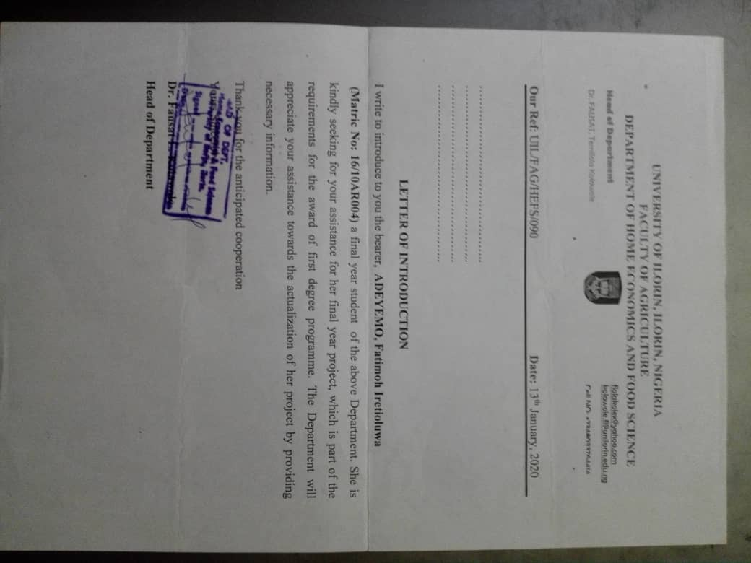

**APPENDIX C**

**RELIABILITY TABLE**

Pilot survey Result

Case Processing Summary

|  |  |  |
| --- | --- | --- |
| CASES | N | % |
| VALID  EXCLUDED  TOTAL | 20  0  20 | 100  0  100 |

|  |  |
| --- | --- |
| CRONBACH’S ALPHA | NO. OF ITEMS |
| 0.871 | 42 |

Source: Field Survey, 2021

**APPENDIX D**

**RAW SCORE OF FIELD SURVEY OF DATA ANALYSIS**

**Research Question 1:** What are the reasons for garments disposal among consumers in the area of study?

Result of frequency, percentage, mean and standard deviation on research question 2.

|  |  |  |  |  |  |  |  |  |
| --- | --- | --- | --- | --- | --- | --- | --- | --- |
| STATEMENTS | SA | A | UD | D | SD | X | SD | REMARKS |
| The garments can fade easily | 24(34.3%) | 30(42.9%) | 6(8.6%) | 5(7.1%) | 5(7.1%) | 3.9 | 1.169 | Agree |
| The styles became unfashionable | 21(30%) | 33(47.1%) | 2(2.9%) | 9(12.9%) | 5(7.1%) | 3.8 | 1.211 | Agree |
| The garment became monotonous | 18(25.7%) | 30(42.9%) | 4(5.7%) | 9(12.9%) | 9(12.9%) | 3.56 | 1.347 | Agree |
| To prevent wastage of garment | 20(28.6%) | 30(42.9%) | 2(2.9%) | 11(15.7%) | 7(10%) | 3.64 | 1.319 | Agree |
| Stains can mar the garment. | 27(38.6%) | 28(40%) | 2(2.9%) | 6(6.8%) | 7(10%) | 3.89 | 1.291 | Agree |
| When the garments are too tight | 28(40%) | 28(40%) | 6(8.6%) | 3(4.3%) | 5(7.1%) | 4.01 | 1.1148 | Agree |
| To renew the old garment and look unique | 26(37.1%) | 37(52.9%) | 3(4.3%) | 2(2.9%) | 2(2.9%) | 4.19 | 0.873 | Agree |
| The garment show signs of wear and tear. | 25(35.7%) | 31(44.3%) | 6(8.6%) | 4(5.7%) | 4(5.7%) | 3.99 | 1.097 | Agree |
| Change the appearance of the garment | 34(48.6%) | 27(38.6%) | 3(4.3%) | 4(5.7%) | 2(2.9%) | 4.24 | 0.984 | Agree |
| Outgrown some of the garments. | 33(47.1%) | 30(42.9%) | NIL | 1(1.4%) | 6(8.6%) | 4.19 | 1.133 | Agree |

Source: Field Survey, 2021

**Research Question 2:** What are the benefits of recycling and renovation in the study area?

Result of frequency, percentage, mean and standard deviation on research question 3.

|  |  |  |  |  |  |  |  |  |
| --- | --- | --- | --- | --- | --- | --- | --- | --- |
| STATEMENTS | SA | A | UD | D | SD | X | SD | REMARK |
| Changing the outlook of the garment | 37(52.9%) | 31(44.3%) | NIL | NIL | 2(2.9%) | 4.44 | 0.773 | Agree |
| Saves money to purchase another garment | 29(41.4%) | 37(52.9%) | NIL | 2(2.9%) | 2(2.9%) | 4.27 | 0.85 | Agree |
| Reduces environmental pollution | 24(34.3%) | 33(47.1%) | 4(5.7%) | 4(5.7%) | 5(7.1%) | 3.96 | 1.135 | Agree |
| It is a waste of time | 7(10%) | 17(24.3%) | 2(2.9%) | 27(38.6%) | 17(24.3%) | 2.57 | 1.357 | Disagree |
| It increases the garment in the wardrobe | 17(24.3%) | 24(34.3%) | 8(11.4%) | 10(14.3%) | 11(15.7%) | 3.37 | 1.406 | Agree |
| It boost social status | 23(32.9%) | 20(28.6%) | 4(5.7%) | 15(21.4%) | 8(11.4%) | 3.5 | 1.432 | Agree |
| It Exhibit ones creativity | 36(51.4%) | 25(35.7%) | NIL | 3(4.3%) | 6(8.6%) | 4.17 | 1.204 | Agree |
| Be fashionable in garment in vogue | 26(37.1%) | 31(44.5%) | 3(4.3%) | 7(10%) | 3(4.3%) | 4 | 1.103 | Agree |
| To prevent wastage of garment | 28(40%) | 36(51.4%) | 2(2.9%) | 1(1.4%) | 3(4.3%) | 4.21 | 0.915 | Agree |
| It saves time and energy | 25(35.7%) | 25(35.7%) | 3(4.3%) | 11(15.7%) | 6(8.6%) | 3.74 | 1.326 | Agree |
| It is expensive to implement | 10(14.3%) | 17(24.3%) | 6(8.6%) | 18(25.7%) | 19(27.1%) | 2.73 | 1.454 | Disagree |
| It gives the garment a second life | 36(51.4%) | 27(38.6%) | 2(2.9%) | 2(2.9%) | 3(4.3%) | 4.32 | 0.978 | Agree |

Source: Field Survey, 2021

**Research Question 3:** What are the various garments that can be recycled and renovated in the area of study?

Result of frequency, percentage, mean and standard deviation on research question 4.

|  |  |  |  |  |  |  |  |  |  |  |  |  |  |  |  |
| --- | --- | --- | --- | --- | --- | --- | --- | --- | --- | --- | --- | --- | --- | --- | --- |
|  | | | RECYCLING | | | | | RENOVATION | | | | |  |  |  |
|  | STATEMENTS | SA | | A | UD | D | SD | SA | A | UD | D | SD | X | SD | REMARK |
| 1. | Parents garment can be changed to children garments | 2(2.9%) | | 24(34.3%) | 1(1.4%) | 2(2.9%) | 37(S2.9%) | NIL | 2(2.9%) | 1(1.4%) | NIL | 1(1.4%) | 2.60 | 2.003 | Recyclable |
| 2. | Stained shirt can be sewn to apron and chef cap | 32(45.7%) | | 26(37.1%) | 2(2.9%) | 3(4.3%) | 1(1.4%) | 2 (2.9%) | 4(5.7%) | NIL | NIL | NIL | 4.76 | 1.646 | Recyclable |
| 3. | Faded jeans can be changed to short knickers | 32(45.7%) | | 18(25.7%) | 1(1.4%) | NIL | 1(1.4%) | 11(15.7%) | 7(10%) | NIL | NIL | NIL | 5.84 | 2.332 | Renovation |
| 4. | Long sleeve damaged at the cuff can be changed to short sleeve | 16(22.9%) | | 11(15.7%) | 2(2.9%) | NIL | 2(2.9%) | 23(32.9%) | 15(21.4%) | NIL | 1(1.4%) | NIL | 7.20 | 2.775 | Renovation |
| 5 | Pyjamas can be changed to bibs. | 33(47.1%) | | 16(22.9%) | 4(5.7%) | 8(11.4%) | 3(4.3%) | 1(1.4%) | 3(4.3%) | 2(2.9%) | NIL | NIL | 4.47 | 1.800 | Recyclable |
| 6. | Father’s shirt can be sewn to baby’s gown | 38(54.3%) | | 16(22.9%) | 4(5.7%) | 3(4.3%) | 3(4.3%) | NIL | 2(2.9%) | 2(2.9%) | 1(1.4%) | 1(1.4%) | 4.60 | 1.478 | Recyclable |
| 7. | Jumped trouser can be changed to small pants and shorts | 17(24.3%) | | 22(31.4%) | 3(4.3%) | 6(8.6%) | NIL | 9(12.9%) | 12(17.1%) | 1(1.4%) | NIL | NIL | 5.71 | 2.633 | Renovation |
| 8. | Mother’s skirt can be sewn to boy’ short | 30(42.9%) | | 26(37.1%) | 2(2.9%) | 4(5.7%) | 2(2.9%) | 1(1.4%) | 1(1.4%) | 2(2.9%) | NIL | 2(2.9%) | 4.53 | 1.462 | Recyclable |
| 9. | Torn wrapper can be sewn to skirt | 27(38.6%) | | 21(30%) | 2(2.9%) | 8(11.4%) | 1(1.4%) | 4(5.7%) | 4(5.7%) | 2(2.9%) | NIL | 1(1.4%) | 4.86 | 2.080 | Recyclable |
| 10. | Plain t- shirt can be tied and dyed | 14(20%) | | 11(15.7%) | NIL | 1(1.4%) | NIL | 28(40%) | 14(20%) | 1(1.4%) | NIL | 1(1.4%) | 7.66 | 2.581 | Renovation |

Source: Field Survey, 2021

**Research Question 4:** What are the methods of recycling and renovation in the area of study?

Result of frequency, percentage, mean and standard deviation on research question 5.

|  |  |  |  |  |  |  |  |  |  |  |  |  |  |
| --- | --- | --- | --- | --- | --- | --- | --- | --- | --- | --- | --- | --- | --- |
|  | RECYCLING | | | | | RENOVATION | | | | |  |  |  |
| STATEMENTS | SA | A | UD | D | SD | SA | A | UD | D | SD | X | SD | REMARK |
| Application of tie-dye: to obtain new design | 13(18.6%) | 4(5.7%) | NIL | 1(1.4%) | 1(1.4%) | 37(52.9%) | 14(20%) | NIL | NIL | NIL | 8.29 | 2.474 | Renovation |
| Batik printing: a resist decorative technique | 9(12.9%) | 8(11.4%) | 2(2.9%) | 1(1.4%) | NIL | 30(42.9%) | 17(24.3%) | NIL | 2(2.9%) | 1(1.4%) | 7.97 | 2.519 | Renovation |
| Patchwork: to obtain new designed articles | 16(22.9%) | 7(10%) | 1(1.4%) | NIL | 1(1.4%) | 17(24.3%) | 28(40%) | NIL | NIL | NIL | 7.63 | 2.406 | Renovation |
| Embroidery: decorative stitching technique using coloured threads | 15(21.4%) | 5(7.1%) | 1(1.4%) | 1(1.4%) | 1(1.4%) | 20(28.6%) | 21(30%) | 4(5.7%) | 1(1.4%) | 1(1.4%) | 7.64 | 2.473 | Renovation |
| Application of darning: to fill a hole in the garments. | 22(31.4%) | 13(18.6%) | 3(4.3%) | 1(1.4%) | 3(4.3%) | 16(22.9%) | 11(15.7%) | NIL | NIL | 1(1.4%) | 6.30 | 2.799 | Renovation |
| Sewing process: using stiches to join garments together | 30(42.9%) | 21(30%) | 3(4.3%) | 1(1.4%) | 2(2.9%) | 5(7.1%) | 6(8.6%) | NIL | NIL | 2(2.9%) | 5.19 | 2.066 | Recycling |
| Screen printing: to bring out new designs on the fabric. | 14(20%) | 10(14.3%) | 2(2.9%) | 2(2.9%) | 1(1.4%) | 20(28.6%) | 16(22.9%) | 1(1.4%) | NIL | 4(5.7%) | 7.10 | 2.725 | Renovation |
| Change of style: to produce new garment | 32(45.7%) | 22(31.4%) | 4(5.7%) | 1(1.4%) | NIL | 3(4.3%) | 5(7.1%) | NIL | 1(1.4%) | 2(2.9%) | 5.09 | 1.734 | Recycling |
| Quilting: to form decorative patterns on the garment | 15(21.4%) | 12(17.1%) | 4(5.7%) | 1(1.4%) | NIL | 15(21.4%) | 19(27.1%) | 1(1.4%) | 1(1.4%) | 2(2.9%) | 6.93 | 2.612 | Renovation |
| Application of Applique: to the garment. | 12(17.1%) | 13(18.6%) | 4(5.7%) | NIL | 1(1.4%) | 17(24.3%) | 21(30%) | NIL | 1(1.4%) | 1(1.4%) | 7.10 | 2.698 | Renovation |

Source: Field Survey, 2021

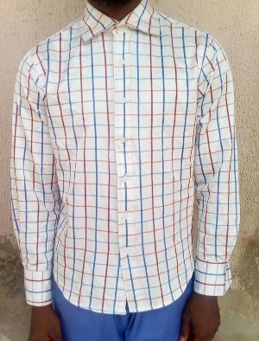 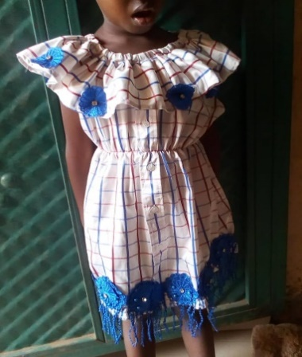

**Fig 3a**: Father’s shirt **Fig 3b**: Recycled Baby’s dress

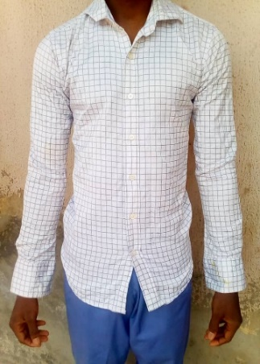 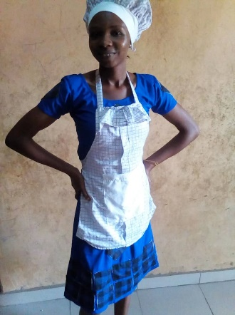

**Fig 4a**: Stained shirt **Fig** 4**b**: Recycled to Apron and Chef Cap

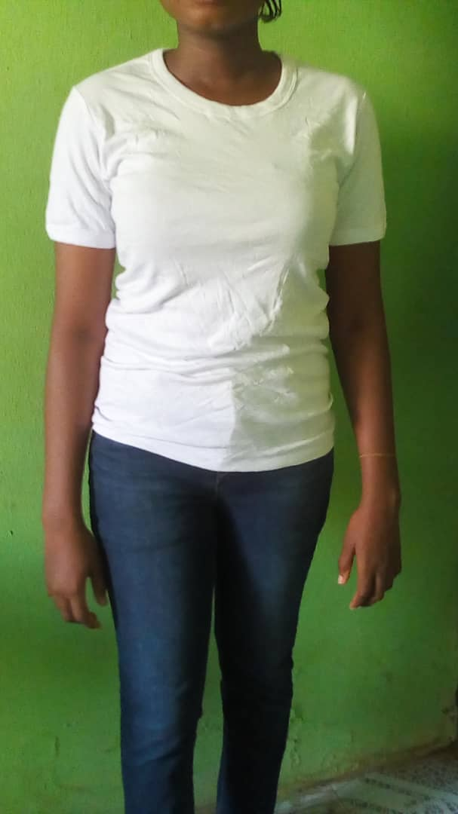 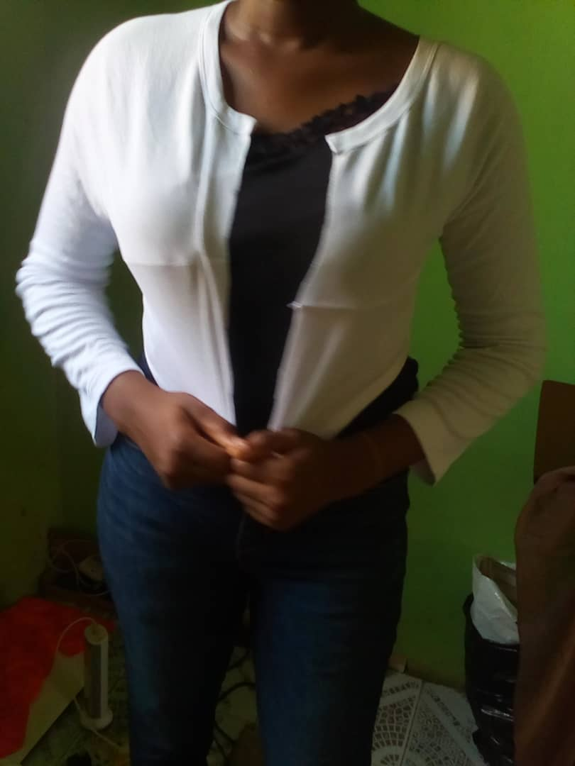

**Fig 5a**: T- shirt **Fig 5b**: Recycled to jacket

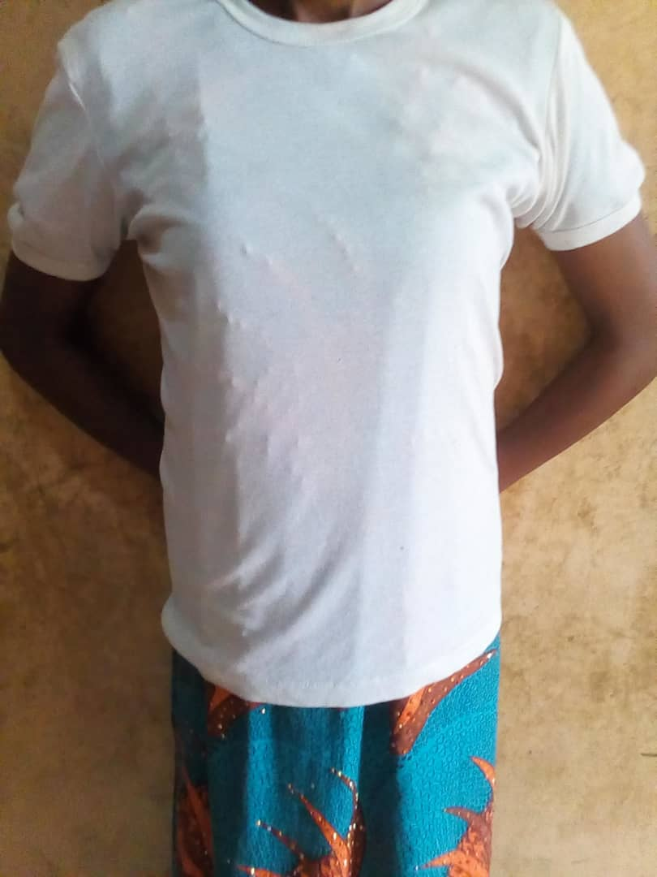 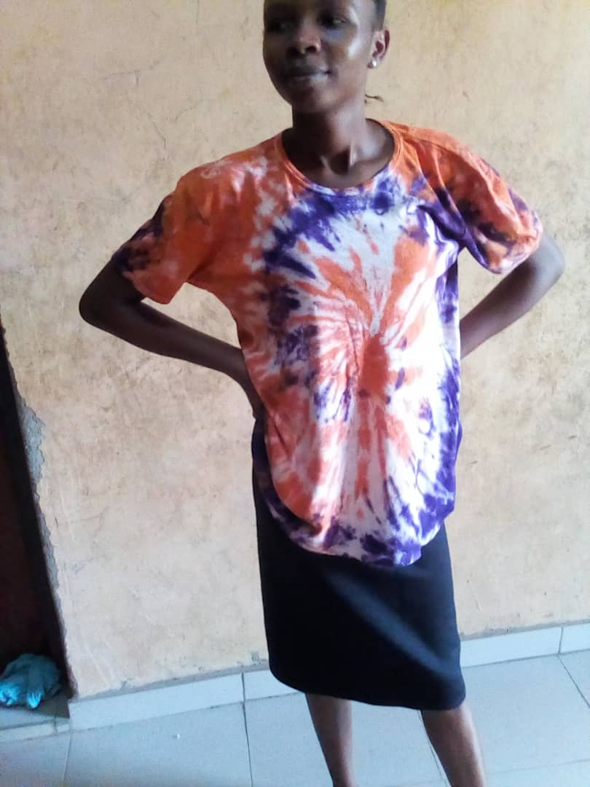

**Fig 6a**: Old T shirt **Fig 6b**: Renovated to tie dye t shirt

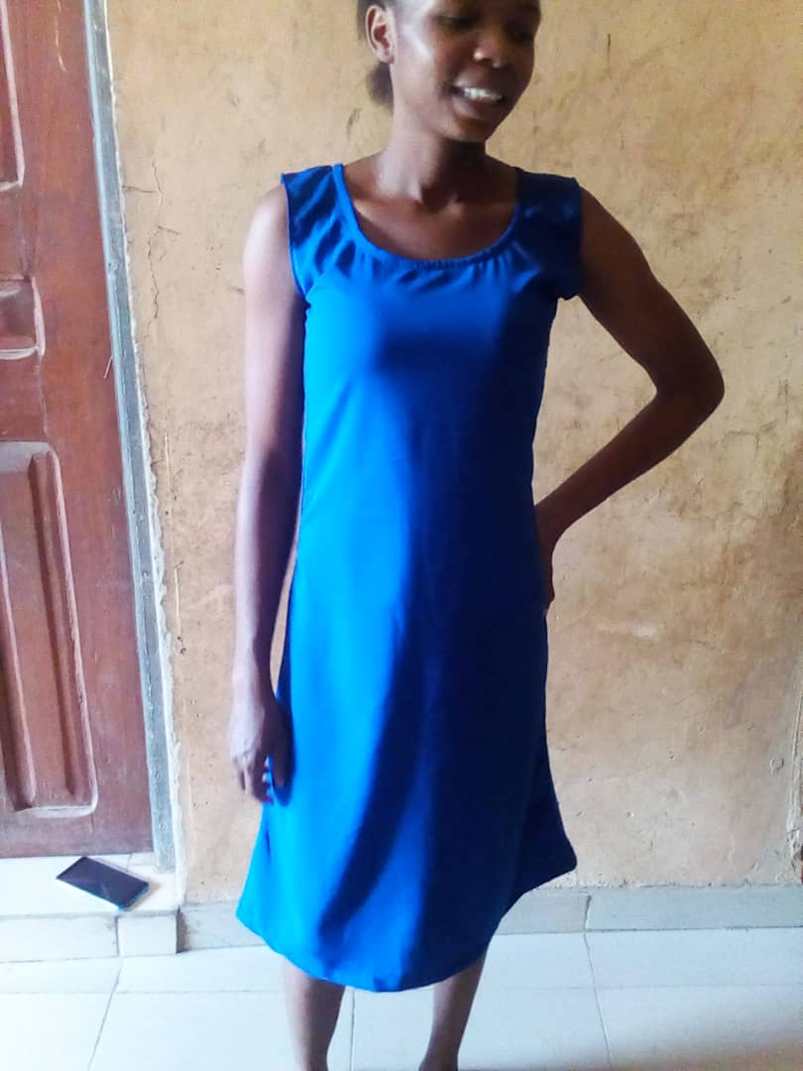 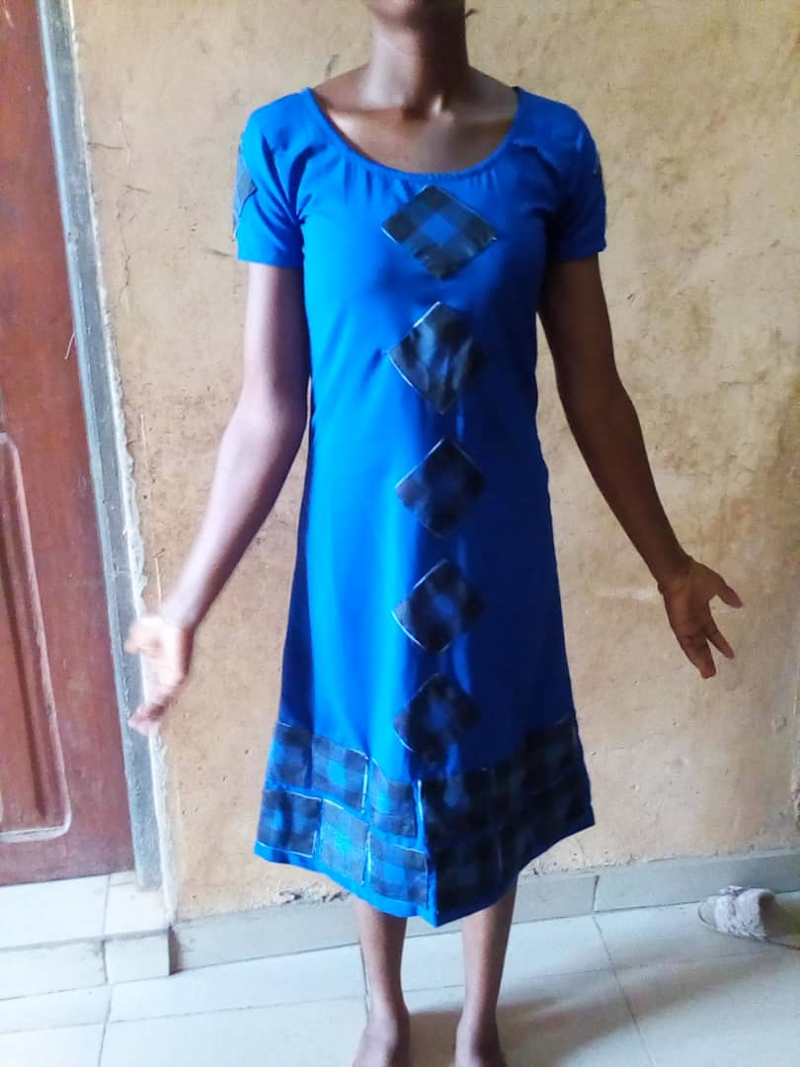

**Fig 7a**: Simple gown **Fig 7b**: Renovated using Applique

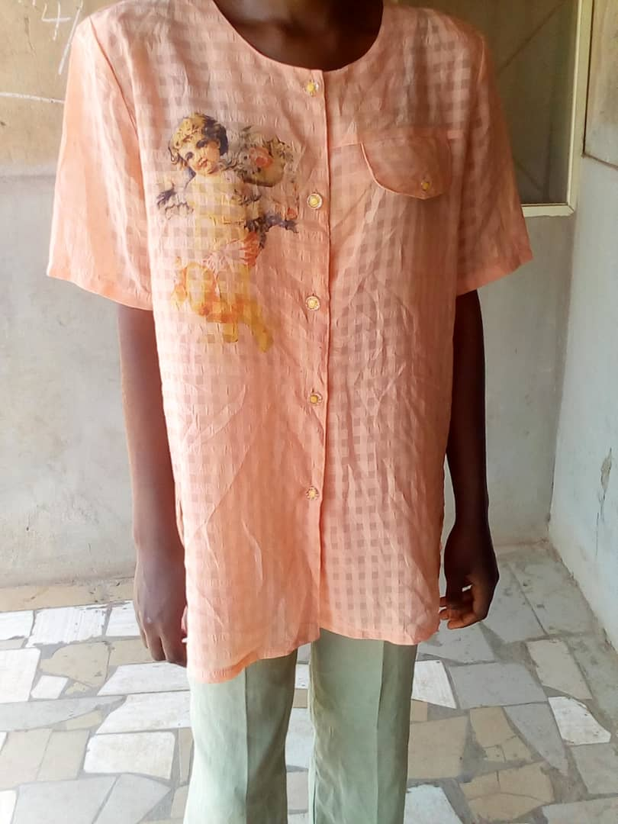 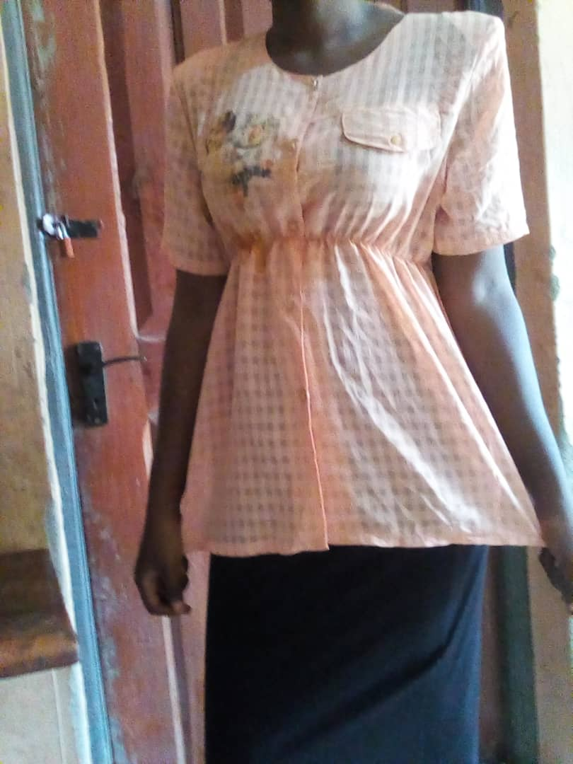

**Fig 8a**: Big dress **Fig 8b**: Renovated to make it fitted