Development of a Biometric –based Electronic Voting System

By

AGBOOLA Damilola Florence

(EPD1700027)

PGD. Computer Science (LAUTECH)

A PROJECT SUBMITTED TO

DEPARTMENT OF COMPUTER SCIENCE AND TECHNOLOGY,

FACULTY OF ENGINEERING AND TECHNOLOGY,

LADOKE AKINTOLA UNIVERSITY OF TECHNOLOGY OGBOMOSO, OYO

STATE, NIGERIA.

IN PARTIAL FULFILMENT FOR THE AWARD OF POST GRADUATE DIPLOMA IN COMPUTER SCIENCE.

APRIL, 2019.

**CERTIFICATION**

This Post-data report with title **Development of a Biometric-based Electronic Voting System** submitted by **Agboola Damilola Florence** was carried out under

our supervision at Ladoke Akintola University of Technology, Ogbomoso.

................................... ……………………….

**Supervisor**  Date

**Prof. Omidiora,** B.Sc, M.tech, Ph.D

Professor

Department of Computer Science and Engineering

Ladoke Akintola University of Technology,

Ogbomoso, Nigeria

Attestation

I hereby attest that this research work was carried out in the Department of Computer Science and Engineering, Faculty of Engineering and Technology, Ladoke Akinola University of Technology, Ogbomoso, Nigeria.

………………………….. ………………………

**Head of Department** Date

**Dr. Mrs Oke**, B.Sc, M.Tech,Ph.D

Department of Computer Science and Engineering

Ladoke Akintola University of Technology,

Ogbomoso,Nigeria.

Dedictation

To the God Almighty, the Giver of life.

**ACKNOWLEDGEMENT**

My sincere appreciation goes to God Almighty for making me a partaker of this program and for also seeing me through it.

**ABSTRACT**

The manual voting method is no longer reliable due to its many manipulations and inefficiencies. Therefore, there is a need for an advanced voting system that could address these flaws inherent in it.

The purpose of this research project was to design a biometric voting system which is aimed at providing an e-facility for conducting free, fair and credible elections at all levels in the Ladoke Akintola University of Technology (LAUTECH), Ogbomosho.

The study highlighted the demerits of manual voting method, and devised an e-voting system of voting which eliminates the issue of rigging, vote buying, vote selling, and delay of results, impersonation, multiple voting and the likes.

The software is designed such that, voters are registered along with their fingerprint identification in a centralized database, voters authentication is carried out using a biometric device and they cast their vote using this same device connected to an electronic platform which generate the election result in real time.

Keywords: online, e-voting, biometrics, fingerprint identification, centralized database, authentication, election.

**CHAPTER ONE**

**INTRODUCTION**

* 1. **Preamble**

A free, fair and credible election is feasible when we stick to the mantra of ‘one man, one vote’. But, this is difficult to achieve in a society like ours where the candidates and their supporters are ready to sabotage the election results to achieve their desired position.

One of the means of engaged in discrediting a credible election results is multiple voting, whereby a single voter can vote as many times as possible and in many polling booths as available due to manual means of verification and authentication. Also in this list is impersonation of valid voters, such that rented voters are made to stand in for them.

There is no gain saying that to make our votes count, there is a need for a system that could eradicate the malice of impersonation, multiple voting, and results manipulation. A system that could validate a voter as genuine due to its uniqueness of each person, and it is no other method other than biometrics embedded in an e-voting system.

Biometrics is the technical term for body measurements and calculations; it refers to metrics related to human characteristics. Biometric identifiers are the distinctive, measurable characteristics used to label and describe individuals.

Biometric identifiers are often categorized as physiological and behavioral. Physiological characteristics are related to the shape of the body like [fingerprint](https://en.m.wikipedia.org/wiki/Fingerprint), palm veins, [face recognition](https://en.m.wikipedia.org/wiki/Facial_recognition_system), [DNA](https://en.m.wikipedia.org/wiki/DNA), [palm print](https://en.m.wikipedia.org/wiki/Palm_print), [hand geometry](https://en.m.wikipedia.org/wiki/Hand_geometry), [iris recognition](https://en.m.wikipedia.org/wiki/Iris_recognition), [retina](https://en.m.wikipedia.org/wiki/Retinal_scan) and odour/scent. Behavioral characteristics are related to the pattern of behavior of a person, such as [typing rhythm](https://en.m.wikipedia.org/wiki/Keystroke_dynamics), [gait](https://en.m.wikipedia.org/wiki/Gait_analysis), and [voice](https://en.m.wikipedia.org/wiki/Speaker_recognition).

Biometrics identification cannot be forgotten or lost, it is a technology that brings about improved trust in the electoral process, reduced the cost of procuring artificial means of identification and lessen the burden of manual verification.

Electronic voting technology intends to speed the counting of ballots, reduce the cost of paying staff to count votes manually and make results available in real time. Electronic voting system enables smooth creation of voters’ registration on a centralized database. This database is then use to authenticate valid voters on Election Day. Additionally, this database removes the need for printing of paper ballots and reduce the cost of procurements.

**1.2 What is Voting**

Voting according to Merriam-Webster Dictionary is defined as a formal expression of opinion or will in response to a proposed decision *especially* one that is given as an indication of approval or disapproval of a proposal, motion, or candidate for office. Through voting, power is transferred to the people to choose their desired leader, and allows the majority which are the masses to have their say. The electorates express their franchise through the use of open ballot, secret ballot, roll call, voice vote, and e-voting which are all forms of voting.

1.3 **AIM AND OBJECTIVES**

The aim of the project is to design and implement a biometric-based electronic voting system to elect student leaders in tertiary institution of learning.

The Specific objectives are to:-

1. Embark on reviewing existing systems that perform similar tasks
2. Design and implement database for record keeping on elections
3. Design and implement an application that handles the biometric voting procedures
4. Implement Secured network platform that provides authentic voting process.
5. Provide Electoral Commission (EC) of the university the platform to generate and announce results.
6. Provide platform for viewing current and previous election reports.

**1.4 Significance of Study**

Voting in general requires being very precise or cost cutting to produce an effective election. To achieve this requires robust and secured software (such as this Biometric Electronic Voting System – BEVS) that can help officials of voting process to manage election proceedings effectively. Therefore, crucial points that this (BEVS) emphasizes on are listed below.

* Require less number of staff during the election.
* Easy to use.
* Reinforcement of transparency and fairness.
* Less capital, less effort, and less labour intensive, as the primary cost and effort will focus primarily on creating, managing, and running a secure online looting portal.
* Adapting to increasing number of voters as individual voters join in, especially in student societies where lectures might be in session during election

**1.5 Statement of the Problem**

On every campus in higher institutions, there is a need for student representatives, to voice out the needs of students to the management for better academic performance and welfarism. The method used in electing these students body is manual and primitive. Hence, there is a need for an e-voting systems to enhance our electoral process in tandem with the digital age for an advanced student community.

**1.6 Method of Study**

In order to make any business decision, collecting data and information is very important and this process known as research methodology.

In order to develop biometric voting system, enormous research must be done to find the suitable software that is capable to meet the project requirements.

The research methodology include research techniques such as:

1. Interviews.
2. Publication research.
3. and Questionnaires were sets and designed to generate enough raw data for accomplishing the information requirements between the actual sampled results and the estimated true population results.

**1.7 Definition of Terms**

This section shall explain the term and principles employed in this project work.

1. Biometric System: Capturing unique physical features of an individual (fingerprinting & Facial are the most commonly used)
2. Electronic Voting: The use of technology to enhance voting system
3. Voting: A formal expression of opinion or will in response to a proposed decision.

**1.8 Scope and Limitation of Study**

Although there may be many user requirements, this research seeks to focus on the major issues that had to be resolved in the voting procedures and hence has the scope as spelt out in order to be accomplished. This scope includes the following:

**Voter Register Module**: The product shall include module for registering students who will take part of the voting. The registration procedure shall encompass taking the student details including biometric enrolment.

**Official and Voter Security Module:** To ensure the authenticity of the voting processes, the system shall include security module that would ensure that both electoral commission official and voters provide credentials before using the system. Electoral commission officials shall use their user account credentials at all times to login before using the system. Voters shall be verified by biometric device before casting their votes.

**Result Generation Module:** The system shall provide module for electoral commission officials to generate result right after the completion of voting proceedings. The voting results shall be presented statistically and graphically for easy interpretations.

**Reporting Module:** This application shall include module for all voting reporting for previous and current voting proceedings.

**Administrative Module:** The system shall include modules that would be used by the system administrators to manage and maintain the software by providing the necessary settings to tune up the system.

Aside the above modules, the system will ensure the continual running over a local area network or VPN.

**CHAPTER TWO**

**LITERATURE REVIEW**

**2.1 VOTING**

It has been the norm of the day that selecting leaders to lead countries, organizations, students in educational institutions and smaller groups in communities in the modern era is always associated with voting procedures. No matter how small or large a group may be, when it comes to its elections, all the stakeholders of such bodies may ascribe great interest. Not long, in the year 2016 to be precise, the country Ghana conducted its periodic election and the entire country became silent a while when the election results were pending to be announced by the Electoral Commission (EC) of the nation. At that moment, almost all Ghanaians with television set, radio set and other means of communications were completely glued to such means of communication when they were waiting to hear

from the EC’s declaration of the

election results. This scenario suggests that, people put in all their emotions when it comes to elections and therefore suggests that all voting procedures must be authentic, free and fair and reliable

**2.2 ANALYSIS OF VOTING SYSTEMS**

Electoral systems are set of rules which guide the conduct of an electoral process and determine its outcome. Electoral process could either be governmental or non-governmental which are carried out by business organizations, private bodies, and students’ unions.

Electoral systems determine the electoral commission, the timeline of the process, who is eligible to vote, who is qualified to be voted for, how the votes is casted and counted, and who is declared the winner.

Types of voting systems:

1. Open ballot system
2. Secret ballot system
3. Electronic voting system
   * 1. **Open Ballot System**: - A ballot is a device used to cast vote in an election which can either be a piece of paper or a small ball. The open ballot system, also known as option A4 in Nigeria parlance is a voting system in which voters vote openly by queuing or otherwise, indicating their candidate of their choice. This voting system requires no ballot papers and ballot boxes. The result is immediate as the head count is being carried out right on the queue. Though cheap and transparent, the open ballot system has its shortcomings.

**The following are the problems associated with this type of voting: -**

1. **Insecurity**: - the lives of voters could be at risk as they could be easily identified by opposition political thugs while on queue.
2. **Intimidation:** - also political thugs may threaten voters to votes to against their preferred candidates.
3. **Votes selling and buying**: - voters could be coerced into voting for a particular candidate with money and they cannot do otherwise, because they would be seen on the queue.
4. **Enmity**: - the open ballot voting system creates division and rivalry among friends, families, business associates and course mates.

**2.2.2 Secret Ballot System**: - The secret ballot, also known as Australian ballot, is a voting method in which a voter's choices in an election or a referendum are anonymous; forestalling attempts to influence the voter by intimidation, blackmailing, and potential vote buying. The secret ballot voting system is aimed at political privacy. This system of voting, with its assured confidentiality and safety of voters as opposed the open ballot system has its own flaws as well.

**The following are the problems of secret ballots system of voting:**

1. **Operational cost:** this voting system is quite expensive in comparison with the open ballot system as there is need for the procurement of election materials like ballot papers and ballot boxes.
2. **Rigging: -** it could easily be rigged as the outcome of the votes casted is not revealed at the polling centres.
3. **Void votes:** - the ignorance of some of the voters could lead to many void votes which undermines the real intent of the electorates.
4. **Multiple voting:** - it encourages individuals to vote multiple times due to the absence of means of validation of voters. This goes against the mantra of ‘one man, one vote’ of credible elections.

**2.2.3 Electronic voting system**

The goal of introducing electronics computation in voting is to enhance the efficiency of traditional paper ballot without compromising existing security, privacy, or legal requirements (Data Science and Pattern Recognition 2017)

Electronic voting system, also known as e-voting is a voting system that uses electronic means to aid the casting and counting of votes. It may use standalone Electronic voting machines (EVM) or computers connected to the internet.

Electronic voting system is used to automate vote input, vote recording, data encryption and transmission to servers, counting and tabulation of election results.

Electronic voting system is used to automate vote input, vote recording, data encryption and transmission to servers, counting and tabulation of election results.

A worthy e-voting system is characterized with security, accuracy, integrity, swiftness, privacy, audit ability, accessibility, cost-effectiveness, scalabity, and ecology sustainability

Electronic voting technology includes punched cards, optical scanners, direct recording electronic systems (DRE), computer networks, internet, centralized database and biometrics recognition device.

Electronic voting is used for parliamentary elections in Australia in 2001, for student union elections in Austria in 2003, for municipal elections in Canada in 2003, for both general and local elections in India in 2003. (Adem, A. 2011).

An e-voting system could either be online and remote through the internet which is also known as internet voting (i-voting) or offline using electronic voting machines embedded with a biometric recognition device with a centralized database. In the former system, electorates cast their votes remotely via the internet, while later system is supervised by the electoral body.

The online and remote type of e-voting system is vulnerable to hackers’ threat. As alleged in the U.S controversial election of 2016 that brought in President Donald which was rumored to have been penetrated by Russian hackers. This type of voting system is also prone to multi-voting and impersonation.

Electronic voting system if operated efficiently tends to speed up votes counting, reduce staff cost, eradicate vote rigging and provide improved accessibility to disabled voters.

**Highlighted below are the benefits associated with an electronic voting system.**

According to Rachid Anane et al, and Steve Kremer et al the following are the benefits e-voting is expected to offer:

1. Fairness: no early results can be obtained which could influence the remaining voters. Eligibility: only legitimate voters can vote, and only once.
2. Privacy: the system cannot reveal how a particular voter voted. Receipt-freeness: a voter does not gain any information (a receipt) which can be used to prove to a coercer that she voted in a certain way. Coercion-resistance: a voter cannot cooperate with a coercer to prove to him that she voted in a certain way. Individual verifiability: a voter can verify that her vote was really counted. Universal verifiability: the published outcome really is the sum of all the votes.
3. Mobility: e-voting would allow voters to cast their vote from a convenient location instead of being required to travel to a specific polling station. Increased participation: electronic voting has the potential to maximise turnout at elections. An Internet based system might appeal to younger voters who are currently less likely to exercise their vote. Increased efficiency and accuracy: e-voting promises to remove some of the human errors inherent to the manual systems especially in the counting of votes. A computerized system it is argued is more efficient and allows for a quicker delivery of results.
4. Transparency: e-voting is also expected to be more open to public scrutiny.

**E-voting Requirements:**

The following are the requirements of a secure e-voting system (Schneier 1996)

1. Only eligible voters are able to vote.
2. No voter is permitted to vote more than once.
3. No one should be able to determine the value of anyone else’s vote.
4. No one can duplicate a vote.
5. No one can alter another person’s vote without being detected.
6. Voters can verify that their vote has been counted.

**Biometrics**

Biometric identifiers are the distinctive, measurable characteristics used to label and describe individuals. (Jain, A. et al 2000)

Biometrics identifiers are often categorized as physiological versus behavioral characteristics (Anil K. et al 2008)

The physiological characteristics include fingerprint, palm veins, face recognition, DNA, palm print, hand geometry, iris recognition and body odour. Behavioral characteristics include typing rhythm, gait and voice recognition. The term behaviometrics have been coined to describe the behavioral class of biometrics (BioSecure)

The irrefutable identification of voters in real time is a complex goal of biometric recognition. (Reid 2004) The uniqueness of the biometric identifiers makes it a more reliable form of verifying identity.

**2.2.4 Biometric functionality**

Many different aspects of human physiology, chemistry or behavior can be used for biometric authentication. The selection of a particular biometric for use in a specific application involves a weighting of several factors. (Jain *et al* 1999) identified seven such factors to be used when assessing the suitability of any trait for use in biometric authentication.

1. Universality means that every person using a system should possess the trait.
2. Uniqueness means the trait should be sufficiently different for individuals in the relevant population such that they can be distinguished from one another.
3. Permanence relates to the manner in which a trait varies over time. More specifically, a trait with 'good' permanence will be reasonably invariant over time with respect to the specific matching algorithm.
4. Measurability (collectability) relates to the ease of acquisition or measurement of the trait. In addition, acquired data should be in a form that permits subsequent processing and extraction of the relevant feature sets.
5. Performance relates to the accuracy, speed, and robustness of technology used.
6. Acceptability relates to how well individuals in the relevant population accept the technology such that they are willing to have their biometric trait captured and assessed.
7. Circumvention relates to the ease with which a trait might be imitated using an artifact or substitute.

**2.2.5 Biometrics Mode of Operation**

The two basic modes of biometrics operation are authentication mode and identification mode.

Authentication mode: also called the verification mode, is the mode where the system performs a one-to-one comparison of a captured biometric with a specific template stored in a biometric database in order to verify the individual is the person they claim to be.

Identification mode: it is mode where the system performs a one-to-many comparison against a biometric database in an attempt to establish the identity of an unknown individual.

The first time an individual uses a biometric system is called *enrollment*. During the enrollment, biometric information from an individual is captured and stored. In subsequent uses, biometric information is detected and compared with the information stored at the time of enrollment.

**Fingerprint Identification**

Fingerprints are one of many forms of [biometrics](https://en.wikipedia.org/wiki/Biometrics) used to [identify](https://en.wikipedia.org/wiki/Forensic_identification) individuals and [verify](https://en.wikipedia.org/wiki/Verification_and_validation) their [identity](https://en.wikipedia.org/wiki/Personally_identifiable_information).Human fingerprints are detailed, nearly unique, difficult to alter, and durable over the life of an individual, making them suitable as long-term markers of human identity. Hence they are a good characteristics of physiological biometrics.

The procedure for capturing a fingerprint using a sensor consists of rolling or touching with the finger onto a sensing area, which according to the physical principle in use (optical, ultrasonic, capacitive or thermal) captures the difference between valleys and ridges. When a finger touches or rolls onto a surface, the elastic skin deforms.

Fingerprint systems translate illuminated images of fingerprints into digital code for further software such as enrolment (fingerprint registration) and verification (authentication or verification of registered users).

The scanner uses an advanced CMOS image sensor to capture high contrast, high resolution fingerprint images that are virtually distortion-free. A series of powerful algorithms extract data from the image, mapping the distinguishing characteristics of the fingerprint.

This data is then converted into an encoded binary string known as a digital template, and stored in a database. The actual fingerprint image is never stored. To identify or verify a fingerprint, a proprietary matching algorithm compares the new template made from the extracted characteristics from the input fingerprint on the optical module to a previously stored sample. The entire matching process takes roughly one second. Authentication takes place locally at the device or on a server, depending on system configuration. (VirdiTech)

**Centralized Database**

A **centralized database**, **CDB** is a [database](https://en.wikipedia.org/wiki/Database) that is located, stored, and maintained in a single location. The location of a CDB is most often a central computer or database system, like a desktop, a CPU server or a mainframe computer. A centralized database is mostly used by organization or an institution like a university. Users access a centralized database through a computer network which is able to give them access to the central CPU, which in turn maintains to the database itself.

An electronic voting system also make use of a central database where voters’ registration records are stored, accessed and retrieved throughout the electioneering process.

**Benefits of a centralized database**

The following are the benefits of using a centralized database in an electronic voting system

1. [Data integrity](https://en.wikipedia.org/wiki/Data_integrity) is maximized and [data redundancy](https://en.wikipedia.org/wiki/Data_redundancy) is minimized, as the single storing place of all the voters’ records also implies that a given set of data only has one primary record. This aids in the maintaining of data as accurate and as consistent as possible and enhances data reliability.

2. Generally bigger [data security](https://en.wikipedia.org/wiki/Data_security), as the single data storage location implies only one possible place from which the database can be [attacked](https://en.wikipedia.org/wiki/Hacker_(computer_security)) and sets of data can be stolen or tampered with.

3. Better data preservation than other types of databases due to often-included fault-tolerant setup.

4. Easier for using by the end-user due to the simplicity of having a single database design.

5. Generally easier [data portability](https://en.wikipedia.org/wiki/Data_portability) and [database administration](https://en.wikipedia.org/wiki/Database_administration_and_automation).

6. More cost effective than other types of database systems as labor, power supply and maintenance costs are all minimized.

7. Data kept in the same location is easier to be changed, re-organized, mirrored, or analyzed.

8. All the voters’ information can be accessed at the same time from the same location.

**CHAPTER THREE**

**SYSTEM ANALYSIS AND DESIGN**

**3.0. ANALYSIS OF THE EXIXISTING SYSTEM**

Every institutions and organizations always have a system in which they utilize in deploying their operations. The Ladoke Akintola University of Technology (LAUTECH) students’ community is no exception. They deploy the manual secret ballot voting system and online i-voting system which has been highlighted in the literature review. Due to the iniquities and inefficiencies of this system, we therefore proposed an advanced system, which is the biometric e-voting system with a centralized database.

**3.1. THE PROPOSED SYSTEM**

The proposed system is a biometric e-voting system with a centralized database that will enable eligible voters to be registered in the database, validate their identity using a biometric device and cast their using an e-platform. It makes provisions for voters’ security, accuracy and efficiency that is the bane of a free, fair and credible election

The proposed system utilizes a physiological biometric feature (fingerprint) to authenticate voters. Fingerprint identification device is integrated into the in order to eradicate the problem of impersonation and multiple voting in the existing system.

The new system also makes use of other digital devices to automate operations and speed up the electoral process.

**3.2.0. OBJECTIVE OF THE PROPOSED SYSTEM**

i. To provide a platform for free, fair and fair election.

ii. To ensure only eligible registered voters partake in the process

iii. To reduce cost in terms of ballot boxes and papers

iv. To ease the task of counting and collation of votes.

v. To get election result in real time with zero delay.

**3.2.1. OPERATIONS OF THE PROPOSED SYSTEM**

1. Provides an interface for the administrator, which is electoral officer to login into the system

3. Provide an interface to register the voters into the centralized database.

2. Provides an interface to capture the voters’ fingerprints during registration extracts their features and stores it into the centralized database.

2. Verifies the identity of the voter on election day, by comparing the fingerprint that has been pre-stored in the centralized database with the fingerprint being supplied for voting.

3. Provides an interface for the voter to cast votes if a match is found.

4. Provides an interface for viewing the results of the election in real-time.

**3.3. REQUIREMENTS OF THE PROPOSED SYSTEM**

The following are the functional, non-functional and security requirements of the proposed system.

1. The system must store the voters’ data accurately.

2. The system must allow the administrator, which is the electoral officer to updates to the voters’ data on the centralized database.

3. The system must ensure data integrity and confidentiality by allowing only authorized administrator login.

4. The system should provide an easy to use interface and ensure good user experience.

5. The system must be working efficiently during the voting process.

6. All voters should cast their vote in one day.

7. Voting is carried out from many computers using the internet.

8. There should be provision for the voters’ data backup.

9. The system must conform the electoral requirements of the University management.

10. The voting system should be secure against cyber-attack and compromise.

**3.4. DESIGN OF THE PROPOSED SYSTEM**

The proposed system is designed so as to meet the system requirements defined above. To meet up this requirement, standard design models and tools were used as highlighted below.

**3.4.1. DFD – DATA FLOW DIAGRAM**

A context diagram is a top level (also known as "Level 0") data flow diagram. It only contains one process node ("Process 0") that generalizes the function of the entire system in relationship to external entities. The level zero data flow diagram of the system is visualized below.

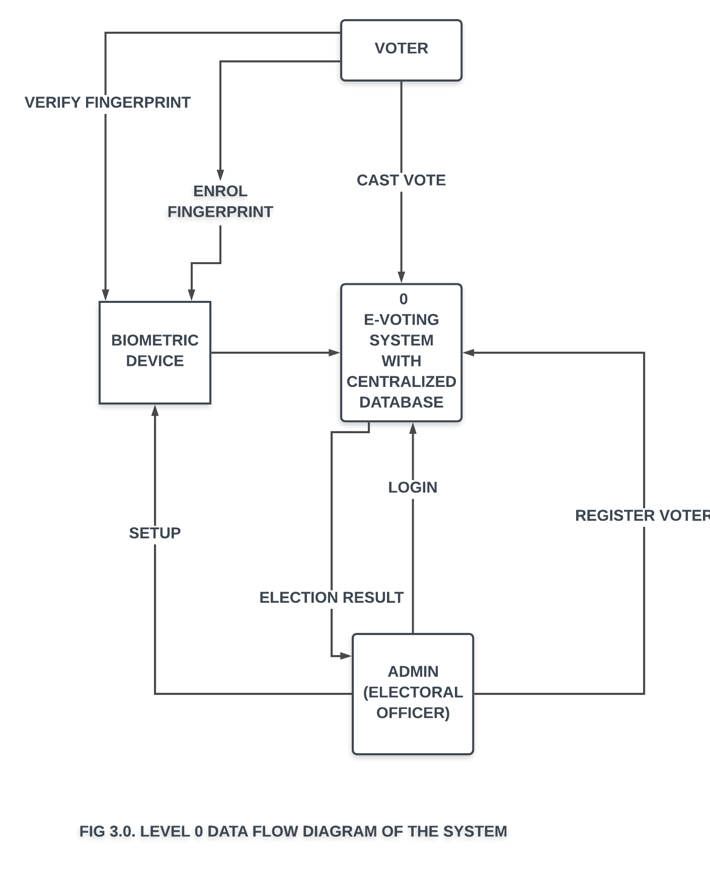

**3.4.2. USE CASE DIAGRAM**

A **use case diagram** is a representation of a user's interaction with the system that shows the relationship between the user and the different **use** cases in which the user is involved. The use case diagram is represented below

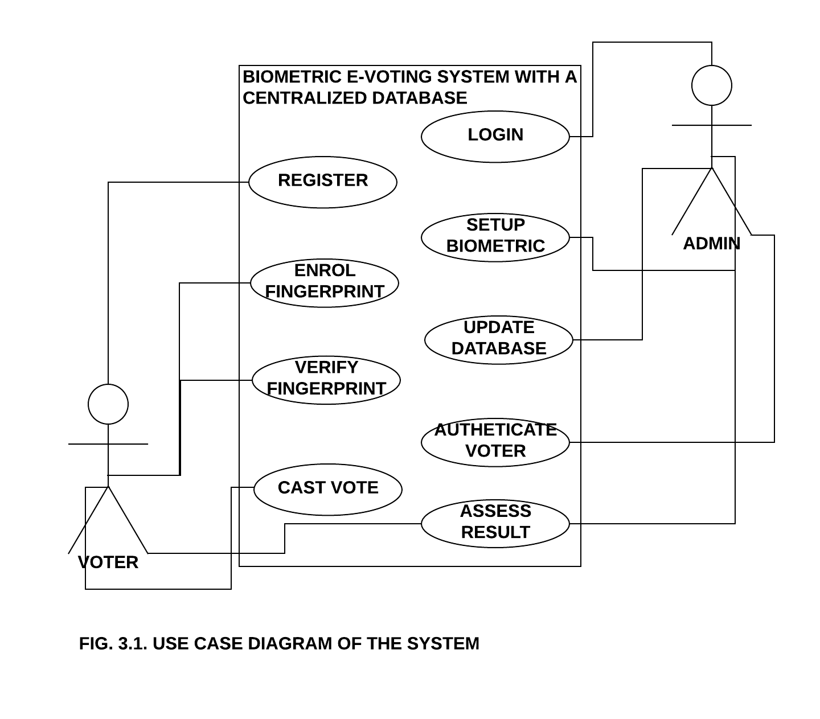



**FIG 3.3. WORKFLOW CHART FOR FINGERPRINT ENROLLMENT**

**3.3.1 INPUT DESIGN**

An input is any data requested by the system and provided by the user to be processed on. The proposed system is designed having a signup page where the administrator, an electoral officer register. After signing up, the admin login into the system via the signup page.

Represented below are the screenshot of the proposed system signup and login pages:

The voters’ data are input into the centralized database by the admin for registration by uploading the voters in batches or adding individual voters on the system. The screenshot of the registration interface is displayed below.

**3.3.2 OUTPUT DESIGN**

The information obtained from the process carried out on a system is known as the output.

The output may either be displayed on the screen as softcopy or printed out as hardcopy. A pre-knowledge of the likely output which is the outcome of a system helps in designing the input and processes of that system

The major output of our proposed system is the election result.

**3.4. THE DATABASE DESIGN**

The system uses the concept of a centralized database, whereby all data captured are stored in a central database and accessible anywhere the system is being implemented.

The database also uses the RDBMS – Relational DataBase Management System model whereby all the data are interlinked from one table to another.

The database software used is Navicat Premium, the RDBMS is MySQL and the query language used is SQL – Structured Query Language.

Represented below are the screen grab of the various tables in the centralized database.

**CHAPTER FOUR**

**SYSTEM IMPLEMENTATION AND DOCUMENTATION**

**4.0 SYSTEM IMPLEMENTATION**

This stage is where the new system designed is made to function i.e. the process of converting the developed system into operation. This stage involves technicality due to the practical it entails. It compromises the installation testing and changeover.

**4.1 PRE-IMPLEMENTATION**

For any new system to work correctly as expected there is need to specify the hardware, software and user requirement and these are stated below:

**4.1.1 HARDWARE REQUIREMENT**

These are the various hardware devices that are required for the proper use of the software package by the users: -

1. Intel Pentium iv Processor
2. 512MB RAM
3. High capacity fixed disc or 10GB Hard Disk
4. An enhanced keyboard
5. A standard mouse and mouse pad
6. A super video graphic adapter (SVGA) monitor
7. CD Rom Drive
8. Uninterrupted power supply (U.P.S)
9. A Modem and network card (Ethernet Adaptor)
10. Hub, Cables and clips
11. Printer

To install the program it requires web server installation to get the files started.

1. Open the folder name web server
2. Run Wampserver 1.7.1
3. Start the web server by clicking on START then PROGRAMS then WAMP and click IB procedures.

**SYSTEM INSTALLATION SEVER**

1. Locate this path as created as created by the installation C:\WAMP\WWW
2. Load your Mozilla Firefox
3. Type<http://localhost/vs1/index.php>

**4.1.2 SYSTEM TESTING**

This is a sub stage in system implementation by the developed system accuracy is ensured as well as its efficiency before it could be actually put into operation or application.

This stages sole aim is to test the system and check for bugs such as syntax logical errors which should be debugged since the system developed need to put users into consideration so that there would be familiarity with between the system and the users.

**4.1.3 CHANGEOVER PROCEDURES**

Changes over procedure refer to the technique in replacing the old system by the new one. It is highly dependent on the testing of the system when it is proved to be bugging (error) free.

There are three techniques of changeover procedures which

i. Direct ii. Phase iii. Parallel

1. **Direct changeover:** This is a method whereby the new system design replaces the old immediately when setting it up, since it effectiveness would have assured. But this system is not too good.
2. **Phase changeover:** In this method the new system will be replacing the existing one a phase at a time, in the case where there are different department that makes use of computers or needs to be computerized. Each department is being replaced on the outcome from another department.
3. **Parallel changeover**: - In this method both systems old and new will be working simultaneously and the most effective one is chosen.

**4.2 SOFTWARE REQUIREMENT**

The software requirements for the smooth running of this system are:

i. An operating system (preferably windows)

ii. PHP and MySQL runtime environment

iii. Local host and Wamp server

v. Web Browser (internet explorer, Mozilla Firefox, opera e.t.c)

**4.3 SYSTEM SECURITY**

The developed system needs to be secured by the database administrator in order to avoid unauthorized access to the database of the system, in order to avoid altering of the election results. Accessed of an unauthorized people can be limited with the use of valid usernames.

**4.5 SYSTEM MAINTENANCE AND MANAGEMENT**

One major aspect of the computer system usage is the maintenance just in the same way electrical appliances or motor car system has to be maintained to have a prolonged life span. Computer software has to be maintained too.

1. Back-up copies of this software package must be kept safely
2. Users must get in touch with the analyst for necessary modification or if there is any malfunction of the system.

**4.6 USER'S GUIDE**

After the step by step installation guide follow the user's guide

1. Left click on the folder named OVS to show the home page which is main menu.
2. Click on the register menu to display the registration page after which you fill correctly the information correctly the information required.
3. Click on submit to confirm that your information has been registered on the database.
4. Click on the menu labeled **VOTE NOW** after the registration to display the log in page where you enter your user name after which you click on the log-in button which finally display the candidate’s options.
5. After clicking on the corresponding candidate of choice click on vote button in order to confirm your vote.
6. Finally, click on result menu option to check the result.

**4.7 PROGRAMMING LANGUAGE USED**

In the course of writing the program the preferred software tool to be used are-

i. Dream weaver to design the front-end.

ii. PHP (Pre Hypertext Processor) to design the middle tear.

iii. And MySQL database to design the back-end.

**CHAPTER FIVE**

**CONCLUSION AND RECOMMENDATION**

**5.1 SUMMARY**

The system developed is based on the time priority which allows eligible voter to vote in an election with the use of fingerprint while result is generated in real-time. The chapter one gave a general introduction of the topic. The chapter two discussed extensively on the literature part of the study. The chapter three outlined the system on the literature part of the study. The chapter four dealt with the system of implementation of the developed system. Finally, the concluding part is included in this very chapter of the study.

**5.2 ACHIVEMENTS**

The achievements of the developed system are as follows:

1. The need for voting boxes is eliminated by using an automated collation system which in return reduces the overhead expenditures of the election.

2. The issue of multiple voting is eliminated

3. Human error during voting and counting of votes is eliminated.

4. The system provide the result of the election in real time.

5. The issue of impersonation and proxy voting are also eliminated.

**5.3 LIMITATIONS**

Restricted by physical location, that is, all voters must come to a central location.

Prone to long queues as the system is tightly-coupled, i.e. both the voter’s and

Admin’s login buttons are on the same interface thus rendering concurrent access

impossible *(Akinyemi A.E, 2014).*

**RECOMMENDATIONS**

In big elections, there are huge number of people want to cast their votes, in order to avoid the congestion at the voting point there is need to provide online Access be connected to the main computer/server in order to allow many people to perform voting at the same time and prevent congestion. Therefore, this application should be built online with a server architecture. As an improvement, multiple client machines including mobile applications should be interacting with the server simultaneously. Clients will interact with the system through an interactive GUI, while the server serves the clients request and does the processing in the backend.

Reducing the number of fingerprint algorithm size from 8 filters to 4 filters will be good idea in order to speed up the algorithm taking into account maintaining the efficiency of the algorithm during the identification process of the fingerprint.

This fingerprint electronic voting system is considered as a PC based fingerprint voting system. For future work, it will be better to design a fingerprint voting machine works dependently without need for PC to perform the voting in order to decrease the project cost.

**5.5 CONCLUSION**

Fingerprints considered as one of the most popular biometric methods used for human recognition. Every person in the globe is born with unique fingerprint even twins born with totally different fingerprints and fingerprint is naturally unchangeable throughout life. For that reason, biometric (fingerprint) voting system has been made and the person ID has been replaced with his fingerprint. This fingerprint voting system is implemented and evaluated successfully. The evaluation of the system is made using different PCs with different specifications in order to stand on system strength and weaknesses. The final result of the system was amazingly significant and computable with other voting system. The system’s accuracy came from the image enhancement and speed of network between the clients and server.

In conclusion, with all the advantages of biometric voting system, its implementation is indeed incomparable to other primitive ways of voting therefore the project is an indispensable for true democratic governments in our University.

**REFERENCES**

Jain, A.; Hong, L. and Pankanti, S. (2000). ["Biometric Identification"](http://helios.et.put.poznan.pl/~dgajew/download/PUT/SEMESTR_10/IO/FACE_RECOGNITION/BiometricsACM.pdf) [Archived](https://web.archive.org/web/20120330083547/http:/helios.et.put.poznan.pl/~dgajew/download/PUT/SEMESTR_10/IO/FACE_RECOGNITION/BiometricsACM.pdf) 30 March 2012 at the [Wayback Machine](https://en.wikipedia.org/wiki/Wayback_Machine). [*Communications of the ACM*](https://en.wikipedia.org/wiki/Commun._ACM),

Jain, Anil K.; Ross, Arun (2008). "Introduction to Biometrics". In Jain, AK; Flynn; Ross, A. [*Handbook of Biometrics*](https://www.springer.com/computer/image+processing/book/978-1-4419-4375-0). Springer. pp. 1–22. [ISBN](https://en.wikipedia.org/wiki/International_Standard_Book_Number) [978-0-387-71040-2](https://en.wikipedia.org/wiki/Special:BookSources/978-0-387-71040-2).

Jain, A. K.; Bolle, R.; Pankanti, S., eds. (1999). *Biometrics: Personal Identification in Networked Society*. Kluwer Academic Publications. [ISBN](https://en.wikipedia.org/wiki/International_Standard_Book_Number) [978-0-7923-8345-1](https://en.wikipedia.org/wiki/Special:BookSources/978-0-7923-8345-1).

Jain, Anil K.; Ross, Arun (2008). "Introduction to Biometrics". In Jain, AK; Flynn; Ross, A. [*Handbook of Biometrics*](https://www.springer.com/computer/image+processing/book/978-1-4419-4375-0). Springer. pp. 1–22. [ISBN](https://en.wikipedia.org/wiki/International_Standard_Book_Number) [978-0-387-71040-2](https://en.wikipedia.org/wiki/Special:BookSources/978-0-387-71040-2). [Archived](https://web.archive.org/web/20110309042959/http:/www.springer.com/computer/image+processing/book/978-1-4419-4375-0) from the original on 9 March 2011. (Mode of operation diagram)

Reid P. (2004) “Biometrics for Network Security”. *Prentice Hall*.

Data Science and Pattern Recognition, (2017). A Review of Contemporary E-voting: Requirements, Technology, Systems and Usability.

Stephaine Delaune Steve Kremer, Mark Ryan, (2009). Verifying Properties of Electronic Voting Protocols.

**VirdiTech, Overview of Fingerprint Biometric Technology**

Scientific Research and Essays Vol. 6(12), pp. 2494-2500, 18 June, 2011

BioSecure – Biometrics for secure authentication

Available online at <http://www.academicjournals.org/SRE>

DOI: 10.5897/SRE11.102 ISSN 1992-2248 ©2011 Academic Journals

URLs

Lautech official website

**APPENDIX**

System Inputs Design

|  |  |  |  |
| --- | --- | --- | --- |
| Name | Type | Length | Key |
| ID | INT | 11 |  |
| Username | VARCHAR | 50 |  |
| Password | VARCHAR | 50 |  |
| Fullname | VARCHAR | 50 |  |

Admin Table

|  |  |  |  |
| --- | --- | --- | --- |
| Name | Type | Length | Key |
| ID | INT | 11 | PrimaryKey |
| SN | VARCHAR | 50 |  |
| LastActivity | VARCHAR | 50 |  |
| DeviceName | VARCHAR | 50 |  |
| ElectionPost | VARCHAR | 50 |  |
| IP Address | VARCHAR | 20 |  |
| DeviceType | VARCHAR | 20 |  |

Election Device Table

|  |  |  |  |
| --- | --- | --- | --- |
| Name | Type | Length | Key |
| ID | INT | 11 | PrimaryKey |
| AspirantName | VARCHAR | 50 |  |
| Party | VARCHAR | 50 |  |
| ElectionPost | VARCHAR | 50 |  |
| CreatedBy | VARCHAR | 20 |  |

Aspirant Table

|  |  |  |  |
| --- | --- | --- | --- |
| Name | Type | Length | Key |
| ID | INT | 11 | PrimaryKey |
| VoterName | VARCHAR | 50 |  |
| Address | VARCHAR | 50 |  |
| Phone | VARCHAR | 50 |  |
| DateOfBirth | Date | 0 |  |
| CreatedBy | VARCHAR | 20 |  |

Voter Table

|  |  |  |  |
| --- | --- | --- | --- |
| Name | Type | Length | Key |
| ID | INT | 11 | PrimaryKey |
| VoterID | VARCHAR | 50 | ForeignKey |
| AspirantID | VARCHAR | 50 | ForeignKey |
| Date | Date | 0 |  |

BioMetricRecord Table

System Outputs Design

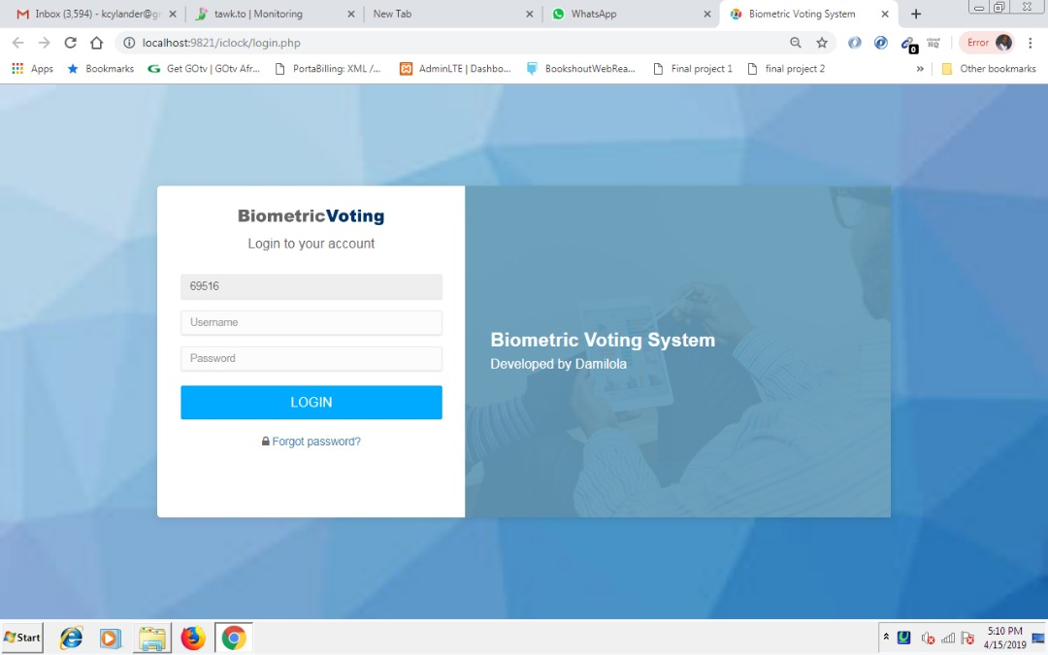

Login Page

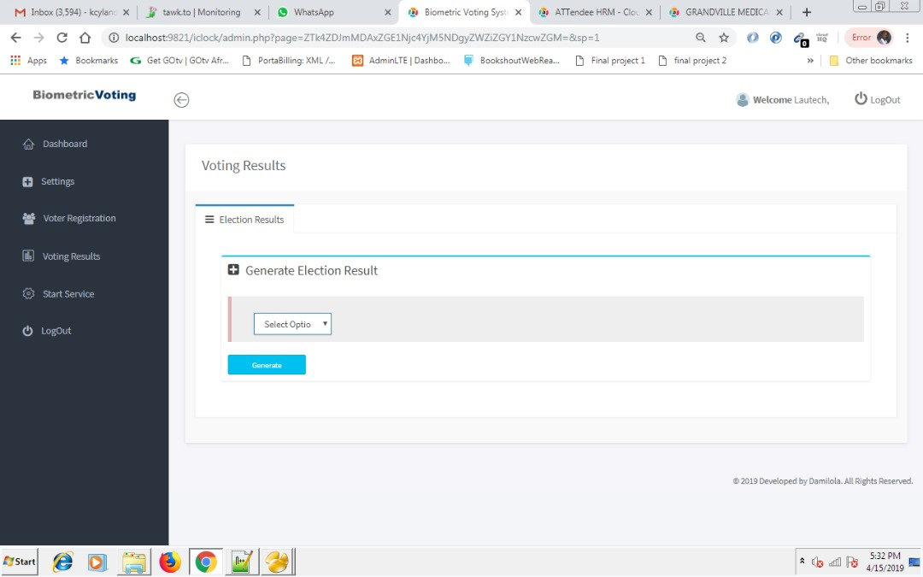

Election Result

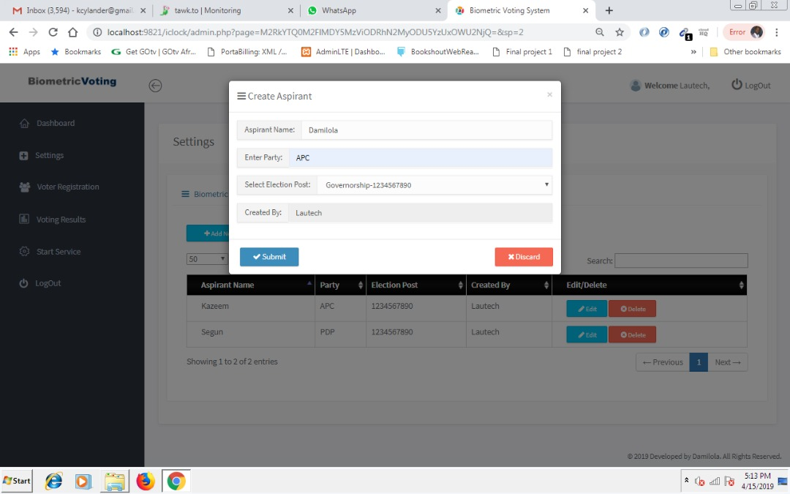

Aspirant Page

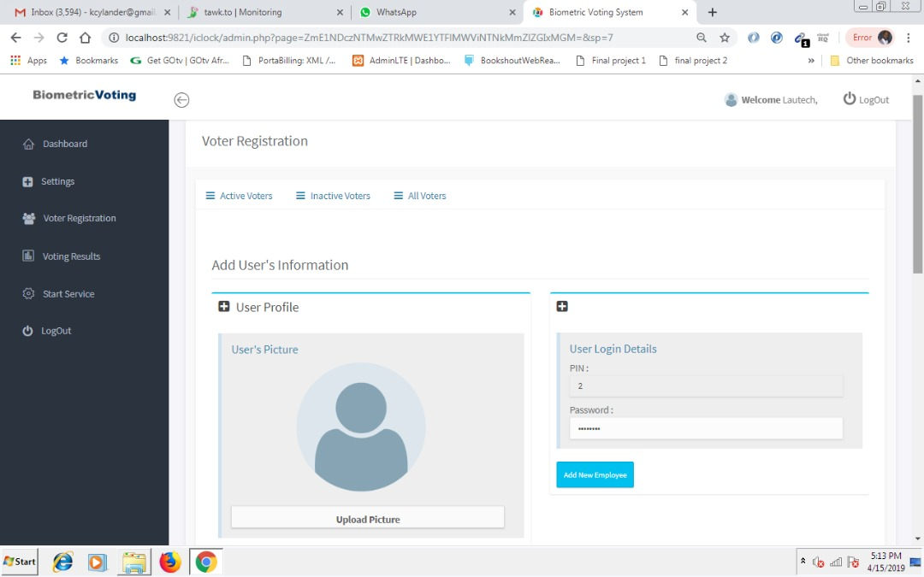

Voter Registration

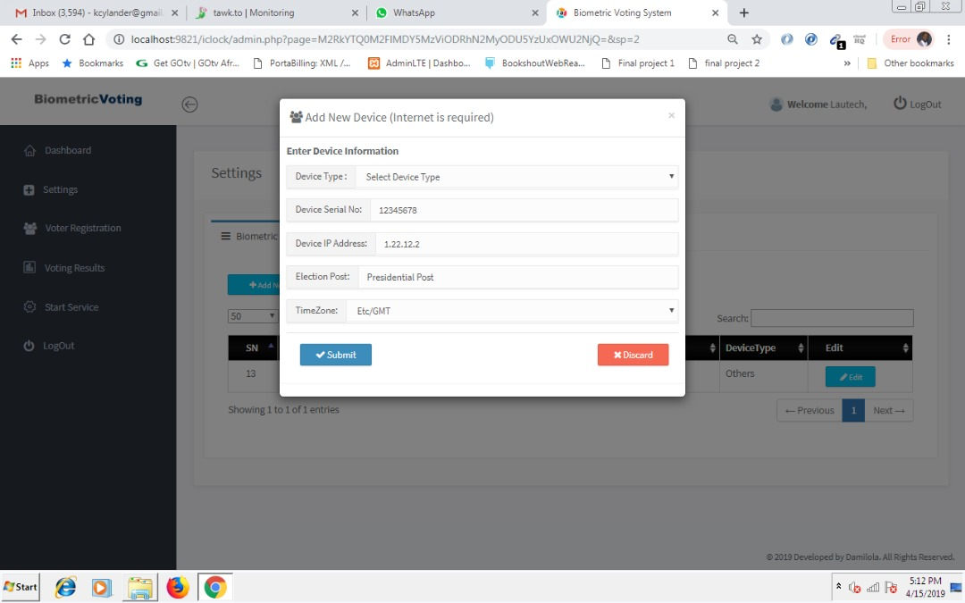

Election Biometric Device

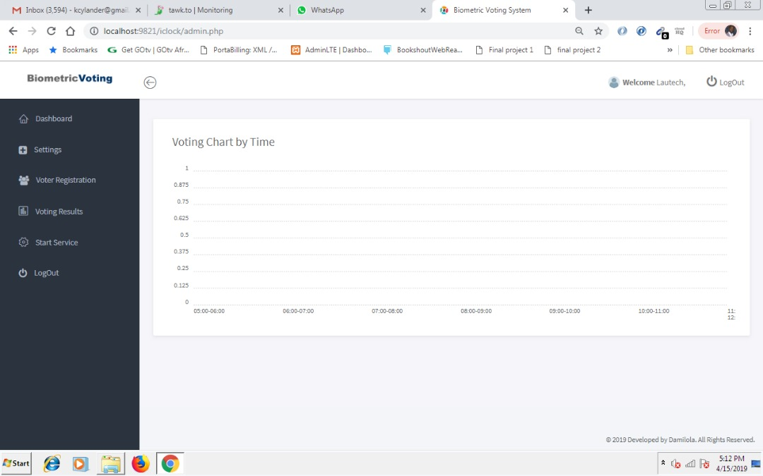

DashBoard

Program Source Code

<?php

error_reporting(0);

?>

<div class="main">

<!-- MAIN CONTENT -->

<div class="main-content">

<div class="container-fluid">

<!-- OVERVIEW -->

<div class="panel panel-headline">

<div class="panel-heading">

<h3 class="panel-title">Settings</h3>

</div>

<!-- Content Header (Page header) -->

<section class="content">

<div class="row">

<div class="col-md-12">

<!-- Custom Tabs -->

<div class="nav-tabs-custom" style="padding:10px;">

<ul class="nav nav-tabs" >

<?php

if($_GET[sp]==1)

{

$V2oeueugqj3l='class=active';

$V35lxrlndjod='active';

}

elseif($_GET[sp]==2 )

{

$V3ororxhsobi='class=active';

$V51ghekkpkqe='active';

}

elseif($_GET[sp]==3)

{

$Vhv4y0gi5035='class=active';

$Vg55ngsymtib='active';

}

elseif($_GET[sp]==4 )

{

$Vzeai4lahts0='class=active';

$Vozoofdr4pvt='active';

}

elseif($_GET[sp]==5)

{

$Vcf3w4uqryha='class=active';

$V54bhhiwionh='active';

}

elseif($_GET[sp]==17)

{

$Vz0gxxckhakt='class=active';

$Vyyjgybv50oq='active';

}

elseif($_GET[sp]==6)

{

$Vscmnzxgqhpc='class=active';

$Vqspqaftezk1='active';

}

elseif($_GET[sp]==7 and ($_SESSION['accesslevel']=="Company" or $_SESSION['accesslevel']=="HR" or $_SESSION['accesslevel']=="Location"))

{

$Vc4oiej5xeau='class=active';

$Vk54xt34ujgo='active';

}

elseif($_GET[sp]==8 and ($_SESSION['accesslevel']=="Company" or $_SESSION['accesslevel']=="HR" or $_SESSION['accesslevel']=="Location"))

{

$Vvuoi31wdj2g='class=active';

$V5zqvsmjryw4='active';

}

elseif($_GET[sp]==9 and ($_SESSION['accesslevel']=="Company" or $_SESSION['accesslevel']=="HR" or $_SESSION['accesslevel']=="Location"))

{

$Voemwrjovzyj='class=active';

$V1jtcpvupwq5='active';

}

elseif($_GET[sp]==10 and ($_SESSION['accesslevel']=="Company" or $_SESSION['accesslevel']=="HR" or $_SESSION['accesslevel']=="Location"))

{

$Vcyhhzq34cxi='class=active';

$Vmsrjak5hzni='active';

}

elseif($_GET[sp]==11 and ($_SESSION['accesslevel']=="Company" or $_SESSION['accesslevel']=="HR" or $_SESSION['accesslevel']=="Location"))

{

$V4fsikqihhfd='class=active';

$Vsniq2t4k4ar='active';

}

elseif($_GET[sp]==12 and ($_SESSION['accesslevel']=="Company" or $_SESSION['accesslevel']=="HR" or $_SESSION['accesslevel']=="Location"))

{

$Vqtr5npvbkde='class=active';

$V50dqftizcff='active';

}

elseif($_GET[sp]==13 and ($_SESSION['accesslevel']=="Company" or $_SESSION['accesslevel']=="HR" or $_SESSION['accesslevel']=="Location"))

{

$Vegysfrgda5b='class=active';

$Vwrmwhpz2cj5='active';

}

elseif($_GET[sp]==14 and ($_SESSION['accesslevel']=="Company" or $_SESSION['accesslevel']=="HR" or $_SESSION['accesslevel']=="Location"))

{

$V1owwpdx2ss4='class=active';

$Vkbulbhcwlmj='active';

}

elseif($_GET[sp]==15 and ($_SESSION['accesslevel']=="Company"))

{

$Vodbsd33f2z1='class=active';

$Vhsnv5cxbuij='active';

}

elseif($_GET[sp]==33 and ($_SESSION['accesslevel']=="Company"))

{

$Vhv4y0gi50353='class=active';

$Vg55ngsymtib3='active';

}

?>

<!--li <?=$V2oeueugqj3l?> ><a href="#tab_0" data-toggle="tab" title="Company Details"><i class="fa fa-bars"></i> &nbsp; Company Details</a></li-->

<li <?=$V3ororxhsobi?> ><a href="#tab_2" data-toggle="tab" title="Company Devices"> <i class="fa fa-bars"></i> &nbsp; Biometric Devices</a></li>

<li <?=$Vhv4y0gi5035?> ><a href="#tab_3" data-toggle="tab" title="Administrative Users"> <i class="fa fa-bars"></i> &nbsp; Administrators</a></li>

<li <?=$Vzeai4lahts0?> ><a href="#tab_4" data-toggle="tab" title="Manage Company's Location"> <i class="fa fa-bars"></i> &nbsp; Aspirant List</a></li>

</ul>

<div class="tab-content">

<!-- tab 0 -->

<div class="tab-pane <?=$V35lxrlndjod?>" id="tab_0">

<div class="box-body">

<!-- text input -->

<div class="err" id="eddlocation_err"></div>

<table class="table table-bordered table-hover">

<thead>

<tr class="trhead">

<th>Company Name</th>

<th>Contact Name</th>

<th>Contact Email</th>

<th>Contact Phone</th>

<th>Expiry Date</th>

<th>Edit</th>

</tr>

</thead>

<tbody>

<?php

$V3jyl2l5r5o4 = $Vath4dzo2itz->query("SELECT * FROM company where compid='".$_SESSION['compid']."' ");

while($rows = $V3jyl2l5r5o4->fetchArray())

{

?>

<tr>

<td><?php echo $rows["comprname"]; ?></td>

<td><?php echo $rows["cperson"]; ?></td>

<td><?php echo $rows["email"]; ?></td>

<td><?php echo $rows["phone"]; ?></td>

<td><?php echo $rows["expires"] ? $rows["expires"]:"FREE" ; ?></td>

<td>

<button class="btn btn-info btn-sm" data-toggle="modal" data-target="#getcompany-modal" value="<?=$rows["id"]?>" onclick="getcompany(this.value)"> Edit Company's Details</button>

</td>

</tr>

<?php

}

?>

</tbody>

</table>

</div><!-- /.box-body -->

</div><!-- /.tab-pane -->

<!-- tab 2 -->

<div class="tab-pane <?=$V51ghekkpkqe?>" id="tab_2">

<div class="box-body">

<!-- text input -->

<?php

//db

if($_SESSION['accesslevel']=="Company")

{

?>

<a class="btn btn-info btn-sm" style="width:120px;" data-toggle="modal" data-target="#adddevice-modal_2"><i class="fa fa-plus"></i> Add New</a>

<br><br><?=$_GET[err]?>

<?php

}

?>

<div class="err" id="editdevice_err"></div>

<table id="devicetbl" class="table table-bordered table-hover" >

<thead>

<tr class="trhead">

<th>SN</th>

<th>Election Post</th>

<th>Device SN</th>

<th>IP Address</th>

<th>Status</th>

<th>LastTransaction</th>

<th>DeviceType</th>

<th>Edit</th>

</tr>

</thead>

<tbody>

<?php

$V3jyl2l5r5o4s = $Vath4dzo2itz->query("SELECT * FROM tbl_device where CompanyId='".$_SESSION['compid']."' ");

while($rows = $V3jyl2l5r5o4s->fetchArray())

{

?>

<tr>

<td><?php echo $rows["id"]; ?></td>

<td><?php echo $rows["Alias"]; ?></td>

<td><?php echo $rows["SN"]; ?></td>

<td><?php echo $rows["IPAddress"]; ?></td>

<td>

<?php if($rows["State"]==1)

echo "<font color=blue>Online</font>" ;

else

echo "<font color=red>Offline</font>" ;

?>

</td>

<td><?php echo $rows["LastActivity"]; ?></td>

<td><?php echo $rows["deviceType"] ; ?></td>

<!--<td><?php echo $rows["UserCount"]; ?></td>

<td><?php echo $rows["FPCount"]; ?></td>

<td><?php echo $rows["TransactionCount"]; ?></td>

<td><?php echo $rows["MaxFingerStorage"]; ?></td> -->

<td><button class="btn btn-info btn-sm" data-toggle="modal" data-target="#device-modal" name="edit" value="<?=$rows["id"]?>" onclick="getdevice(this.value)"><i class="fa fa-fw fa-pencil"></i>Edit</button>

<?php if($rows["admin_device"]<>"yes")

{?><button class="btn btn-danger btn-sm" value="<?=$rows["id"]?>" onclick="deletedevice(this.value)"><i class="fa fa-fw fa-times-circle"></i></i>Delete</button>

<?php } ?>

</td>

</tr>

<?php

}

?>

</tbody>

</table>

</div><!-- /.box-body -->

</div><!-- /.tab-pane -->

<!-- tab 3 -->

<div class="tab-pane <?=$Vg55ngsymtib?>" id="tab_3">

<div class="box-body">

<!-- text input -->

<a class="btn btn-info btn-sm" style="width:150px;" data-toggle="modal" data-target="#adduser-modal"><i class="fa fa-pencil"></i> Create Administrator</a><br><br>

<div class="err" id="add_err"></div>

<table id="usertbl" class="table table-bordered table-hover">

<thead>

<tr class="trhead">

<th>UserName</th>

<th>AccessLevel</th>

<th>Name</th>

<th>Email</th>

<th>Edit/Delete</th>

</tr>

</thead>

<tbody>

<?php

if($_SESSION['accesslevel']=="Company")

$V3jyl2l5r5o4 = $Vath4dzo2itz->query("SELECT * FROM user1 where compid='".$_SESSION['compid']."' ");

elseif($_SESSION['accesslevel']=="Location")

$V3jyl2l5r5o4 = $Vath4dzo2itz->query("SELECT * FROM user1 where compid='".$_SESSION['compid']."' and u='".$_SESSION['useradmin']."' ");

while($rows = $V3jyl2l5r5o4->fetchArray())

{

?>

<tr>

<td><?php echo $rows["u"]; ?></td>

<td><?php echo $rows["accesslevel"]; ?></td>

<td><?php echo $rows["cperson"]; ?></td>

<td><?php echo $rows["email"]; ?></td>

<td><button class="btn btn-info btn-sm" data-toggle="modal"

data-target="#compose-modal" name="edit" value="<?=$rows["id"]?>" onclick="getuser(this.value)"><i class="fa fa-fw fa-pencil"></i>Edit</button>

<button class="btn btn-danger btn-sm" value="<?=$rows["id"]?>" onclick="deleteuser(this.value)"><i class="fa fa-fw fa-times-circle"></i></i>Delete</button></td>

</tr>

<?php

}

?>

</tbody>

</table>

</div><!-- /.box-body -->

</div><!-- /.tab-pane -->

<!-- tab 4 -->

<div class="tab-pane <?=$Vozoofdr4pvt?>" id="tab_4">

<div class="box-body">

<!-- text input -->

<a class="btn btn-info btn-sm" style="width:120px;" data-toggle="modal" data-target="#addaspirant-modal"><i class="fa fa-plus"></i> Add New </a><br><br>

<div class="err" id="eddlocation_err"></div>

<div class=" with-header">

<table id="locationtbl" class="table table-bordered table-hover">

<thead>

<tr class="trhead">

<th>Aspirant Name</th>

<th>Party</th>

<th>Election Post</th>

<th>Created By</th>

<th>Edit/Delete</th>

</tr>

</thead>

<tbody>

<?php

$V3jyl2l5r5o4 = $Vath4dzo2itz->query("SELECT * FROM aspirant where compid='".$_SESSION['compid']."' ");

while($rows = $V3jyl2l5r5o4->fetchArray())

{

?>

<tr>

<td><?php echo $rows["aspirantname"]; ?></td>

<td><?php echo $rows["party"]; ?></td>

<td><?php echo $rows["SN"]; ?></td>

<td><?php echo $rows["user"]; ?></td>

<td><button class="btn btn-info btn-sm" data-toggle="modal"

data-target="#getasp-modal" name="edit" value="<?=$rows["id"]?>" onclick="getasp(this.value)"><i class="fa fa-fw fa-pencil"></i>Edit</button>

<button class="btn btn-danger btn-sm" value="<?=$rows["id"]?>" onclick="deleteasp(this.value)"><i class="fa fa-fw fa-times-circle"></i></i>Delete</button></td>

</tr>

<?php

}

?>

</tbody>

</table>

</div>

</div><!-- /.box-body -->

</div><!-- /.tab-pane -->

</div><!-- /.tab-content -->

</div><!-- nav-tabs-custom -->

</div><!-- /.col -->

</div> <!-- /.row -->

</section>

<!--begins of modals -->

<!-- update user info -->

<div class="modal fade" id="compose-modal" tabindex="-1" role="dialog" aria-hidden="true">

<div class="modal-dialog">

<div class="modal-content">

<div id="getuser"></div>

</div><!-- /.modal-content -->

</div><!-- /.modal-dialog -->

</div><!-- /.modal -->

<!-- update device info -->

<div class="modal fade" id="device-modal" tabindex="-1" role="dialog" aria-hidden="true">

<div class="modal-dialog">

<div class="modal-content">

<div id="getdevice"></div>

</div><!-- /.modal-content -->

</div><!-- /.modal-dialog -->

</div><!-- /.modal -->

<!-- update company info -->

<div class="modal fade" id="getcompany-modal" tabindex="-1" role="dialog" aria-hidden="true">

<div class="modal-dialog">

<div class="modal-content">

<div id="getcompany"></div>

</div><!-- /.modal-content -->

</div><!-- /.modal-dialog -->

</div><!-- /.modal -->

<!-- update location info -->

<div class="modal fade" id="getasp-modal" tabindex="-1" role="dialog" aria-hidden="true">

<div class="modal-dialog">

<div class="modal-content">

<div id="getasp"></div>

</div><!-- /.modal-content -->

</div><!-- /.modal-dialog -->

</div><!-- /.modal -->

<div class="modal fade" id="adduser-modal" tabindex="-1" role="dialog" aria-hidden="true">

<div class="modal-dialog">

<div class="modal-content">

<div class="modal-header">

<button type="button" class="close" data-dismiss="modal" aria-hidden="true">&times;</button>

<h4 class="modal-title"><i class="fa fa-users"></i> Create User's Record</h4>

</div>

<form action="#" method="post">

<div class="modal-body">

<div class="form-group">

<div class="input-group">

<span class="input-group-addon">Access Level:</span>

<select class="form-control" id="_accesslevel" onchange="showlocation()" >

<option value="Company" >Company</option>

<!--option value="Location" >Location</option-->

</select>

</div>

</div>

<div class="form-group" id="location_div">

<div class="input-group">

<span class="input-group-addon">Location:</span>

<select multiple="multiple" size="5" class="form-control" id="_location" >

<?php

$result= $Vath4dzo2itz->query("select * from location1 where compid='".$_SESSION['compid']."'");

$Vjsq5kytxoyb=mysql_affected_rows();

for($Vvs4tf422bo0=1; $Vvs4tf422bo0<=$Vjsq5kytxoyb; $Vvs4tf422bo0++)

{

$rows=$result->fetchArray();;

$Vj4lyagkcjdt=$rows["location"];

$V41glzpkymb5=$rows["id"];

?>

<option value="<?php echo $V41glzpkymb5; ?>" ><?php echo $Vj4lyagkcjdt; ?> </option>

<?php

}

?>

</select>

</div>

</div>

<div class="form-group">

<div class="input-group">

<span class="input-group-addon">User Name:</span>

<input id="_username" type="text" class="form-control" >

</div>

</div>

<div class="form-group">

<div class="input-group">

<span class="input-group-addon">Full Name:</span>

<input id="_cperson" type="text" class="form-control" >

</div>

</div>

<div class="form-group">

<div class="input-group">

<span class="input-group-addon">Email:</span>

<input id="_email" type="email" class="form-control" >

</div>

</div>

</div>

<div class="err" id="adduser_err" style="padding-left:20px; color:#FF0000;"></div>

<div class="modal-footer clearfix">

<button type="button" class="btn btn-danger" data-dismiss="modal"><i class="fa fa-times"></i> Discard</button>

<button type="button" class="btn btn-primary pull-left" onclick="adduser()"><i class="fa fa-check"></i> Submit</button>

</div>

</form>

</div><!-- /.modal-content -->

</div><!-- /.modal-dialog -->

</div><!-- /.modal -->

<!-- add device info 2-->

<div class="modal fade" id="adddevice-modal_2" tabindex="-1" role="dialog" aria-hidden="true">

<div class="modal-dialog">

<div class="modal-content">

<div class="modal-header">

<button type="button" class="close" data-dismiss="modal" aria-hidden="true">&times;</button>

<h4 class="modal-title"><i class="fa fa-users"></i> Add New Election Device</h4>

</div>

<!-- Custom Tabs -->

<div class="nav-tabs-custom">

<div class="tab-content">

<div class="box-body">

<!-- text input -->

<div class="err" id="editdevice_err"></div>

<p><b>Enter Device Information </b></p>

<div class="form-group">

<div class="input-group">

<span class="input-group-addon" >Device Type :</span>

<select class="form-control" onchange="sn_note()" id="dev_storage" >

<option value="">Select Device Type</option>

<option value="INO1A">INO1A</option>

<option value="ICLOCK700">ICLOCK700</option>

<option value="ICLOCK880">ICLOCK880</option>

<option value="S900">S900</option>

<option value="IFACE402/302">IFACE402/302</option>

<option value="DS100">DS100</option>

<option value="K40">K40</option>

<option value="TX628">TX628</option>

<option value="ZK F SERIES">ZK F SERIES</option>

<option value="Others">Others</option>

</select>

</div>

</div>

<div class="form-group">

<div class="input-group">

<span class="input-group-addon">Device Serial No:</span>

<input id="sn" type="text" class="form-control" >

</div>

</div>

<div class="form-group">

<div class="input-group">

<span class="input-group-addon">Device IP Address:</span>

<input id="ipaddress" type="text" class="form-control" >

</div>

</div>

<div class="form-group">

<div class="input-group">

<span class="input-group-addon">Election Post:</span>

<input id="alias" type="text" class="form-control" >

</div>

</div>

<div class="form-group">

<div class="input-group">

<span class="input-group-addon">TimeZone:</span>

<select class="form-control" id="gmt" >

<option value="-750">Etc/GMT-12:30</option>

<option value="-12">Etc/GMT-12</option>

<option value="-690">Etc/GMT-11:30</option>

<option value="-11">Etc/GMT-11</option>

<option value="-630">Etc/GMT-10:30</option>

<option value="-10">Etc/GMT-10</option>

<option value="-570">Etc/GMT-9:30</option>

<option value="-9">Etc/GMT-9</option>

<option value="-510">Etc/GMT-8:30</option>

<option value="-8">Etc/GMT-8</option>

<option value="-450">Etc/GMT-7:30</option>

<option value="-7">Etc/GMT-7</option>

<option value="-390">Etc/GMT-6:30</option>

<option value="-6">Etc/GMT-6</option>

<option value="-330">Etc/GMT-5:30</option>

<option value="-5">Etc/GMT-5</option>

<option value="-270">Etc/GMT-4:30</option>

<option value="-4">Etc/GMT-4</option>

<option value="-210">Etc/GMT-3:30</option>

<option value="-3">Etc/GMT-3</option>

<option value="-150">Etc/GMT-2:30</option>

<option value="-2">Etc/GMT-2</option>

<option value="-90">Etc/GMT-1:30</option>

<option value="-1">Etc/GMT-1</option>

<option value="-30">Etc/GMT-0:30</option>

<option value="0" selected>Etc/GMT</option>

<option value="30">Etc/GMT+0:30</option>

<option value="1">Etc/GMT+1</option>

<option value="90">Etc/GMT+1:30</option>

<option value="2">Etc/GMT+2</option>

<option value="150">Etc/GMT+2:30</option>

<option value="3">Etc/GMT+3</option>

<option value="210">Etc/GMT+3:30</option>

<option value="4">Etc/GMT+4</option>

<option value="270">Etc/GMT+4:30</option>

<option value="5">Etc/GMT+5</option>

<option value="330">Etc/GMT+5:30</option>

<option value="6">Etc/GMT+6</option>

<option value="390">Etc/GMT+6:30</option>

<option value="7">Etc/GMT+7</option>

<option value="450">Etc/GMT+7:30</option>

<option value="8">Etc/GMT+8</option>

<option value="510">Etc/GMT+8:30</option>

<option value="9">Etc/GMT+9</option>

<option value="570">Etc/GMT+9:30</option>

<option value="10">Etc/GMT+10</option>

<option value="630">Etc/GMT+10:30</option>

<option value="11">Etc/GMT+10</option>

<option value="690">Etc/GMT+10:30</option>

<option value="12">Etc/GMT+12</option>

<option value="750">Etc/GMT+12:30</option>

<option value="13">Etc/GMT+13</option>

<option value="810">Etc/GMT+13:30</option>

</select>

</div>

</div>

<div id="adddevice_err2"> </div>

<div class="modal-footer clearfix">

<button type="button" class="btn btn-danger pull-right" data-dismiss="modal"><i class="fa fa-times"></i> Discard</button>

<button type="button" class="btn btn-primary pull-left" onclick="adddevice2()"><i class="fa fa-check"></i> Submit</button>

</div>

</div>

</div>

</div><!-- nav-tabs-custom -->

</div><!-- /.modal-content -->

</div><!-- /.modal-dialog -->

</div><!-- /.modal -->

<!-- add location info -->

<div class="modal fade" id="addaspirant-modal" tabindex="-1" role="dialog" aria-hidden="true">

<div class="modal-dialog">

<div class="modal-content">

<div class="modal-header">

<button type="button" class="close" data-dismiss="modal" aria-hidden="true">&times;</button>

<h4 class="modal-title"><i class="fa fa-bars"></i> Create Aspirant</h4>

</div>

<form action="#" method="post">

<div class="modal-body">

<div class="form-group">

<div class="input-group">

<span class="input-group-addon">Aspirant Name:</span>

<input id="aspirantname" type="text" class="form-control" >

</div>

</div>

<div class="form-group">

<div class="input-group">

<span class="input-group-addon">Enter Party:</span>

<input id="party" type="text" class="form-control" >

</div>

</div>

<div class="form-group">

<div class="input-group">

<span class="input-group-addon">Select Election Post:</span>

<select id="devices" class="form-control" >

<?php

$result= $Vath4dzo2itz->query("select * from tbl_device where CompanyID='".$_SESSION['compid']."' order by Alias ");

while($rows = $result->fetchArray())

{

$Vkaz2tovzkfz=$rows["SN"];

$V1gdf4jyacmc=$rows["Alias"];

?>

<option value="<?php echo $Vkaz2tovzkfz; ?>" ><?php echo "$V1gdf4jyacmc-$Vkaz2tovzkfz";?> </option>

<?php

}

?>

</select>

</div>

</div>

<div class="form-group">

<div class="input-group">

<span class="input-group-addon">Created By:</span>

<input id="_created" type="text" class="form-control" readonly="readonly" value="<?=$_SESSION['cperson1']?>" />

</div>

</div>

</div>

<div class="err" id="addaspirant_err" style="padding-left:20px; color:#FF0000;"></div>

<div class="modal-footer clearfix">

<button type="button" class="btn btn-danger" data-dismiss="modal"><i class="fa fa-times"></i> Discard</button>

<button type="button" class="btn btn-primary pull-left" onclick="addaspirant()"><i class="fa fa-check"></i> Submit</button>

</div>

</form>

</div><!-- /.modal-content -->

</div><!-- /.modal-dialog -->

</div><!-- /.modal -->

</div><!-- /.modal-content -->

</div><!-- /.modal-dialog -->

</div><!-- /.modal -->

</div>

</div>

<!-- END OVERVIEW -->

</div>

</div>

<!-- END MAIN CONTENT -->

</div>

<script src="assets/vendor/jquery/jquery.min.js"></script>

<script type="text/javascript">

$(function() {

$("#_sa_fromp").datepicker();

$("#_sa_top").datepicker();

$("#_sa_top").hide();

$("#newholiday").hide();

$("#bp").hide();

$("#dept").hide();

$("#locc").hide();

$("#dept1").hide();

$("#locc1").hide();

processemployee();

processemployee1();

$("#dat").hide();

$("#secondapp").hide();

$("#sa_from").datepicker();

$("#sa_to").datepicker();

$("#btnExport").click(function() {

window.open('data:application/vnd.ms-excel,' + encodeURIComponent($('#dvData').html()) );

e.preventDefault();

});

$('#example2').dataTable({

"bPaginate": true,

"bLengthChange": false,

"bFilter": false,

"bSort": true,

"bInfo": true,

"bAutoWidth": false

});

$('#devicetbl').dataTable({

"bPaginate": true,

"bLengthChange": true,

"bFilter": true,

"bSort": true,

"bInfo": true,

"bAutoWidth": false

});

$('#usertbl').dataTable({

"bPaginate": true,

"bLengthChange": true,

"bFilter": true,

"bSort": true,

"bInfo": true,

"bAutoWidth": false

});

$('#upgradetbl').dataTable({

"bPaginate": true,

"bLengthChange": true,

"bFilter": true,

"bSort": true,

"bInfo": true,

"bAutoWidth": false

});

$('#public_tbl').dataTable({

"bPaginate": true,

"bLengthChange": true,

"bFilter": true,

"bSort": true,

"bInfo": true,

"bAutoWidth": false

});

$('#locationtbl').dataTable({

"bPaginate": true,

"bLengthChange": true,

"bFilter": true,

"bSort": true,

"bInfo": true,

"bAutoWidth": false

});

$('#alert_tbl_2').dataTable({

"bPaginate": true,

"bLengthChange": true,

"bFilter": true,

"bSort": true,

"bInfo": true,

"bAutoWidth": false

});

$('#jobtbl').dataTable({

"bPaginate": true,

"bLengthChange": true,

"bFilter": true,

"bSort": true,

"bInfo": true,

"bAutoWidth": false

});

$('#approval').dataTable({

"bPaginate": true,

"bLengthChange": true,

"bFilter": true,

"bSort": true,

"bInfo": true,

"bAutoWidth": false

});

$("#location_div").hide();

});

function processView()

{

var view=$("#view").val();

if(view=="Location")

{

$("#locc").show();

$("#dept").hide();

$("#indi").show();

}

else if(view=="Department")

{

$("#dept").show();

$("#locc").show();

$("#indi").show();

}

else if(view=="All Staff")

{

$("#indi").show();

$("#locc").hide();

$("#dept").hide();

}

}

function processView1()

{

var view=$("#view_").val();

if(view=="Location")

{

$("#locc_").show();

$("#dept_").hide();

$("#indi_").show();

}

else if(view=="Department")

{

$("#dept_").show();

$("#locc_").show();

$("#indi_").show();

}

else if(view=="All Staff")

{

$("#indi_").show();

$("#locc_").hide();

$("#dept_").hide();

}

}

function showlocation()

{

var accesslevel=$("#_accesslevel").val();

if(accesslevel=="Location")

$("#location_div").show();

else if(accesslevel=="Company")

$("#location_div").hide();

}

function getuser(id)

{

$("#add_err").show();

$.ajax({

url: "getuser.php",

data: "id="+id,

success: function(data){

$("#getuser").html(data);

$("#add_err").hide();

},

beforeSend:function()

{

$("#add_err").html('<img src="img/ajax-loader.gif"> <i>Loading...</i>')

}

});

}

function getdevice(id)

{

$("#editdevice_err").show();

$.ajax({

url: "getdevice.php",

data: "id="+id,

success: function(data){

$("#getdevice").html(data);

$("#editdevice_err").hide();

},

beforeSend:function()

{

$("#editdevice_err").html('<img src="img/ajax-loader.gif"> <i>Loading...</i>')

}

});

}

function processemployee()

{

var view=$("#view").val();

var departmentid=$("#department_app").val();

var locationid=$("#location_app").val();

$.ajax({

url: "inc_employee_app.php",

data: "view="+view+"&locationid="+locationid+"&departmentid="+departmentid,

success: function(data){

$("#loademployee").html(data);

},

beforeSend:function()

{

$("#loademployee").html('<img src="img/ajax-loader.gif"> <i>Loading...</i>')

}

});

}

function processemployee1()

{

var view=$("#view_").val();

var departmentid=$("#department_app_").val();

var locationid=$("#location_app_").val();

$.ajax({

url: "inc_employee_app.php",

data: "view="+view+"&locationid="+locationid+"&departmentid="+departmentid,

success: function(data){

$("#loademployee_").html(data);

},

beforeSend:function()

{

$("#loademployee_").html('<img src="img/ajax-loader.gif"> <i>Loading...</i>')

}

});

}

function getasp(id)

{

$("#addaspirant_err").show();

$.ajax({

url: "getasp.php",

data: "id="+id,

success: function(data){

$("#getasp").html(data);

$("#addaspirant_err").hide();

},

beforeSend:function()

{

$("#addaspirant_err").html('<img src="img/ajax-loader.gif"> <i>Loading...</i>')

}

});

}

function getcompany(id)

{

$.ajax({

url: "getcompany.php",

data: "id="+id,

success: function(data){

data= data.trim();

$("#getcompany").html(data);

},

beforeSend:function()

{

$("#getcompany").html('<img src="img/ajax-loader.gif"> <i>Loading...</i>')

}

});

}

function deleteuser(id)

{

var a=confirm("Are You Sure you wish to delete this record ?");

if(a)

{

$.ajax({

url: "deleteuser.php",

data: "id="+id,

success: function(data){

data= data.trim();

if(data=="yes")

{

alert("User Successfully Deleted");

self.location="admin.php?page=<?=base64_encode(md5("organisation"))?>&sp=3";

}

else

{

alert("User Cannot Be Deleted");

}

}

});

}

}

function deletedevice(id)

{

var a=confirm("Are You Sure you wish to delete this record ?");

if(a)

{

$.ajax({

url: "deletedevice.php",

data: "id="+id,

success: function(data){

data= data.trim();

if(data=="yes")

{

alert("Device Successfully Deleted");

self.location="admin.php?page=<?=base64_encode(md5("organisation"))?>&sp=2";

}

else

{

alert("Device Could Not Be Deleted");

}

}

});

}

}

function deleteasp(id)

{

var a=confirm("Are You Sure you wish to delete this record ?");

if(a)

{

$.ajax({

url: "deleteasp.php",

data: "id="+id,

success: function(data){

data= data.trim();

if(data=="yes")

{

alert("Aspirant Successfully Deleted");

self.location="admin.php?page=<?=base64_encode(md5("organisation"))?>&sp=4";

}

else

{

alert("Aspirant could not be deleted");

}

}

});

}

}

function adduser()

{

var accesslevel=$("#_accesslevel").val();

var username=$("#_username").val();

var cperson=$("#_cperson").val();

var email=$("#_email").val();

if(accesslevel=="Location")

var location1=$("#_location").val();

else

var location1="All";

if(!accesslevel || !username || !cperson || !email || !location1 )

{

$("#adduser_err").html('<i>Please enter necessary information. All fields are required...</i>')

return false

}

else if(!validateEmail(email))

{

$("#adduser_err").html('<i>You have entered an Invalid Email, Try a valid one...</i>')

return false

}

else if(!validateUsername(username))

{

$("#adduser_err").html('<i>The username contains illegal characters or Username length is not from 5 to 15.</i>')

return false

}

$.ajax({

url: "adduser.php",

data: "_accesslevel="+accesslevel+"&_username="+username+"&_cperson="+cperson+"&_email="+email+"&_location="+location1,

success: function(data){

data= data.trim();

if(data=="yes")

{

alert("User Successfully Created");

self.location="admin.php?page=<?=base64_encode(md5("organisation"))?>&sp=3";

}

else

{

$("#adduser_err").html(data)

}

},

beforeSend:function()

{

$("#adduser_err").html('<i><b>Processing...</b></i>')

}

});

}

function addaspirant()

{

var aspirantname=$("#aspirantname").val();

var party=$("#party").val();

var devices=$("#devices").val();

if(!aspirantname || !party || !devices)

{

$("#addaspirant_err").html('<i>Please enter necessary information. All fields are required...</i>')

return false

}

$.ajax({

url: "addaspirant.php",

data: "aspirantname="+aspirantname+"&party="+party+"&devices="+devices,

success: function(data){

data= data.trim();

if(data=="yes")

{

alert("Aspirant Successfully Created");

self.location="admin.php?page=<?=base64_encode(md5("organisation"))?>&sp=4";

}

else

{

$("#addaspirant_err").html(data)

}

},

beforeSend:function()

{

$("#addaspirant_err").html('<i><b>Processing...</b></i>')

}

});

}

function adddevice2()

{

var alias=$("#alias").val();

var sn=$("#sn").val();

var gmt=$("#gmt").val();

var dev_storage=$("#dev_storage").val();

var ipaddress=$("#ipaddress").val();

if( !alias || !sn || !gmt || !ipaddress )

{

$("#adddevice_err2").html('<i>Please enter necessary information.</i>')

return false

}

$.ajax({

url: "adddevice.php",

data: "sn="+sn+"&gmt="+gmt+"&alias="+alias+"&dev_storage="+dev_storage+"&ipaddress="+ipaddress,

type:"POST",

success: function(data){

data= data.trim();

if(data=="success")

{

alert("Device Successfully Created. Note: Device shall come online within 2 - 5 minutes");

self.location="admin.php?page=<?=base64_encode(md5("organisation"))?>&sp=2";

}

else

{

$("#adddevice_err2").html(data)

}

},

beforeSend:function()

{

$("#adddevice_err2").html('<i><b>Processing...</b></i>')

}

});

}

function updatedevice()

{

var alias=$("#_alias").val();

var gmt=$("#_gmt").val();

var dev_storage=$("#_dev_storage").val();

var id=$("#_idu").val();

var sn=$("#_sn").val();

var ipaddress=$("#_ipaddress").val();

if( !alias || !sn || !gmt )

{

$("#updatedevice_err").html('<i>Please enter necessary information.</i>')

return false

}

$.ajax({

url: "updatedevice.php",

data: "gmt="+gmt+"&alias="+alias+"&dev_storage="+dev_storage+"&id="+id+"&sn="+sn+"&ipaddress="+ipaddress,

success: function(data){

data= data.trim();

if(data=="yes")

{

alert("Device Successfully Updated. Note: Device shall come online within 2 - 5 minutes OR Click Refresh button from the Server Dialog");

self.location="admin.php?page=<?=base64_encode(md5("organisation"))?>&sp=2";

}

else

{

$("#updatedevice_err").html(data)

}

},

beforeSend:function()

{

$("#updatedevice_err").html('<i><b>Processing...</b></i>')

}

});

}

function updateuser()

{

var accesslevel=$("#_accesslevel").val();

var username=$("#_username").val();

var cperson=$("#_cperson").val();

var password=$("#_password").val();

var email=$("#_email").val();

var id=$("#_id").val();

if(accesslevel=="Location")

var location1=$("#_location").val();

else

var location1="All";

if(!accesslevel || !username || !cperson || !email || !location1 )

{

$("#edituser_err").html('<i>Please enter necessary information. All fields are required...</i>')

return false

}

else if(!validateEmail(email))

{

$("#edituser_err").html('<i>You have entered an Invalid Email, Try a valid one...</i>')

return false

}

else if(!validateUsername(username))

{

$("#edituser_err").html('<i>The username contains illegal characters or Username length is not from 5 to 15.</i>')

return false

}

else if(password.toUpperCase()=="PASSWORD")

{

$("#edituser_err").html('<i>Password cannot be "password".</i>')

return false

}

$.ajax({

url: "updateuser.php",

data: "_accesslevel="+accesslevel+"&_username="+username+"&_cperson="+cperson+"&_email="+email+"&_location="+location1+"&_id="+id+"&_password="+password,

success: function(data){

data= data.trim();

if(data=="yes")

{

alert("User Successfully Updated");

self.location="admin.php?page=<?=base64_encode(md5("organisation"))?>&sp=3";

}

else

{

$("#edituser_err").html(data)

}

},

beforeSend:function()

{

$("#edituser_err").html('<img src="img/ajax-loader.gif"> <i>Updating User informtion...</i>')

}

});

}

function updateasp()

{

var aspirantname=$("#_aspname").val();

var party=$("#_party").val();

var device=$("#_devices").val();

var id=$("#_id").val();

if(!aspirantname || !party || !device)

{

$("#editlocation_err").html('<i>Please enter necessary information. All fields are required...</i>')

return false

}

$.ajax({

url: "updateasp.php",

data: "aspirantname="+aspirantname+"&party="+party+"&SN="+device+"&_id="+id,

success: function(data){

data= data.trim();

if(data=="yes")

{

alert("Aspirant Successfully Updated");

self.location="admin.php?page=<?=base64_encode(md5("organisation"))?>&sp=4";

}

else

{

$("#editlocation_err").html(data)

}

},

beforeSend:function()

{

$("#editlocation_err").html('<img src="img/ajax-loader.gif"> <i>Updating informtion...</i>')

}

});

}

function updatecompany()

{

var img_name=$('#img').val();

var old_img=$('#old_img').val();

if(!img_name || img_name=='undefined')

img_name=old_img;

var field1=$("#field1").val();

var field2=$("#field2").val();

var field3=$("#field3").val();

var field4=$("#field4").val();

var comprname=$("#c_comprname").val();

var comptname=$("#c_comptname").val();

var person=$("#c_person").val();

var phone=$("#c_phone").val();

var fphone=$("#c_fphone").val();

var addr=$("#c_addr").val();

var email=$("#c_email").val();

var functionkey=$("#functionkey").val();

var id=$("#_id").val();

if(!comprname || !comptname || !person || !phone || !email )

{

$("#editcomp_err").html('<i>Please enter necessary information...</i>')

return false

}

else if(!validateEmail(email))

{

$("#editcomp_err").html('<i>You have entered an Invalid Email, Try a valid one...</i>')

return false

}

$.ajax({

url: "updatecompany.php",

data: "comprname="+comprname+"&comptname="+comptname+"&person="+person+"&email="+email+"&phone="+phone+"&_id="+id+"&addr="+addr+"&fphone="+fphone+"&img_name="+img_name+"&field1="+field1+"&field2="+field2+"&field3="+field3+"&field4="+field4+"&functionkey="+functionkey,

success: function(data){

data= data.trim();

if(data=="yes")

{

alert("Company Successfully Updated");

self.location="admin.php?page=<?=base64_encode(md5("organisation"))?>&sp=1";

}

else

{

$("#editcomp_err").html(data)

}

},

beforeSend:function()

{

$("#editcomp_err").html('<img src="img/ajax-loader.gif"> <i>Updating Company informtion...</i>')

}

});

}

function validateEmail(x)

{

var atpos=x.indexOf("@");

var dotpos=x.lastIndexOf(".");

if (atpos<1 || dotpos<atpos+2 || dotpos+2>=x.length)

{

return false;

}

return true;

}

function validateUsername(fld) {

var error = "";

var illegalChars = /\W/;

if (illegalChars.test(fld))

{

return false;

}

else if (fld.length<5 || fld.length>15 )

{

return false;

}

else

{

return true;

}

}

</script>

<script type="text/javascript">

$(function() {

"use strict";

$("#check-all").on('ifUnchecked', function(event) {

$("input[type='checkbox']", ".table-mailbox").iCheck("uncheck");

});

$("#check-all").on('ifChecked', function(event) {

$("input[type='checkbox']", ".table-mailbox").iCheck("check");

});

});

</script>

<script type="text/javascript" src="js/custom.js"></script>