­



**Funding Proposal**

***FOR***

**ATTENDEE HRM SOLUTION**

[**https://attendee.kcysoft.com**](https://attendee.kcysoft.com)

***SUBMITTED TO:***

**MR. FABAMWO**

**Head Office: 33 Sarah Olakunbi Street, Ebute Ikorodu**

**Phone: 08028951734, 07039787233, 08155140578**

**Email:** [**info@kcysoft.com**](mailto:info@kcysoft.com) **Website:** [**www.kcysoft.com**](http://www.kcysoft.com)

**1.0 INTRODUCTION**

**KcySoft Communication** ® is an Information & Communication Technology Company with over 10 years of providing Business Solutions for organizations.

At KcySoft, we are fully equipped to deliver first-class services that result in improved business efficiency and increased ROI cost-effectiveness. At the same time we are highly flexible to meet the needs of various customers – from startups and SMBs to Fortune 500 companies.

However, some of our in-house products include ATTendee HRM, Ideal Job Portal, SendApp Email Marketing and TrackIT.

**2.0 PRODUCT**

**ATTendee HRM** is a desktop/web platform designed to simplify time-consuming and repetitive tasks of HR Managers such as appraisal system, work attendance, document management, payroll, capacity building and many other activities. All human resources management tasks can be carried out on a single platform and in a natively integrated way.

**ATTENDEE PACKAGES WITH ITS CORRESPONDING FEATURES**

|  |  |  |
| --- | --- | --- |
| **BASIC** | **STANDARD** | **PREMIUM** |
| Basic HRM Modules | Everything in Basic Package | Everything in Standard Package |
| Appraisal/Performance System | Leave & Exemption | Loan Management |
| Document Management | Shift Scheduling | Benefits & Deductions |
| Recruitment Portal | Time & Attendance | Payroll Management |

**HOW DOES ATTENDEE HRM WORKS**

1. To sign up on **ATTendee HRM** , visit<https://attendee.kcysoft.com/> and click on Sign Up link on the header section.

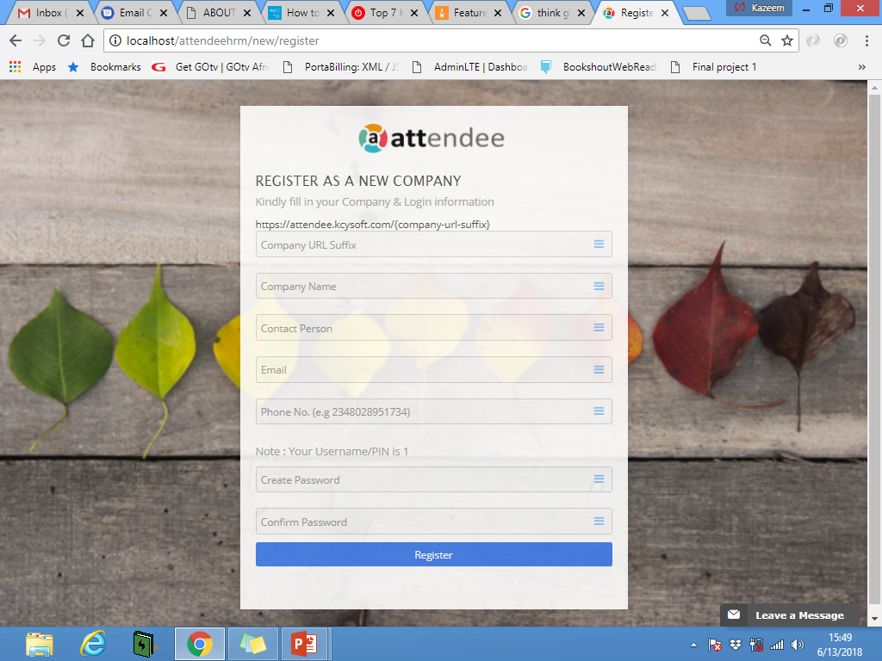

1. Fill in companies and login details then click on Register Button.
2. After step 2, and activation code will be sent to your email and phone in order to activate your account for login purpose.
3. Then after successful activation, a personalized url shall be created for company in order to login and have access to ATTendee HRM interfaces.
4. After login, user may click on the help button on the top right corner of the page to learn more.

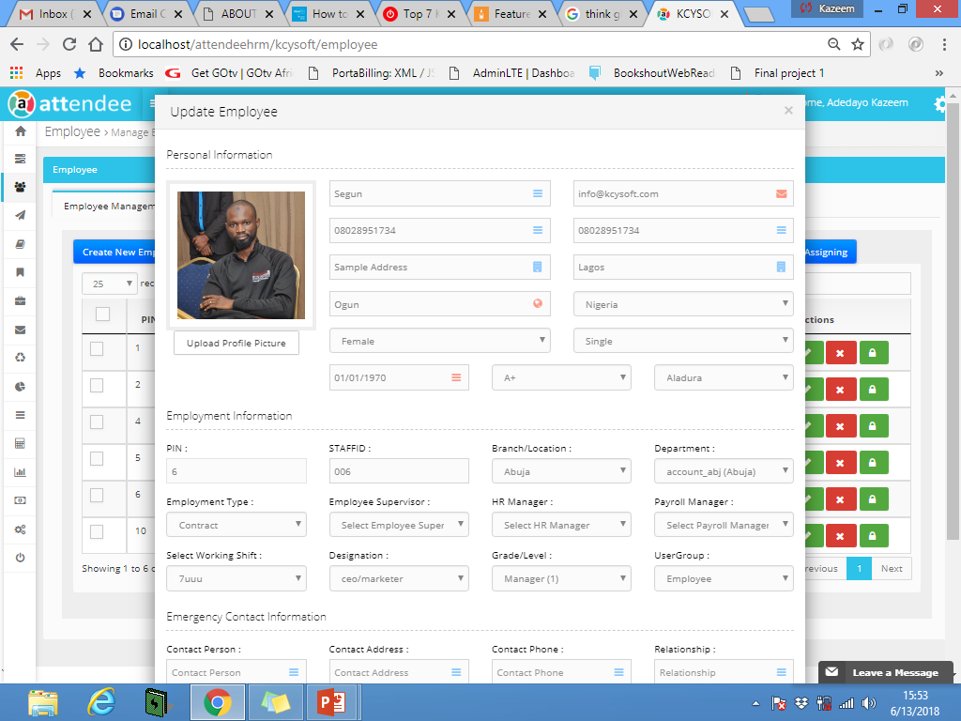

**3.0 PROBLEM TO SOLVE**

1. Ineffective way of managing employees.
2. Significantly high cost for managing human capital in a work place
3. Ghost Worker, Absenteeism and laxity to work.
4. Problem of data integrity.
5. Challenges of Payroll Processing.
6. Biasness in selecting the most productive staff of the year.
7. Loss of staff information due to any eventualities (e.g. fire outbreaks).

**4.0 VALUE PROPOSITION**

1. Increase Company’s Return of Investment
2. Increase Employees’ Productivity
3. Save Money
4. Save Time

**5.0 TARGET AUDIENCE**

Our target audience is Small and Medium Scale enterprises with an average of 1-200 Staff Strength.

Research shows that only 38% of all employees work for companies with more than 1,000 employees, and only 22% work for companies with more than 10,000 employees. So if we focus our software sales and product strategy toward the biggest companies, we are likely to find a saturated market quickly. In fact, there are less than 1000 companies with more than 5,000 employees in Africa.

The mid-market is actually shaped like a dumbbell. In other words, there are a very large number (nearly 30 million) of tiny companies in the Nigeria (startups, small businesses), but far fewer companies of a medium size (companies from 500-2,500 employees only make up 8% of total Nigeria employment).

Our guess about the reason for this is that it is very hard for a business to grow above a few hundred employees, and those that manage to do so are solid enough to either grow much bigger or become acquired.

So, if we can find a way to tap into the small business market, we are likely to find a goldmine. Look at ADP and Paychex, for example. These companies dominate the market for small business payroll and both are very large, profitable, and growing. ADP’s revenues are nearly $9 Billion and Paychex’s is over $2 Billion. Both are highly profitable and continue to grow rapidly.

**6.0 BENEFITS OF THE ATTENDEE TO SMEs**

The landscape is filled with HR and Time attendance system but KcySoft Communication HRMS (**ATTendee HRM**) solution when comparing our capabilities and proposed solution to available alternatives, the benefits of choosing **ATTendee** solution include:

* Robust & Complex Shift Setup
* Cost Effectiveness.
* Increased operational efficiency
* Monitor staff and departmental performance.
* Automated attendance system.
* Improved corporate culture and sense of responsibility
* Improved and organized work environment
* Increased employee safety
* Flexibility and high Specification
* Ability to integrate or export reports to third party solution
* Multi-Company Data Management.

**7.0 ATTENDEE HRM BUSINESS MODEL**

Our business model is basically on annual subscription, we charge an average of N100,000 from a company per annum.

For the period of 1 year, 2 years and 5 years respectively, we have projected to onboard 1000 SMEs on our platform which will result in the following computation:

|  |  |  |  |
| --- | --- | --- | --- |
| **Year** | **No. of Companies** | **Average Price** | **Revenue** |
| 2020 | 200 | 100,000 | N20 Million |
| 2021 | 500 | 100,000 | N50 Million |
| 2024 | 1000 | 100,000 | N100 Million |

**8.0 FUNDING NEEDS**

The following areas are where this fund is essential for us as a startup to scale:

1. Products Research & Development.
2. Improve Operational Activities.
3. Customers Acquisition.
4. Technical resources & server upgrade.

**9.0 CLIENTELE**

Below are few of the companies that are currently using ATTendee HRM.

|  |  |
| --- | --- |
| **Company** | **Year Joined** |
| Protea Hotel | 2018 |
| Radisson Blu | 2018 |
| Nestle | 2018 |
| Grandville Medical Lesser | 2018 |
| American Airsea Cargo | 2019 |
| Brone Energy Group | 2019 |
| Brookstone Property | 2019 |
| Ikeja Medical Center | 2019 |
| Gran Melia Hotel | 2019 |
| RAEANNA Telecommunication | 2019 |

Thank You and Regards